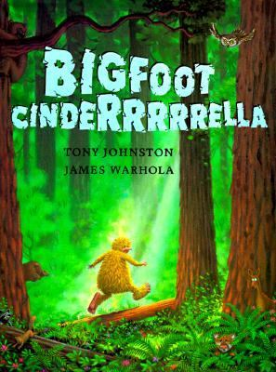

____________________________________________________________________________________________________________________________________________________________________________________________________________________________________

Write about your favorite part of the story Bigfoot Cinderella?

Draw a picture of your favorite part of the story.

Name: _________________________ Date: _________________