 | 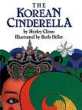  The Korean Cinderella | 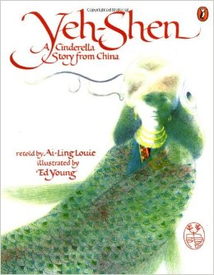  Yeh- Shen
Describe both Cinderellas
Describe the Setting
Key Details

underline experiences that are the SAME

These books are the SAME because

These books are DIFFERENT because

