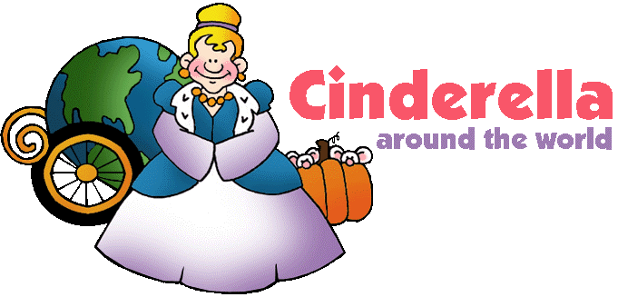

This notebook is helping

_________________________________

compare and contrast Cinderella Stories

AND

learn about continents and cultures.

[](http://www.google.com/imgres?q=target&hl=en&sa=X&rls=com.microsoft:en-us:IE-SearchBox&biw=1024&bih=616&tbm=isch&tbnid=goiLT-isUQqxYM:&imgrefurl=http://www.123rf.com/photo_7557601_computer-generated-image-of-a-target-with-the-shape-of-an-heart-and-an-arrow-in-the-center.html&docid=3e3SNAlO_Or7fM&imgurl=http://us.123rf.com/400wm/400/400/beawolf/beawolf1008/beawolf100800025/7557601-computer-generated-image-of-a-target-with-the-shape-of-an-heart-and-an-arrow-in-the-center.jpg&w=1200&h=1200&ei=6A5fUe7BMMbirAGQtoHoCA&zoom=1&iact=hc&vpx=331&vpy=64&dur=968&hovh=225&hovw=225&tx=132&ty=123&page=3&tbnh=127&tbnw=161&start=43&ndsp=23&ved=1t:429,r:57,s:0,i:327)

I can retell a story. (RL.1.2)

I can tell the difference between fiction and nonfiction. (RL.1.5)

I can compare and contrast what characters in different stories do. (RL. 1.9)

I can identify the main topic and key details. (RI. 1.2)

Table of Contents

|  |  |  |
| --- | --- | --- |
| Date | Title | Page # |
|  | Parts of a fairy tale | 3 |
|  |  |  |
|  |  |  |
|  |  |  |
|  |  |  |
|  |  |  |
|  |  |  |
|  |  |  |
|  |  |  |
|  |  |  |
|  |  |  |
|  |  |  |
|  |  |  |
|  |  |  |

Table of Contents

|  |  |  |
| --- | --- | --- |
| Date | Title | Page # |
|  |  |  |
|  |  |  |
|  |  |  |
|  |  |  |
|  |  |  |
|  |  |  |
|  |  |  |
|  |  |  |
|  |  |  |
|  |  |  |
|  |  |  |
|  |  |  |
|  |  |  |
|  |  |  |

[](http://www.google.com/imgres?q=target&hl=en&sa=X&rls=com.microsoft:en-us:IE-SearchBox&biw=1024&bih=616&tbm=isch&tbnid=goiLT-isUQqxYM:&imgrefurl=http://www.123rf.com/photo_7557601_computer-generated-image-of-a-target-with-the-shape-of-an-heart-and-an-arrow-in-the-center.html&docid=3e3SNAlO_Or7fM&imgurl=http://us.123rf.com/400wm/400/400/beawolf/beawolf1008/beawolf100800025/7557601-computer-generated-image-of-a-target-with-the-shape-of-an-heart-and-an-arrow-in-the-center.jpg&w=1200&h=1200&ei=6A5fUe7BMMbirAGQtoHoCA&zoom=1&iact=hc&vpx=331&vpy=64&dur=968&hovh=225&hovw=225&tx=132&ty=123&page=3&tbnh=127&tbnw=161&start=43&ndsp=23&ved=1t:429,r:57,s:0,i:327)

Goal: I can tell the parts of a fairy tale.

My favorite fairy tale is:

A

P

K

Application



What is a fairy tale?

__________________________

_____________________________

_____________________________

_____________________________

Parts of a Fairy Tale

* 

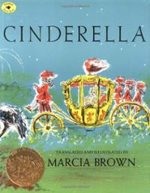

**Cinderella Character Helpers**

**Villain**

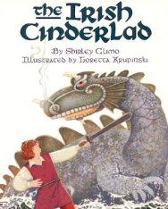

**Cinderella Character Helpers**

**Villain**

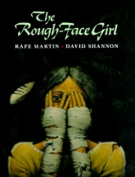

**Cinderella Character Helpers**

**Villain**

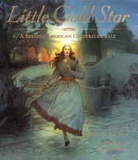

**Cinderella Character Helpers**

**Villain**

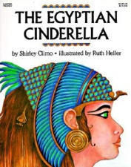

**Cinderella Character Helpers**

**Villain**

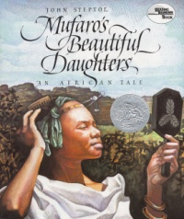

**Cinderella Character Helpers**

**Villain**

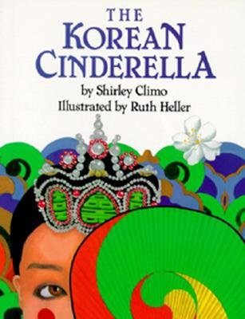

**Cinderella Character Helpers**

**Villain**

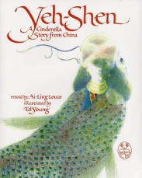

**Cinderella Character Helpers**

**Villain**













When:

Where:

When:

Where:

When:

Where:

When:

Where:

When:

Where:

When:

Where:



When:

Where:

When:

Where:















**Compare and Contrast**

|  |  |
| --- | --- |
| Title 1: | Title 2: |

|  |  |  |
| --- | --- | --- |
| Title 1 Only | Both Stories | Title 2 only |
|  |  |  |
|  |  |  |
|  |  |  |
|  |  |  |
|  |  |  |
|  |  |  |
|  |  |  |

**Compare and Contrast**

**Use information from your chart to tell how __________________________**

Title 1

**is different from _____________________________________________.** 1. _______________________________________________________

Title 2

_________________________________________________________

2.________________________________________________________

__________________________________________________________

3. ________________________________________________________

__________________________________________________________

**Use information from your chart to tell how __________________________**

Title 1

**and _____________________________________________ are the same.**

Title 2

1. ______________________________________________________

______________________________________________________

1. ____________________________________________________________________________________________________________
2. ______________________________________________________

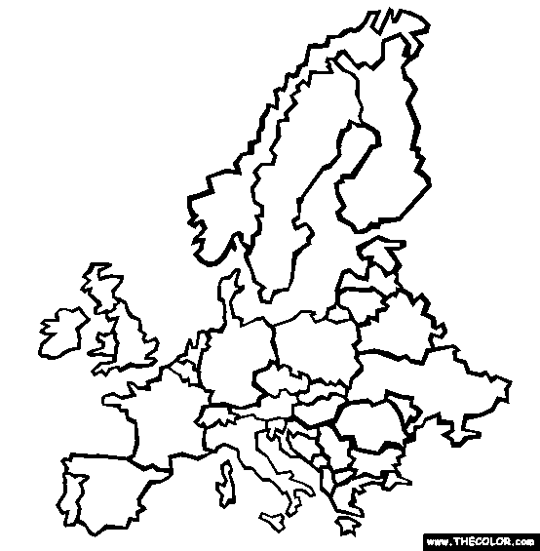

Country of Origin:______________________________________

Continent: ___________________________________

Facts about the culture that the story teaches:

1. _______________________________________________
2. _______________________________________________
3. _______________________________________________
4. _______________________________________________
5. _______________________________________________



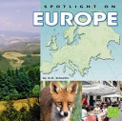

Europe

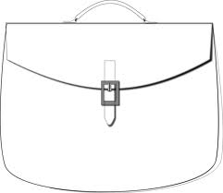

Food

Occupations

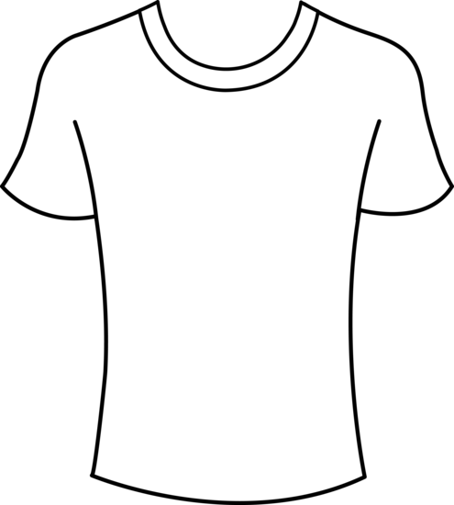

Clothes

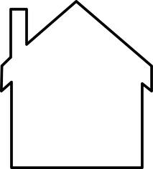

Shelter

Interesting

Fact

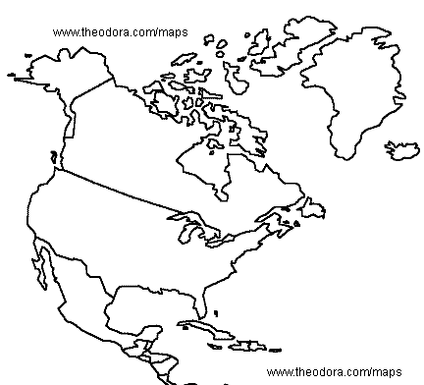

Country of Origin:_______________________

Continent: ___________________________________

Facts about the culture that the story teaches:

1. _______________________________________________
2. _______________________________________________
3. _______________________________________________
4. _______________________________________________
5. _______________________________________________

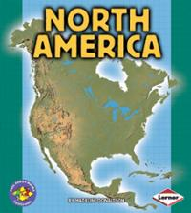

North America





Food

Occupations



Clothes



Shelter

Interesting

Fact



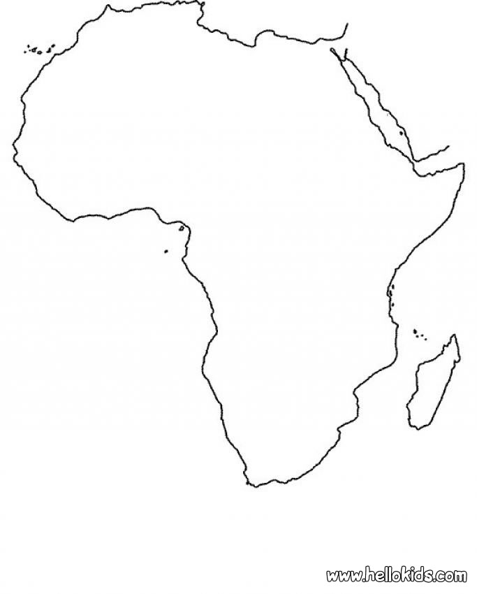

Country of Origin:_______________________

Continent: ___________________________________

Facts about the culture that the story teaches:

1. _______________________________________________
2. _______________________________________________
3. _______________________________________________
4. _______________________________________________
5. _______________________________________________

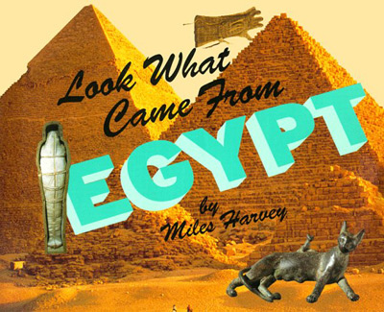

Africa





Food

Occupations



Clothes



Shelter

Interesting

Fact



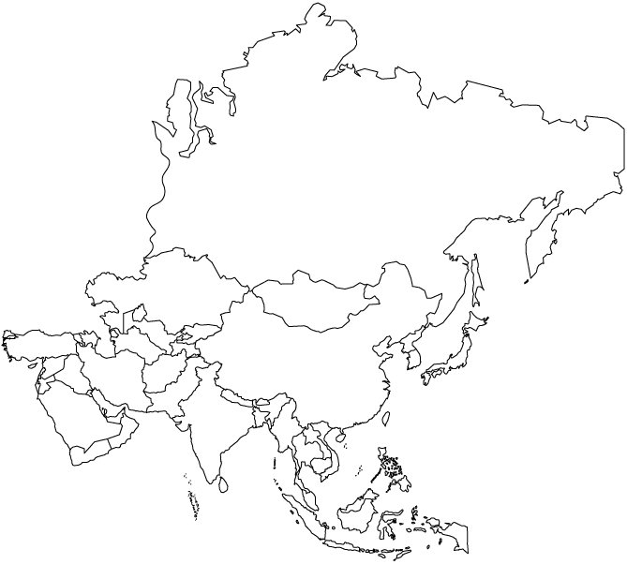

Country of Origin:_______________________

Continent: ___________________________________

Facts about the culture that the story teaches:

1. _______________________________________________
2. _______________________________________________
3. _______________________________________________
4. _______________________________________________
5. _______________________________________________

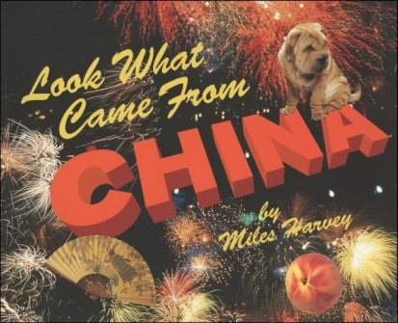

Asia





Food

Occupations



Clothes



Shelter

Interesting

Fact