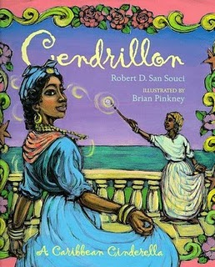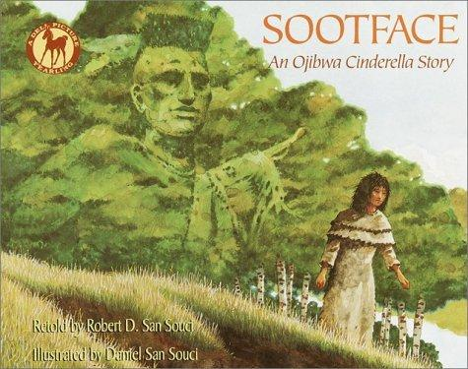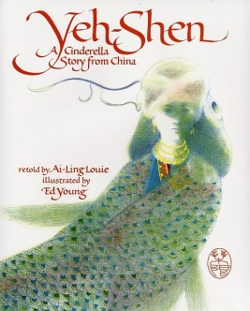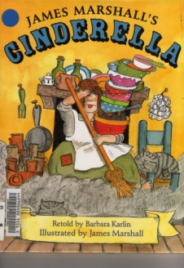

Now use this planner to help you write an opinion piece about your favorite version of Cinderella. Be sure to include the title of the book and at least 2 reasons why you think it is the best one.

Draw a picture of another thing that you liked in the story.

Draw a picture of one thing you liked in the story.

My favorite version of Cinderella is ________________________.