Name:_______________________________________ Date:__________________ Goal: I can use pictures and the text to show understanding of the story.

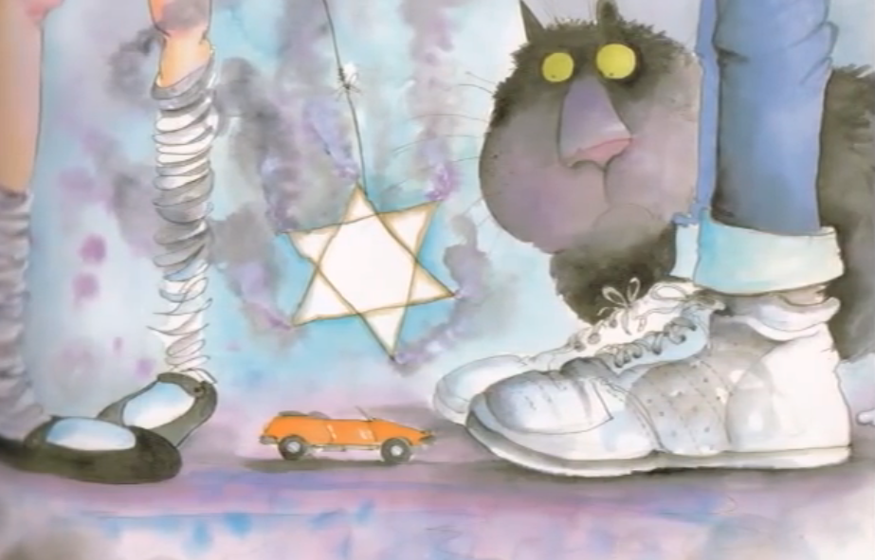

Look at the picture of Prince Cinders and the fairy. What clues from the picture tell us something went wrong? ________________________________________________________________________________________________________________________

“That can’t be right!” said the fairy.

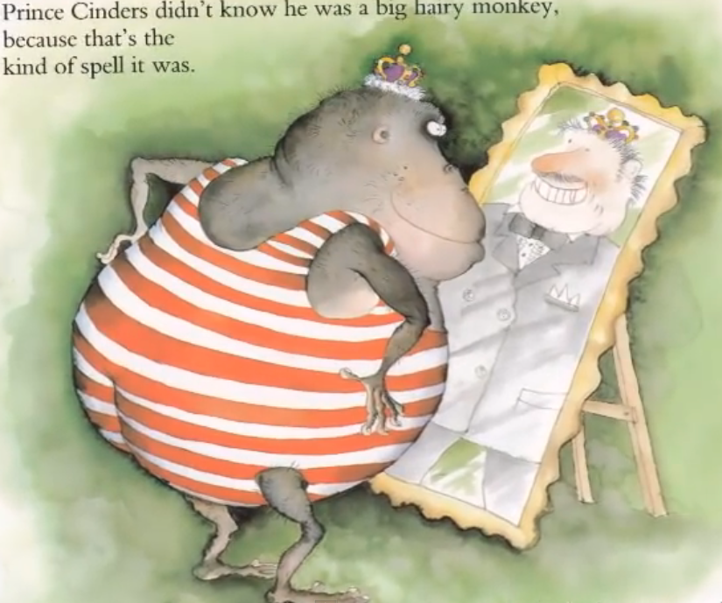

Why did Price Cinders think he looked pretty good? ________________________________________________________________________________________________________________________

Prince Cinders didn’t know he was a big hairy monkey, because that’s the kind of spell it was. He thought he looked pretty good.

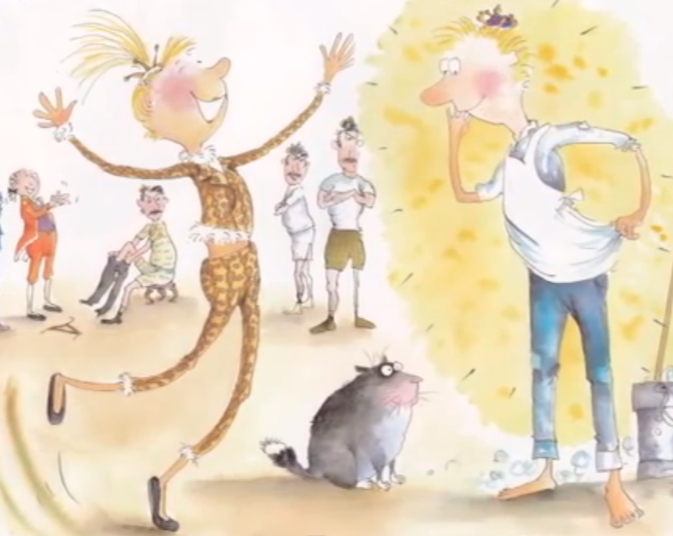

Look at the picture. How you know Princess LovelyPenny is excited? ________________________________________________________________________________________________________________________

Princess LovelyPenny proposed immediately!

How did Prince Cinders change from the beginning of the story, to the end of the story? Be sure to give examples from the story. _____________________________________________________________________________________________________________________________________________________________________________________________

_______________________________________________________________