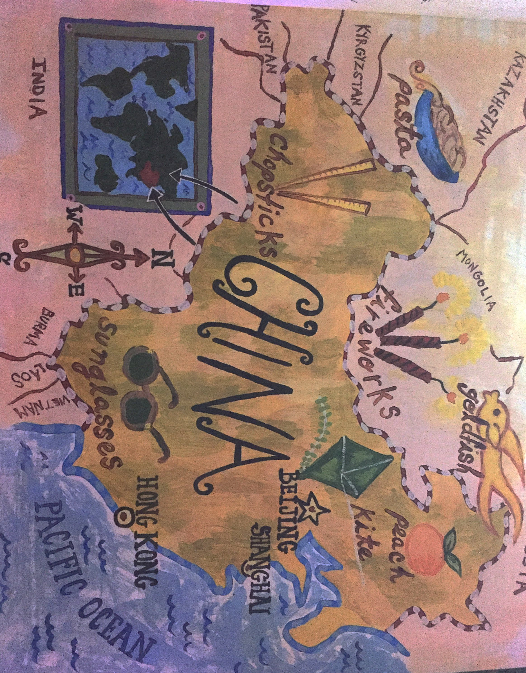 Name:_______________________________________ Date:__________________ Goal: I can use pictures and the text to show understanding of the story.

Look at the map. What are some other things came from China? ________________________________________________________________________________________________________________________________________________________________________

“Many things in your everyday life were invented in China- including the paper that these words are printed on.”

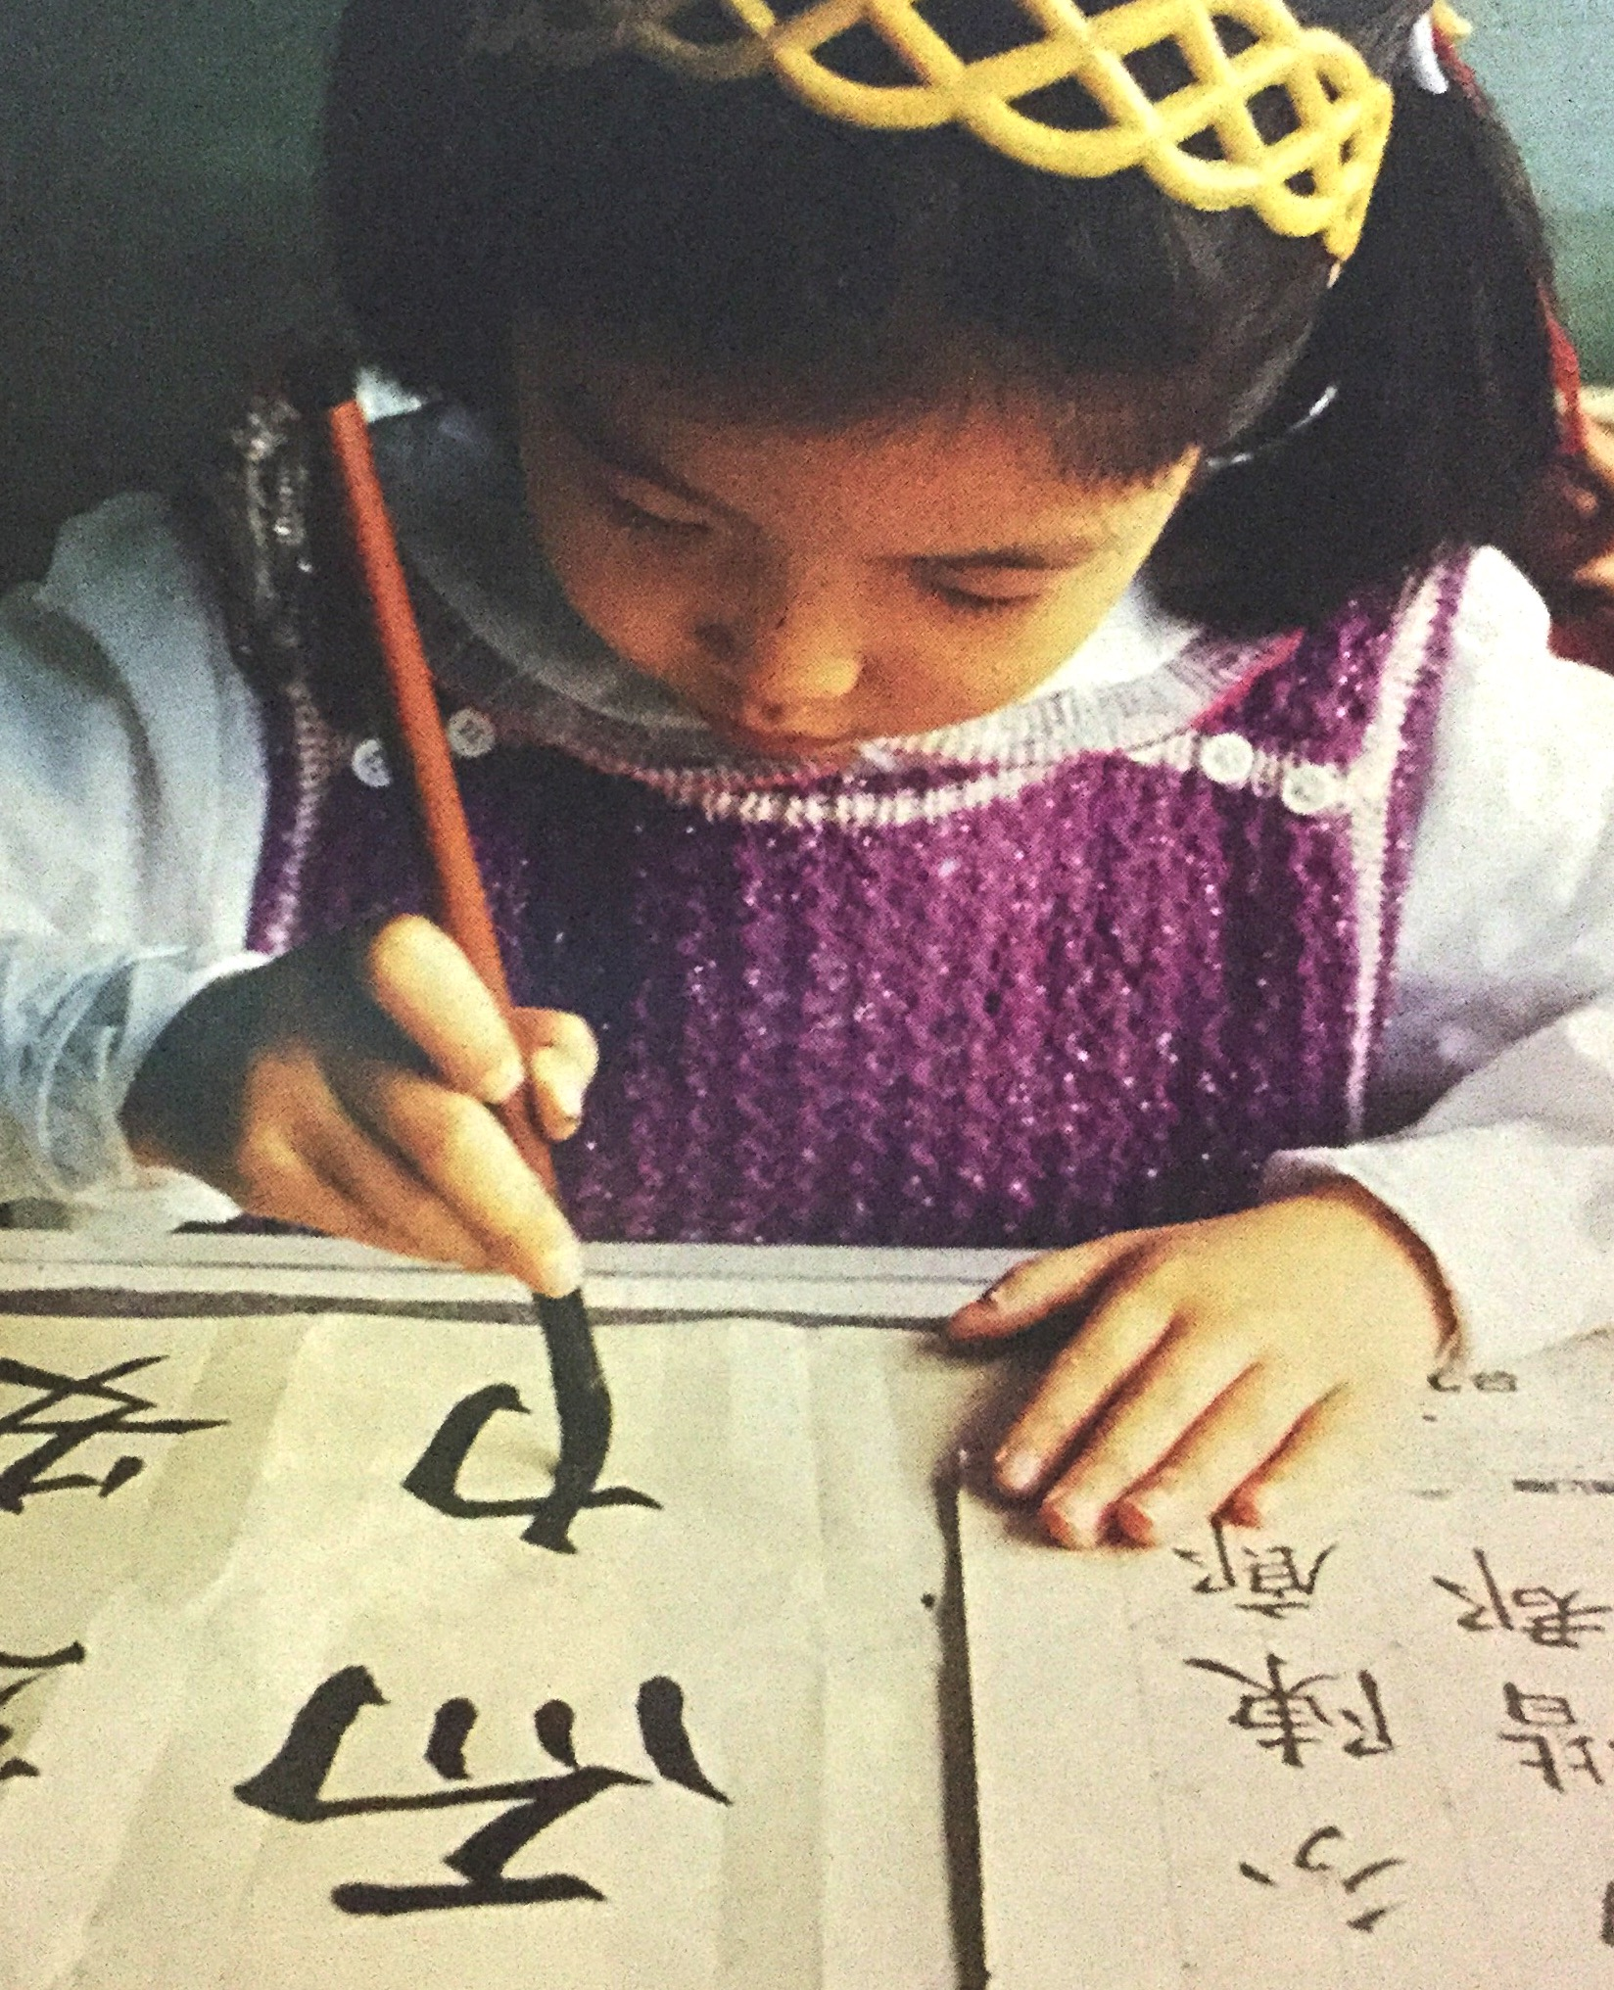

Look at the picture. Why do you think the text said it is hard to write like that? ________________________________________________________________________________________________________________________________________________

________________________

“People in China use a much different kind of writing than we do. Chinese writing is very beautiful, but it is hard to do well.”