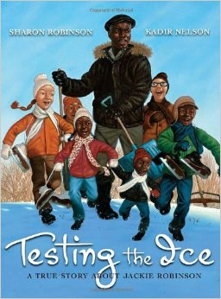RL.1.1 Ask and answer questions about key details in a text.

RL.1.10 With prompting and support, read prose and poetry of appropriate complexity for grade 1

|  |  |
| --- | --- |
| G: | I can answer questions about a text I have read independently. |
| A: | Ask students what they know about the word *bravery*? What does it mean to be *brave*? |
| N: | Tell students that today they will begin reading a book about a brave man who made a big difference in America. He helped to change the rules for who was allowed to play baseball and who was not. Begin reading and discussing *Testing the Ice* by Sharon Robinson. Be sure to point out characters’ names and the setting of the story. Discuss any tricky vocabulary along the way. Read until the top of page 8 which begins with “But to my brothers, Jackie Jr. and David, and me, the best parts…” Read the first paragraph on page 8. The rest of the page will be an independent read for the students. |
| A: | After reading pages 1-top of page 8, give students the handout on the following page. Have students read the passage independently and answer the questions. Consider having students mark their answers with a pen or crayon. If time allows, have students check their work with a partner. If partners disagree on the correct answer, have them discuss their thoughts and return to the text for evidence. |
| G: | In closing, as students what was easy/hard about reading the paragraph on their own. Have them share their thoughts with a partner.  I can answer questions about a text I have read independently. |

We spent our first summer playing by the lake. We had picnics, we swam, and we rowed our boats. But no matter how much we begged, my dad would *never* come into the water.

1. 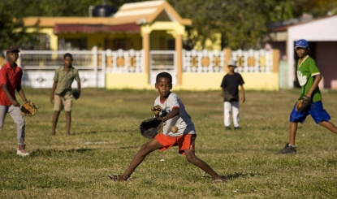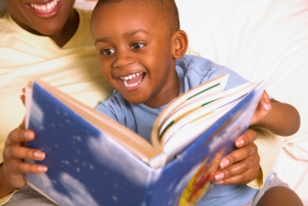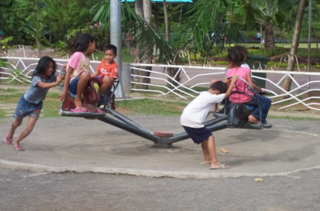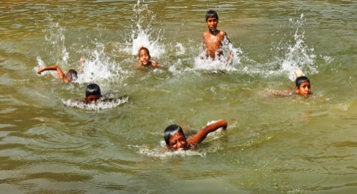Circle the two pictures that the passage says the Robinson children did during the summer.

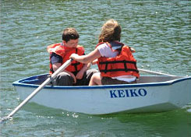

2. According to the story, what would dad *not* do?



play baseball

read books

go swimming