[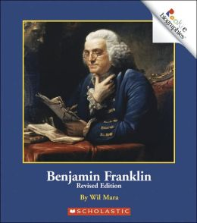](http://images.google.com/url?sa=i&rct=j&q=Benjamin+Franklin+rookie+reader&source=images&cd=&cad=rja&docid=KTfp258B6XC3nM&tbnid=GlnO7GLH-51M7M:&ved=0CAUQjRw&url=http://www.barnesandnoble.com/w/benjamin-franklin-wil-mara/1005753359&ei=YjAoUYCKOu3U2QXQ5IGQDQ&bvm=bv.42768644,d.b2I&psig=AFQjCNG9ITCCj72PTW56GKD0xjZfM2zKIg&ust=1361674714842498)[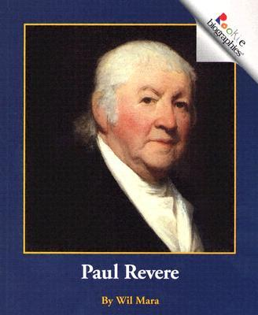](http://images.google.com/url?sa=i&rct=j&q=Paul+Revere+rookie+reader&source=images&cd=&cad=rja&docid=Rt5-n5CQ79pGCM&tbnid=vGxYlDn9a4m3jM:&ved=0CAUQjRw&url=http://www.booktopia.com.au/paul-revere-wil-mara/prod9780516258201.html&ei=vDAoUaSGFYi42QXcsYCYDQ&bvm=bv.42768644,d.b2I&psig=AFQjCNHdG9JsH8miV-dqJv-sI0aQOSNkcw&ust=1361674770731312)

Unit 5:

American Contributions

Name: ______________________________

[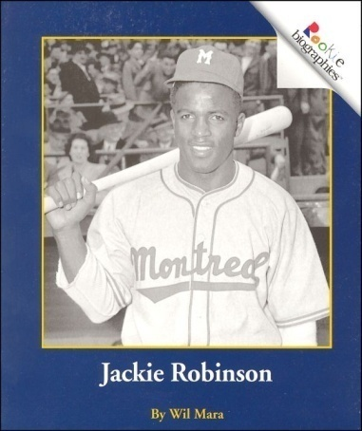](http://images.google.com/url?sa=i&rct=j&q=Paul+Revere+rookie+reader&source=images&cd=&cad=rja&docid=NvMyQluBBQBbMM&tbnid=VVpYvjOUWZ9m7M:&ved=0CAUQjRw&url=http://search.rainbowresource.com/rookie-reader&ei=_jAoUe-7DaSj2QXcwYG4Cw&bvm=bv.42768644,d.b2I&psig=AFQjCNHdG9JsH8miV-dqJv-sI0aQOSNkcw&ust=1361674770731312)[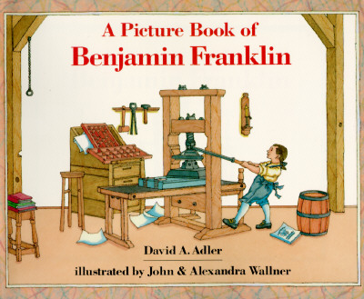](http://images.google.com/url?sa=i&rct=j&q=a+picture+book+of+benjamin+franklin&source=images&cd=&cad=rja&docid=hbdvKH60y2peQM&tbnid=dVrTkDeXf27vMM:&ved=0CAUQjRw&url=http://www.betterworldbooks.com/Wallner-2c-John-H5472.aspx?SuffixId=79&SearchTerm=Wallner,+John&ei=dDIoUfjaO5GK2QWxq4DoDQ&v6u=http://s-v6exp1-ds.metric.gstatic.com/gen_204?ip=70.178.107.253&ts=1361588835379812&auth=mqexlvksk7vgaoerja2wdaxv75kiwpsf&rndm=0.2684526190906371&v6s=2&v6t=11995&bvm=bv.42768644,d.b2I&psig=AFQjCNHkT9g3_9xomgytRVbSP9bLthZVuQ&ust=1361675235406866)[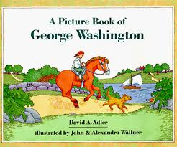](http://images.google.com/url?sa=i&rct=j&q=a+picture+book+of+george+washington&source=images&cd=&cad=rja&docid=jkqPCWO9jfbuCM&tbnid=U0gQEj7V9yGLrM:&ved=0CAUQjRw&url=http://www.lexile.com/book/details/9780823408009/&ei=MjIoUfiyMofm2QXGrIDQBQ&bvm=bv.42768644,d.b2I&psig=AFQjCNGyR50pMxsLZ-V0gD9lUtgb7lItig&ust=1361675072885762)[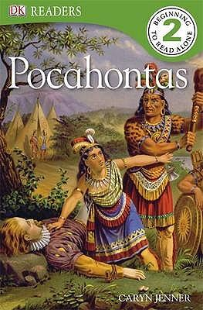](http://images.google.com/url?sa=i&rct=j&q=Pocahontas+DK+reader&source=images&cd=&cad=rja&docid=OGSWaBTUyA1z1M&tbnid=EROmAPsvRLsJhM:&ved=0CAUQjRw&url=http://www.booktopia.com.au/dk-readers-pocahontas-dk-publishing/prod9781405341103.html&ei=AzMoUaG-JaLo2QXmq4CYCA&bvm=bv.42768644,d.b2I&psig=AFQjCNHyeuO-guDXXBmHT8HizHnr2-sQLg&ust=1361675386038163)[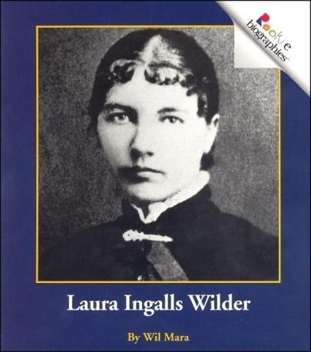](http://images.google.com/url?sa=i&rct=j&q=Laura+Ingalls+Wilder+rookie+reader&source=images&cd=&cad=rja&docid=H8pHunhm4wvCHM&tbnid=8YsyvLw2AMF-wM:&ved=0CAUQjRw&url=http://search.rainbowresource.com/rookie-readers&ei=LzAoUb3JEcX22QXnhoDICw&bvm=bv.42768644,d.b2I&psig=AFQjCNG8N_rDEnTxDsMOj9zN_9kw_W8PUQ&ust=1361673564654475)

How does learning about remarkable people help us learn about history?

Table of Contents

1

2

3

4

5

6

7

8

9

Timeline ...........................

Book T-chart ....................

Pocahontas ......................

Ben Franklin .....................

George Washington .........

Paul Revere ......................

Abraham Lincoln ..............

Laura Ingalls Wilder ..........

Jackie Robinson ...............

2

Books that

Give Information

Books that

Tell Stories

1

Timeline

5 Abraham Lincoln

_________

1 Pocahontas

_________

2 Ben Franklin _________

6 Laura Ingalls Wilder

_________

7 Jackie Robinson

_________

3 George Washington

_________

4 Paul Revere

_________

8 Me

_________

What I know

Goal: Before 1 2 3 4

I can _______________________________

___________________________________

Goal: After 1 2 3 4

Pocahontas

New information from **my teacher**

3

What I know

Goal: Before 1 2 3 4

I can _______________________________

___________________________________

Goal: After 1 2 3 4

Ben Franklin

New information from **my teacher**

4

What I know

Goal: Before 1 2 3 4

I can _______________________________

___________________________________

Goal: After 1 2 3 4

George Washington

New information from **my teacher**

5

What I know

Goal: Before 1 2 3 4

I can _______________________________

___________________________________

Goal: After 1 2 3 4

Paul Revere

New information from **my teacher**

6

What I know

Goal: Before 1 2 3 4

I can _______________________________

___________________________________

Goal: After 1 2 3 4

Abraham Lincoln

New information from **my teacher**

7

What I know

Goal: Before 1 2 3 4

I can _______________________________

___________________________________

Goal: After 1 2 3 4

Laura Ingalls Wilder

New information from **my teacher**

8

What I know

Goal: Before 1 2 3 4

I can _______________________________

___________________________________

Goal: After 1 2 3 4

Jackie Robinson

New information from **my teacher**

9

Cut and paste onto timeline and notebook page as each person is introduced

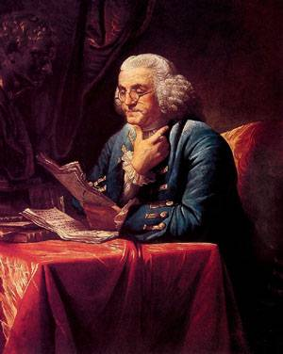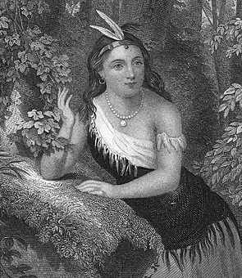

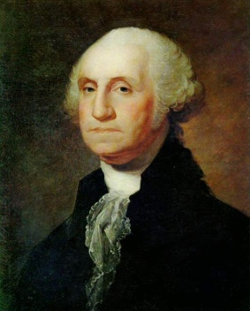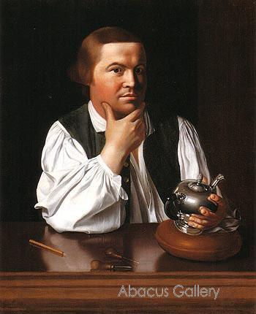

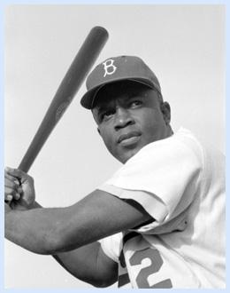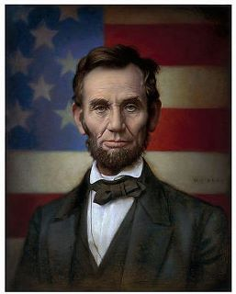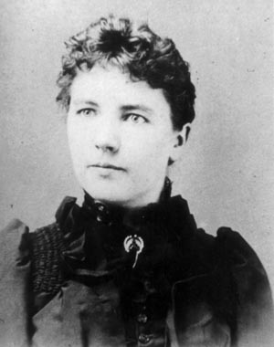

[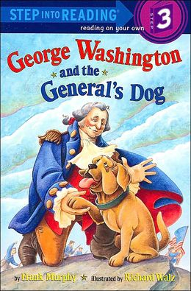](http://www.google.com/url?sa=i&rct=j&q=george+washington+and+the+general's+dog&source=images&cd=&cad=rja&docid=ExdgWOYrlSwBSM&tbnid=-HXEfP2Vn3df6M:&ved=0CAUQjRw&url=http://www.barnesandnoble.com/w/george-washington-and-the-generals-dog-frank-murphy/1100049197&ei=A1IoUa3uJsTi2gWc94GYCg&bvm=bv.42768644,d.aWM&psig=AFQjCNGBYGA065SdMizth5wM4kTCNSOcXw&ust=1361683324189388)[](http://images.google.com/url?sa=i&rct=j&q=a+picture+book+of+benjamin+franklin&source=images&cd=&cad=rja&docid=hbdvKH60y2peQM&tbnid=dVrTkDeXf27vMM:&ved=0CAUQjRw&url=http://www.betterworldbooks.com/Wallner-2c-John-H5472.aspx?SuffixId=79&SearchTerm=Wallner,+John&ei=dDIoUfjaO5GK2QWxq4DoDQ&v6u=http://s-v6exp1-ds.metric.gstatic.com/gen_204?ip=70.178.107.253&ts=1361588835379812&auth=mqexlvksk7vgaoerja2wdaxv75kiwpsf&rndm=0.2684526190906371&v6s=2&v6t=11995&bvm=bv.42768644,d.b2I&psig=AFQjCNHkT9g3_9xomgytRVbSP9bLthZVuQ&ust=1361675235406866)[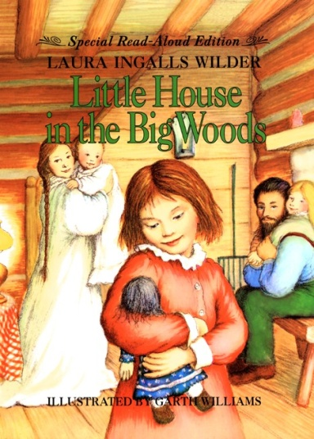](http://www.google.com/url?sa=i&rct=j&q=little+house+in+the+big+woods&source=images&cd=&cad=rja&docid=vOjTVxQJrh7UqM&tbnid=sbVbCtQkrf2SZM:&ved=0CAUQjRw&url=http://blogs.slj.com/afuse8production/2012/06/12/top-100-childrens-novels-19-little-house-in-the-big-woods-by-laura-ingalls-wilder/&ei=gVAoUejQHsqp2gXExYCoCg&bvm=bv.42768644,d.aWM&psig=AFQjCNHFtqeYkYpm9qMIJUJX6MJVnVbO8w&ust=1361682938388717)[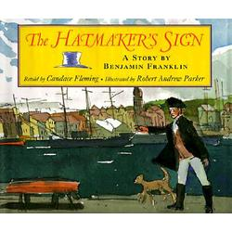](http://www.google.com/url?sa=i&rct=j&q=the+hatmaker's+sign&source=images&cd=&cad=rja&docid=yN9m0CdHBwKPSM&tbnid=hd-mrZR_6VZfWM:&ved=0CAUQjRw&url=http://edu354spring2011.blogspot.com/2011/04/hatmakers-sign.html&ei=m1EoUc7sHvO_2QW2tIG4Ag&bvm=bv.42768644,d.aWM&psig=AFQjCNHfC024d7Sedn0owuP6dI9Zd-ccYA&ust=1361683197781756)[](http://images.google.com/url?sa=i&rct=j&q=Pocahontas+DK+reader&source=images&cd=&cad=rja&docid=OGSWaBTUyA1z1M&tbnid=EROmAPsvRLsJhM:&ved=0CAUQjRw&url=http://www.booktopia.com.au/dk-readers-pocahontas-dk-publishing/prod9781405341103.html&ei=AzMoUaG-JaLo2QXmq4CYCA&bvm=bv.42768644,d.b2I&psig=AFQjCNHyeuO-guDXXBmHT8HizHnr2-sQLg&ust=1361675386038163)[](http://images.google.com/url?sa=i&rct=j&q=a+picture+book+of+george+washington&source=images&cd=&cad=rja&docid=jkqPCWO9jfbuCM&tbnid=U0gQEj7V9yGLrM:&ved=0CAUQjRw&url=http://www.lexile.com/book/details/9780823408009/&ei=MjIoUfiyMofm2QXGrIDQBQ&bvm=bv.42768644,d.b2I&psig=AFQjCNGyR50pMxsLZ-V0gD9lUtgb7lItig&ust=1361675072885762)[](http://images.google.com/url?sa=i&rct=j&q=Paul+Revere+rookie+reader&source=images&cd=&cad=rja&docid=Rt5-n5CQ79pGCM&tbnid=vGxYlDn9a4m3jM:&ved=0CAUQjRw&url=http://www.booktopia.com.au/paul-revere-wil-mara/prod9780516258201.html&ei=vDAoUaSGFYi42QXcsYCYDQ&bvm=bv.42768644,d.b2I&psig=AFQjCNHdG9JsH8miV-dqJv-sI0aQOSNkcw&ust=1361674770731312)[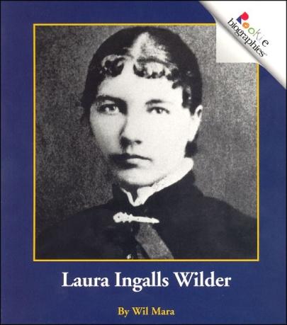](http://images.google.com/url?sa=i&rct=j&q=Laura+Ingalls+Wilder+rookie+reader&source=images&cd=&cad=rja&docid=H8pHunhm4wvCHM&tbnid=8YsyvLw2AMF-wM:&ved=0CAUQjRw&url=http://search.rainbowresource.com/rookie-readers&ei=LzAoUb3JEcX22QXnhoDICw&bvm=bv.42768644,d.b2I&psig=AFQjCNG8N_rDEnTxDsMOj9zN_9kw_W8PUQ&ust=1361673564654475)[](http://images.google.com/url?sa=i&rct=j&q=Benjamin+Franklin+rookie+reader&source=images&cd=&cad=rja&docid=KTfp258B6XC3nM&tbnid=GlnO7GLH-51M7M:&ved=0CAUQjRw&url=http://www.barnesandnoble.com/w/benjamin-franklin-wil-mara/1005753359&ei=YjAoUYCKOu3U2QXQ5IGQDQ&bvm=bv.42768644,d.b2I&psig=AFQjCNG9ITCCj72PTW56GKD0xjZfM2zKIg&ust=1361674714842498)[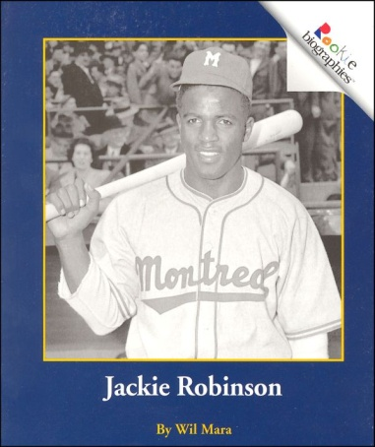](http://images.google.com/url?sa=i&rct=j&q=Paul+Revere+rookie+reader&source=images&cd=&cad=rja&docid=NvMyQluBBQBbMM&tbnid=VVpYvjOUWZ9m7M:&ved=0CAUQjRw&url=http://search.rainbowresource.com/rookie-reader&ei=_jAoUe-7DaSj2QXcwYG4Cw&bvm=bv.42768644,d.b2I&psig=AFQjCNHdG9JsH8miV-dqJv-sI0aQOSNkcw&ust=1361674770731312)[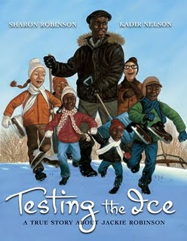](http://www.google.com/url?sa=i&rct=j&q=testing+the+ice&source=images&cd=&cad=rja&docid=QncvePnOz3hauM&tbnid=QmYrtjqSs8DhgM:&ved=0CAUQjRw&url=http://www.wahooschools.org/vnews/display.v/SEC/Media%20Center|Golden%20Sower%20Nominees%3e%3e2011-2012&ei=P1EoUYv4NpHa2wWr8IHICw&bvm=bv.42768644,d.aWM&psig=AFQjCNG3BhahpNsE05wKhqtA1wp4in50Pw&ust=1361683091012026)[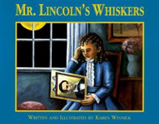](http://www.google.com/url?sa=i&rct=j&q=mr.+lincoln's+whiskers&source=images&cd=&cad=rja&docid=N8V05s28nGUT-M&tbnid=CrEBQWLiyeSh9M:&ved=0CAUQjRw&url=http://www.karenbwinnick.com/lincoln_reviews.html&ei=01AoUYmPFYrV2QXoooG4Aw&bvm=bv.42768644,d.aWM&psig=AFQjCNH6fwr68NTqzhUU_rRvNb-vkRbIJw&ust=1361683012867847)