 | 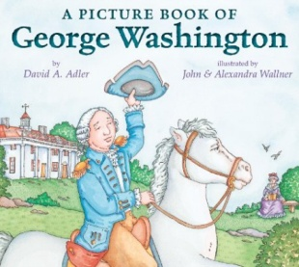  A Picture Book of  George Washington | 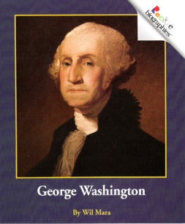  George  Washington
Illustrations
Nonfiction Text Features
Key Details
These books are the SAME because

These books are DIFFERENT because

