My Timeline

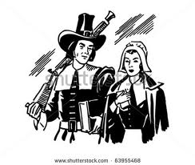

Page

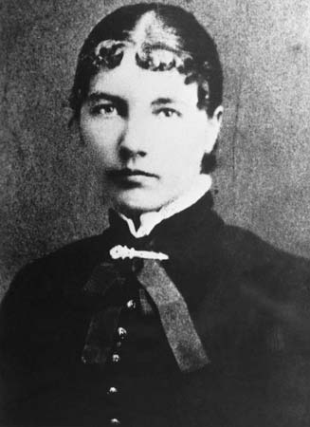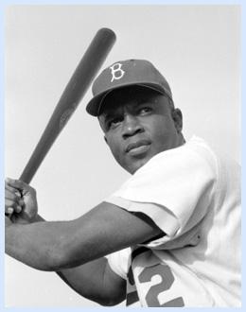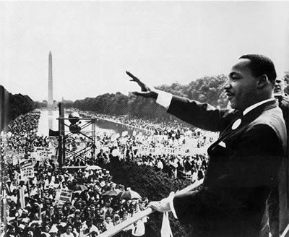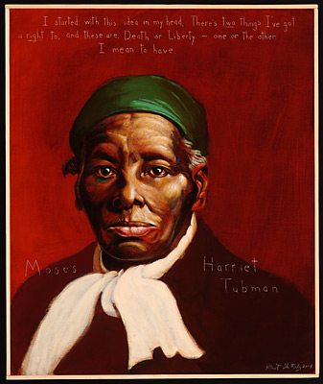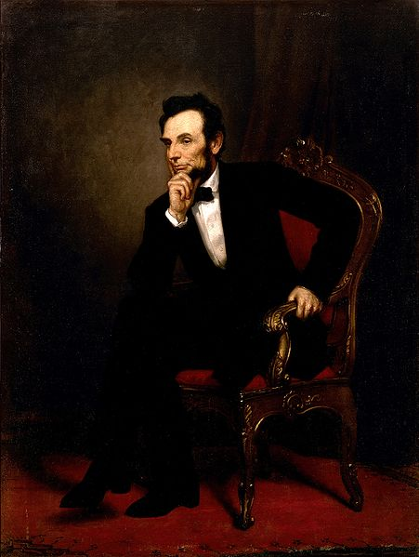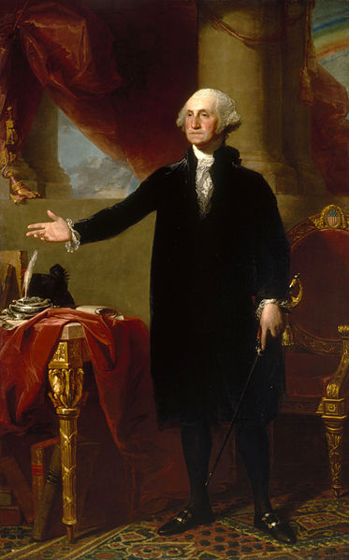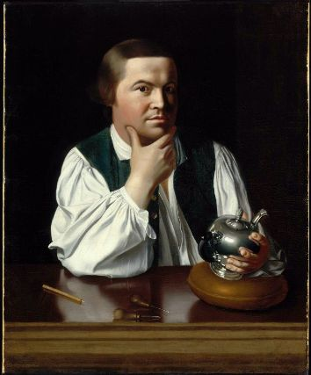

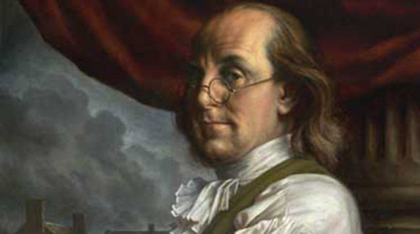

We have been researching remarkable people who have been American contributors. Their stories have helped us learn about our country’s history. Here are my notes about these important American contributors.

**Learning Objectives for American Contributor’s Interactive Notebook**

RL.1.5 Explain major differences between books that tell stories and books that give information, drawing on a wide reading of a range of text types.

SL.1.2 Ask and answer questions about key details in a text read aloud or information presented orally or through other

media.

L.1.1 Demonstrate command of the conventions of standard English grammar and usage when writing or speaking.

|  |
| --- |
| W.1.1 Write opinion pieces in which they introduce the topic or name the book they are writing about, state an opinion, supply a reason for the opinion, and provide some sense of closure. |
| RL.1.7 Use illustrations and details in a story to describe its characters, setting, or events. |

RI.1.3 Describe the connection between two individuals, events, ideas, or pieces of information in a text.

|  |
| --- |
| L.1.2. Demonstrate command of the conventions of standard English capitalization, punctuation, and spelling when writing. |

W.1.7 Participate in shared research and writing projects (e.g., explore a number of “how-to” books on a given topic

and use them to write a sequence of instructions).

W.1.8 With guidance and support from adults, recall information from experiences or gather information from

provided sources to answer a question.

|  |
| --- |
| RI.1.8 Identify the reasons an author gives to support points in a text. |
| RI.1.9 Identify basic similarities in and differences between two texts on the same topic (e.g., in illustrations, descriptions, or procedures). |

**Culminating Project- Opinion piece on favorite American Contributor**

**Interactive Summary Score**

____ Participates in shared research project ___ Writes to give an opinion, explain , or tell a story

___ Includes all parts of a paragraph (add details, topic, conclusion) ___ Handwriting

___________________________________________________________________________________________________________________________________________________________________________________________________________________

Page

___ capitals ___ punctuation ___ complete sentences ___ grammar ___ handwriting

___ topic ___ conclusion ___ details

___________________________________________________________________________________________________________________________________________________________________________________________________________________

Page

___ capitals ___ punctuation ___ complete sentences ___ grammar ___ handwriting

___ topic ___ conclusion ___ details

___________________________________________________________________________________________________________________________________________________________________________________________________________________

Page

___ capitals ___ punctuation ___ complete sentences ___ grammar ___ handwriting

___ topic ___ conclusion ___ details

___________________________________________________________________________________________________________________________________________________________________________________________________________________

Page

___ capitals ___ punctuation ___ complete sentences ___ grammar ___ handwriting

___ topic ___ conclusion ___ details

___________________________________________________________________________________________________________________________________________________________________________________________________________________

Page

___ capitals ___ punctuation ___ complete sentences ___ grammar ___ handwriting

___ topic ___ conclusion ___ details

___________________________________________________________________________________________________________________________________________________________________________________________________________________

Page

___ capitals ___ punctuation ___ complete sentences ___ grammar ___ handwriting

___ topic ___ conclusion ___ details

___________________________________________________________________________________________________________________________________________________________________________________________________________________

Page

___ capitals ___ punctuation ___ complete sentences ___ grammar ___ handwriting

___ topic ___ conclusion ___ details

________________________________________________________________________________________________________________________________________________________________________________________________________________________

___ capitals ___ punctuation ___ complete sentences ___ grammar ___ handwriting

___ topic ___ conclusion ___ details

Page

Table of Contents

_____________________________________........ ______

_____________________________________........ ______

_____________________________________........ ______

_____________________________________........ ______

_____________________________________........ ______

_____________________________________........ ______

_____________________________________........ ______

_____________________________________........ ______

_____________________________________........ ______

Page

after

**contributions**

**interesting facts**

where

date

**childhood**

name of important person:

before