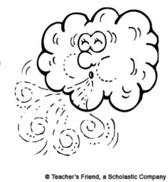Wind

Adapted from the book “Wind” by Ron Bacon

Feel the wind blowing by,

Lifting kites up to the sky.

Feel the wind blowing through,

Chasing clouds across the blue.

Feel the wind blowing free,

Stirring white caps on the sea.

Feel the wind blowing fast,

Whipping sand and papers past.

[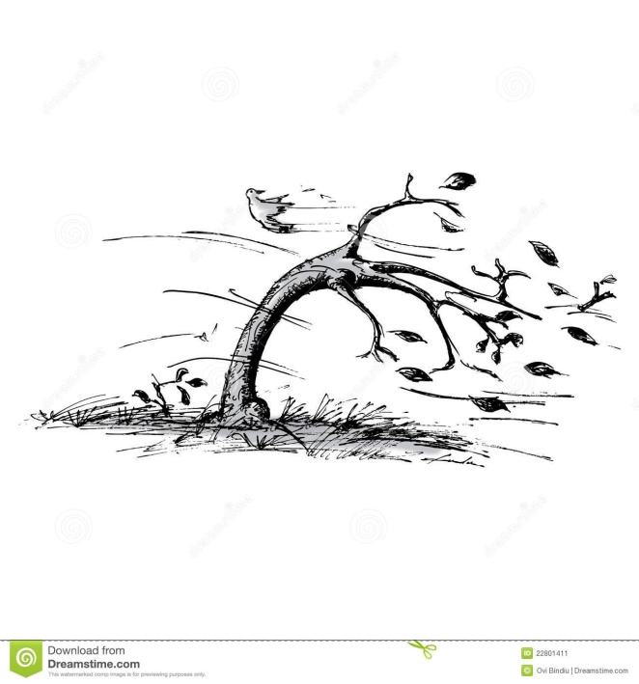](http://www.google.com/url?sa=i&rct=j&q=&esrc=s&frm=1&source=images&cd=&cad=rja&docid=oI0FcNgxi_j3NM&tbnid=9nQ7f8syt0WwfM:&ved=0CAUQjRw&url=http://www.dreamstime.com/stock-image-tree-wind-image22801411&ei=S6YDU4_NOei-8QGy4IAg&psig=AFQjCNHCTq67JLtsrEcMZTjcN1k5fuf-Jw&ust=1392834503708910)

Feel the wind blowing strong,

Tossing leaves and grass along.

Feel the wind blowing hard,

Flinging rubbish ‘round the yard.

Feel the wind blowing on,

Soft, then softer, till it’s gone.