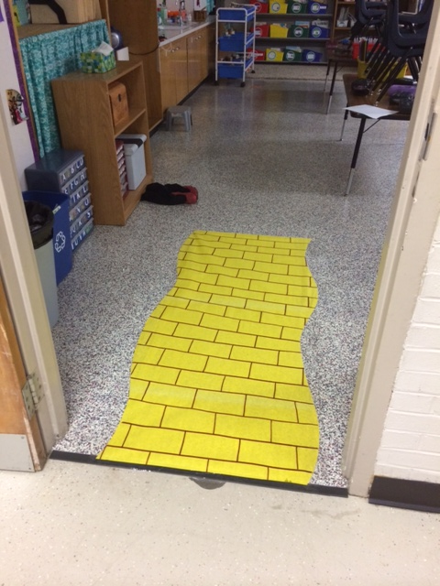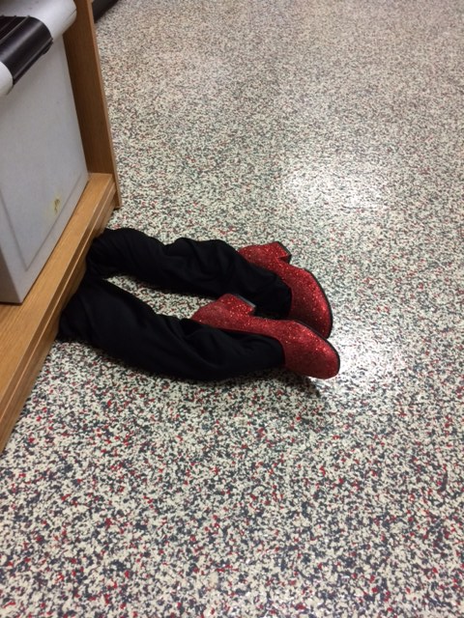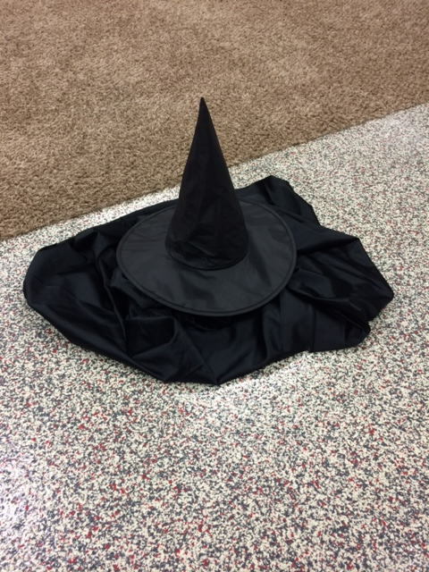**APK** to kick off the reading of The Wonderful Wizard of Oz

1. Students enter the classroom and see the props.
2. The teacher poses a question- *“What did you notice that was different in our classroom today? Did it make you think of anything?”*
3. Students turn and talk