**[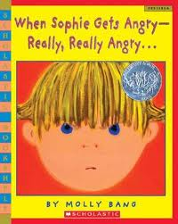](http://www.google.cm/url?sa=i&rct=j&q=when+sophie+gets+angry&source=images&cd=&cad=rja&docid=KCMptmRetJDQWM&tbnid=ajZmmoMuYufsZM:&ved=0CAUQjRw&url=http://www.betterworldbooks.com/when-sophie-gets-angry-really-really-angry-id-0439598451.aspx&ei=r5EfUYXQF4PC2wXOxYGQDQ&bvm=bv.42553238,d.b2I&psig=AFQjCNH1n2lMhXQ-BZ0aFXBjmjKVZ-pr9Q&ust=1361109789848104)Week 3: When Sophie Gets Angry--Really, Really Angry**

**RL.1.4 Identify words and phrases in stories and poems that suggest feeling and appeal to the senses**

We read aloud When Sophie Gets Angry--Really, Really Angry and discussed how Sophie's feelings changed throughout the story. Students then read the book again with a partner and identified words or phrases that suggested feelings and recorded the information on post-it notes. At the end of the lesson students shared their thinking and then placed their post-it notes on the feelings anchor chart with the corresponding feeling words.

