Unit 4: Winds of Change

[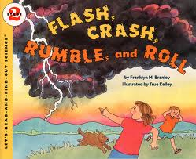](http://www.google.cm/url?sa=i&rct=j&q=flash,+crash,+rumble+and+roll&source=images&cd=&cad=rja&docid=ebL66SCqpJcGZM&tbnid=iQuIcxBJIMEw8M:&ved=0CAUQjRw&url=http://www.harpercollinschildrens.com/books/Flash-Crash-Rumble-Roll/&ei=y4gfUY6JMtT-2QWRsIHADg&bvm=bv.42553238,d.b2I&psig=AFQjCNFLgHARBhuKgFIY_0Rt0WNXGVuoWg&ust=1361107518081616)Essential Question: How do you know what a character is feeling and when these feelings change?

**[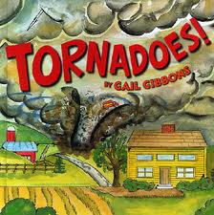](http://www.google.cm/url?sa=i&rct=j&q=Tornadoes+by+Gail+Gibbons&source=images&cd=&cad=rja&docid=IwuG6Gr7FY7blM&tbnid=kVTnJMBFNCSDEM:&ved=0CAUQjRw&url=http://www.gailgibbons.com/tornadoes.html&ei=PogfUcDuIqaP2gXMj4A4&bvm=bv.42553238,d.b2I&psig=AFQjCNEFoUVplCXIxFUe17q_HY61zk0v6w&ust=1361107372966435)Week 1: Tornadoes and Thunderstorms**

**RL.1.8 Identify the reasons an author gives to support points in a text**

**W.1.7 Participate in shared research and writing projects**

**[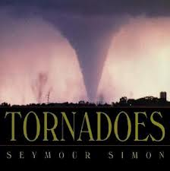](http://www.google.cm/url?sa=i&rct=j&q=Tornadoes+by+Seymour+Simon&source=images&cd=&cad=rja&docid=uwwp5OVuOpFMFM&tbnid=PLiy7LP1fu9CTM:&ved=0CAUQjRw&url=http://www.goodreads.com/book/show/498063.Tornadoes&ei=7YcfUcKJJumX2QX-v4CwDA&bvm=bv.42553238,d.b2I&psig=AFQjCNHoOuc0PrYmKDRBiWlexBY_u1yETQ&ust=1361107280530617)W.1.8 With guidance and support from adults, recall information from experiences of gather information from provided sources to answer questions**

**L.1.4 Determine or clarify the meaning of unknown and multiple meaning words**

Students identified the cause and effect of tornadoes and thunderstorms, and then used that information to write about tornadoes and thunderstorms.

**Week 2: Feelings**

**RL.1.4 Identify words and phrases in stories and poems that suggest feeling and appeal to the senses**

[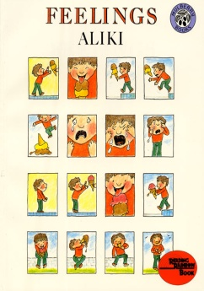](http://www.google.cm/url?sa=i&rct=j&q=Feelings+by+Aliki&source=images&cd=&cad=rja&docid=8uzcVynpHEoaGM&tbnid=JMOKgxsfZ3LTLM:&ved=0CAUQjRw&url=http://www.harpercollinschildrens.com/books/Feelings/&ei=l44fUfaKKcvy2gXb6YC4Ag&psig=AFQjCNED2PjIUExzVUH8dKo8u4IeLKhaTw&ust=1361108983240488)

Students identified various feelings and acted them out. We watched an excellent Reading Rainbow video on Learning 360 for the book Feelings. As a whole class we generated a list of feeling words. Teachers encouraged interesting words (not "happy", "sad" or "mad"). Students illustrated the feeling words on a template created by the teachers and then as a class we organized the feelings onto an anchor chart. The feelings were placed in the categories with a happy face, straight face, and sad face. This chart was added to and used throughout the remainder of Unit 4.

Students read the poem *The Drinking Fountain* by Marchette Chute and identified words or phrases that suggested feelings. Students worked with partners to act out each stanza of the poem, making sure to express the feeling that was implied.

**[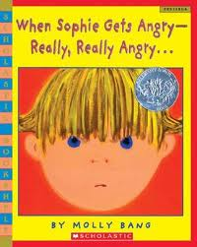](http://www.google.cm/url?sa=i&rct=j&q=when+sophie+gets+angry&source=images&cd=&cad=rja&docid=KCMptmRetJDQWM&tbnid=ajZmmoMuYufsZM:&ved=0CAUQjRw&url=http://www.betterworldbooks.com/when-sophie-gets-angry-really-really-angry-id-0439598451.aspx&ei=r5EfUYXQF4PC2wXOxYGQDQ&bvm=bv.42553238,d.b2I&psig=AFQjCNH1n2lMhXQ-BZ0aFXBjmjKVZ-pr9Q&ust=1361109789848104)Week 3: When Sophie Gets Angry--Really, Really Angry**

**RL.1.4 Identify words and phrases in stories and poems that suggest feeling and appeal to the senses**

We read aloud When Sophie Gets Angry--Really, Really Angry and discussed how Sophie's feelings changed throughout the story. Students then read the book again with a partner and identified words or phrases that suggested feelings and recorded the information on post-it notes. At the end of the lesson students shared their thinking and then placed their post-it notes on the feelings anchor chart with the corresponding feeling words.

**Middle of Week 3--Week 6: The Wonderful Wizard of Oz**

We spent several weeks reading The Wonderful Wizard of Oz. The standards we taught for each chapter are listed below:

[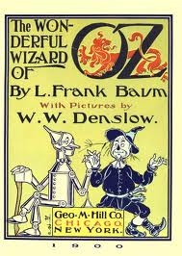](http://www.google.cm/url?sa=i&rct=j&q=the+wonderful+wizard+of+oz&source=images&cd=&cad=rja&docid=FjbBH8zc0hzI6M&tbnid=AaEbtDVJbg1AUM:&ved=&url=http://www.booki.cc/the-wonderful-wizard-of-oz/title-page/&ei=GZMfUfHbG-bp2QWQ7oDYCg&bvm=bv.42553238,d.b2I&psig=AFQjCNG4T7ZKPOk4qmcoRLxqx2Vy6tn7vg&ust=1361110169896618)

**Chapter 1:**

**RL.1.3 Describe characters, settings, and major events using key details**

* During reading, students worked in small groups to create frozen pictures of characters, settings, and major events in the chapter. After reading, each group chose one major event and made a frozen picture of it. They also wrote a sentence to match their frozen picture. The chapter was retold through students' frozen pictures.

**Chapter 2:**

**RL.1.3 Describe characters, settings, and major events using key details**

**RL.1.4 Identify words and phrases in stories that suggests feelings and appeal to the senses**

* During reading,we listed words to describe what DOROTHY looked like and also how she felt? Some teachers created anchor charts with their students. Students acted out the various feelings that Dorothy had in this chapter and then recorded the information on the "Dorothy page" in their "Wizard of Oz Journal". Feeling words we focused on were **SURPRISED, CONFUSED, WORRIED, ANXIOUS,** and **LONELY.**

**Chapter 3:**

**RL.1.3 Describe characters, settings, and major events using key details**

* During reading, students worked in small groups to create frozen pictures of characters, settings, and major events in the chapter. After reading, each group chose one major event and made a frozen picture of it. They also wrote a sentence to match their frozen picture. The chapter was retold through students' frozen pictures.

**Chapter 4:**

**RL.1.3 Describe characters, settings, and major events using key details**

**RL.1.4 Identify words and phrases in stories that suggests feelings and appeal to the senses**

* Followed same lesson format as chapter 2, but our focus was on the SCARECROW this time. Feeling words we focused on were **SILLY, PROUD, LONELY, SAD, DISAPPOINTED, ANXIOUS, UNCOMFORTABLE.**

**Chapter 5:**

**RL.1.3 Describe characters, settings, and major events using key details**

**RL.1.4 Identify words and phrases in stories that suggests feelings and appeal to the senses**

* Followed same lesson format as chapter s 2 and 4, but our focus was on the TIN WOODMAN this time. Feeling words we focused on were **RELIEVED, GRATEFUL, HEART BROKEN, ANXIOUS**

**Chapter 6:**

**RL.1.3 Describe characters, settings, and major events using key details**

**RL.1.4 Identify words and phrases in stories that suggests feelings and appeal to the senses**

* Followed same lesson format as chapter s 2, 4, and 5, but our focus was on the LION this time. Feeling words we focused on were **ASHAMED, COWARDLY, SAD**

**Chapters 7-9:**

**RL.1.3 Describe characters, settings, and major events using key details**

* 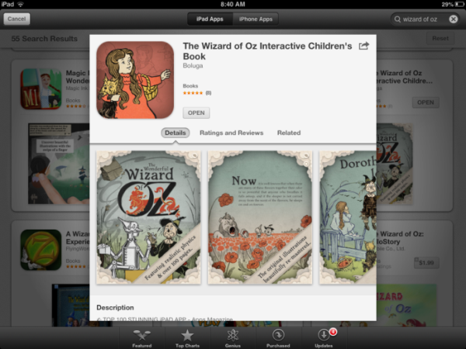Some of us read these chapters in one day, utilizing an app on our i-pads called "The Wizard of Oz Interactive Children's Book." This is a beautiful, FREE APP and it is an abridged version of the original story. Original illustrations are included as well. It is a great resource for completing portions of the book faster, but still staying true to the original story
* Others read one chapter each day.
* Students worked in pairs and made frozen pictures for major events . They wrote sentences to match and the chapters were retold through their frozen pictures

**Movie:** We watched the first part of the movie on this day and stopped it as the characters emerged from the field of poppies. We will watch the remainder of the movie on the last day of Unit 4.

**Chapter 10 and the first 2 pages of chapter 11 that describe the Emerald City:**

**RL.1.3 Describe characters, settings, and major events using key details**

* There is a major setting change when the characters enter the Emerald City. As the characters received green spectacles prior to entering the Emerald City, our students received strips of green cellophane to look through. Students drew a picture of the Emerald City as we were reading aloud. At the end of the reading, students wrote to describe the Emerald City.

**Chapter 11:**

**RL.1.9 Compare and contrast the adventures and experiences of characters in stories**

* We revisited this standard from Unit 3. Although it is not on the Unit 4 scoring guide, it was perfect to use with chapter 11 and allowed us to incorporate a thinking skill into the lesson.
* During reading, students completed a comparison matrix identifying what each character SAW, ASKED FOR, and FELT upon meeting the Wizard of Oz for the first time.
* Students used the information on their comparison matrix to write sentences stating how the characters' experience was the same and how it was different.

**Chapter 12:**

**RL.1.3 Describe characters, settings, and major events using key details**

**RL.1.4 Identify words and phrases in stories that suggests feelings and appeal to the senses**

* Followed same lesson format as chapter s 2, 4, 5, and 6, but our focus was on the WICKED WITCH OF THE WEST this time. Feeling words we focused on were **ANGRY, FURIOUS, JEALOUS, and SCARED.**

**Chapters 13--End**

We plan to continue reading The Wizard of Oz aloud to our students during the last week of Unit 4. Due to the length of the story we will not be able to finish it. On the last day of Unit 4, students will watch the remainder of the movie. We will complete our Wizard of Oz Journals documenting how each character feels at the end of the story and tie our discussion back to the essential question "How do you know what a character is feeling and when these feelings change?"

**Language Standards Addressed Using The Wizard of Oz:**

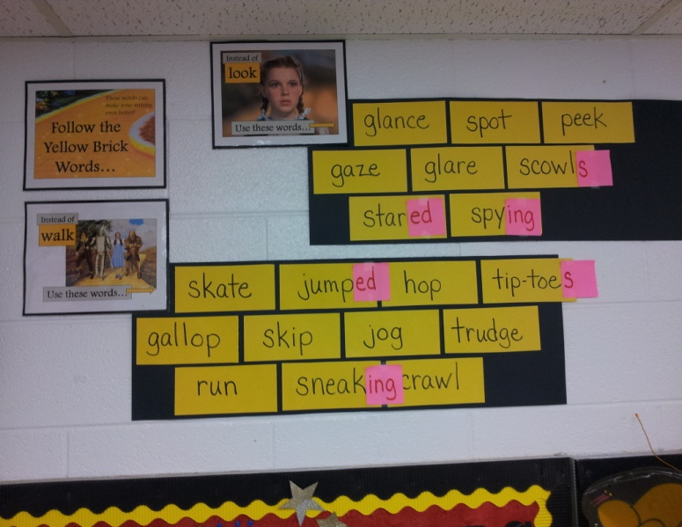

**L.1.5.d Distinguish shades of meaning among verbs differing in manner and adjectives differing in intensity**

**L.1.5.c Identify frequently occurring root words and their inflectional forms**

**L.1.1.e Use verbs to convey a sense of past, present, and future**

**L.1.1.f Use frequently occurring adjectives**

During the second week of The Wizard of Oz, we introduced the YELLOW BRICK WORDS (this is linked on the teacher created resource page for Unit 4). We used this resource to teach the language standards above. We focused on replacing boring verbs (walk, said, look) with more interesting verbs. For example, students acted out look, peek, glance, glare, etc., and really understood the meaning of each and how feelings can be inferred based on the verb used. We began our YELLOW BRICK WORDS display on the wall. We made sure to record the verbs in present tense so that we could use this in a future lesson on adding -s, -ed, and -ing endings. We will continue adding other verbs and adjectives throughout the unit. Students used this resource to incorporate these language skills in their writing.

**Week 6: The Bat Boy and His Violin and remaining text talks**

**RL.1.4 Identify words and phrases in stories that suggests feelings and appeal to the senses**

**[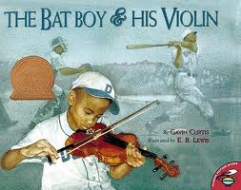](http://www.google.com/url?sa=i&rct=j&q=the+bat+boy+and+his+violin&source=images&cd=&cad=rja&docid=rFm7ZGNole7guM&tbnid=stHMR-6ouboohM:&ved=0CAUQjRw&url=http://www.betterworldbooks.com/the-bat-boy-and-his-violin-id-0689841159.aspx&ei=caMfUZr9B8PI2AWKloDwDg&bvm=bv.42553238,d.b2I&psig=AFQjCNE8alx0Vo1PgyjNlGPaaS_MkGDQ7A&ust=1361114344220854)L.1.4 Determine or clarify the meaning of unknown and multiple meaning words**

* Students listened to various violin music referred to in The Bat Boy and His Violin and wrote about how each one made them feel.
* Students identified words and phrases in the story that suggested feelings and worked in small groups to create frozen pictures.
* Students identified the cause and effect of the feelings.

[](http://www.google.com/url?sa=i&rct=j&q=goin'+someplace+special&source=images&cd=&cad=rja&docid=19Tpa4Fuz4FxUM&tbnid=Q-X0u3j2mxFVuM:&ved=0CAUQjRw&url=http://www.cobb.k12.ga.us/kemp/bom/bom0405/feb.htm&ei=uKMfUaOSB-OO2wXXjoHQAw&bvm=bv.42553238,d.b2I&psig=AFQjCNFBiYk4YE7RBPBsiIEY6_ygxVcPGA&ust=1361114417694973)

**[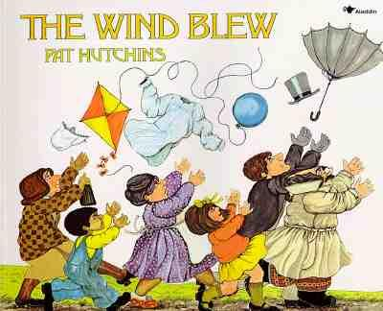](http://www.google.com/url?sa=i&source=images&cd=&cad=rja&docid=PNg0QshaTCuN6M&tbnid=m-4xNJPiA0o7cM:&ved=0CAgQjRwwAA&url=http://petitbookshelf.blogspot.com/2011/01/wind-blew-by-pat-hutchins.html&ei=R6QfUf2gDofc2QW9soDACQ&psig=AFQjCNFlMDwrGmJfEPlEBG_cjOIrLXd0Bg&ust=1361114567283624)**