Goin’ Someplace Special

Name________________________

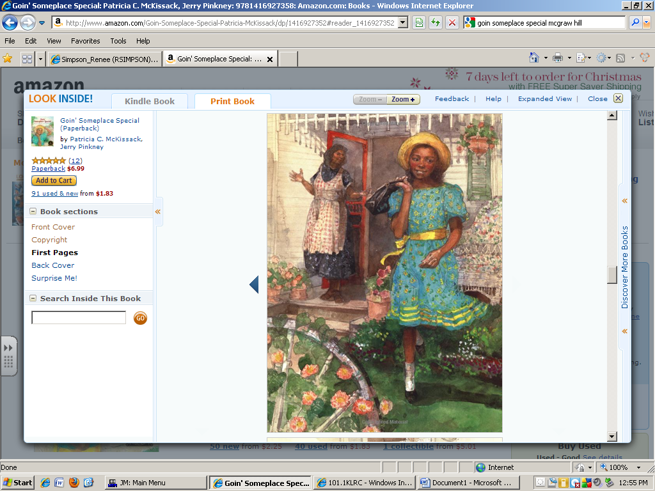

Tricia Ann is ______________.

singing smiling silly

The ___________ are blooming.

flowers bugs friends

A place where plants grow is a...

home garden store school