Name:_____________________

It was October. The leaves had fallen off the trees. They were lying on the ground. “I will go to Toad’s house,” said Frog. I will rake all of the leaves that have fallen on his lawn. Toad will be surprised.” Frog took a rake out of the garden shed.

Frog ran through the woods so that Toad would not see him. Frog came to Toad’s house. He looked in the window. “Good,” said Frog. Toad is out. He will never know who raked his leaves.

Frog worked hard. He raked the leaves into a pile. Soon Toad’s lawn was clean. Frog picked up his rake and started home.

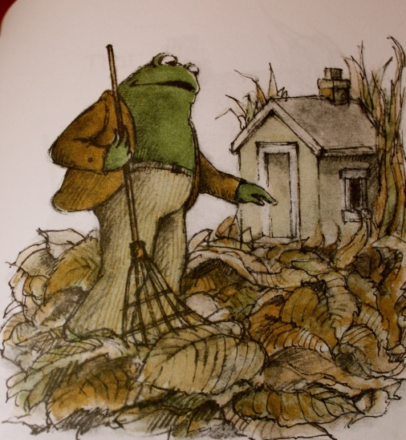

Why did Frog rake Toad’s leaves?

Toad hates leaves.

Frog is his friend.

Toad doesn’t have a rake.

Why didn’t Frog tell Toad he was raking the leaves?

It was cold.

It was scary.

It was a surprise.

How will Toad feel when he sees his clean yard?

Angry

Disappointed

Surprised