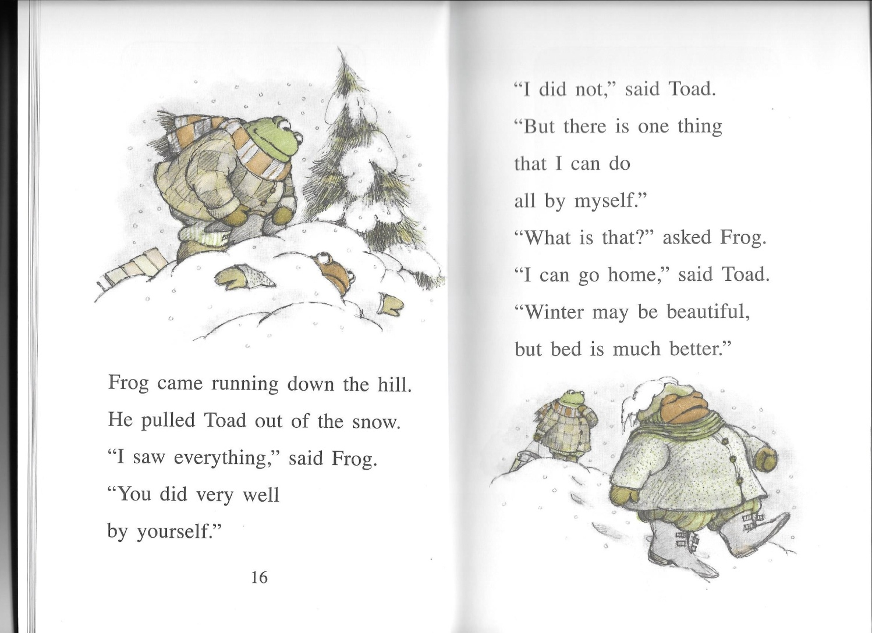

RL.1.6

Name: ___________________________________ Date: ____________________

Read this page and highlight words that show if Frog is speaking or if Toad is speaking. Highlight **FROG in GREEN** and **TOAD in BROWN**.