
Retold by _______class

Name :________________________________________________ Date____________________________



______________
______________
______________
______________
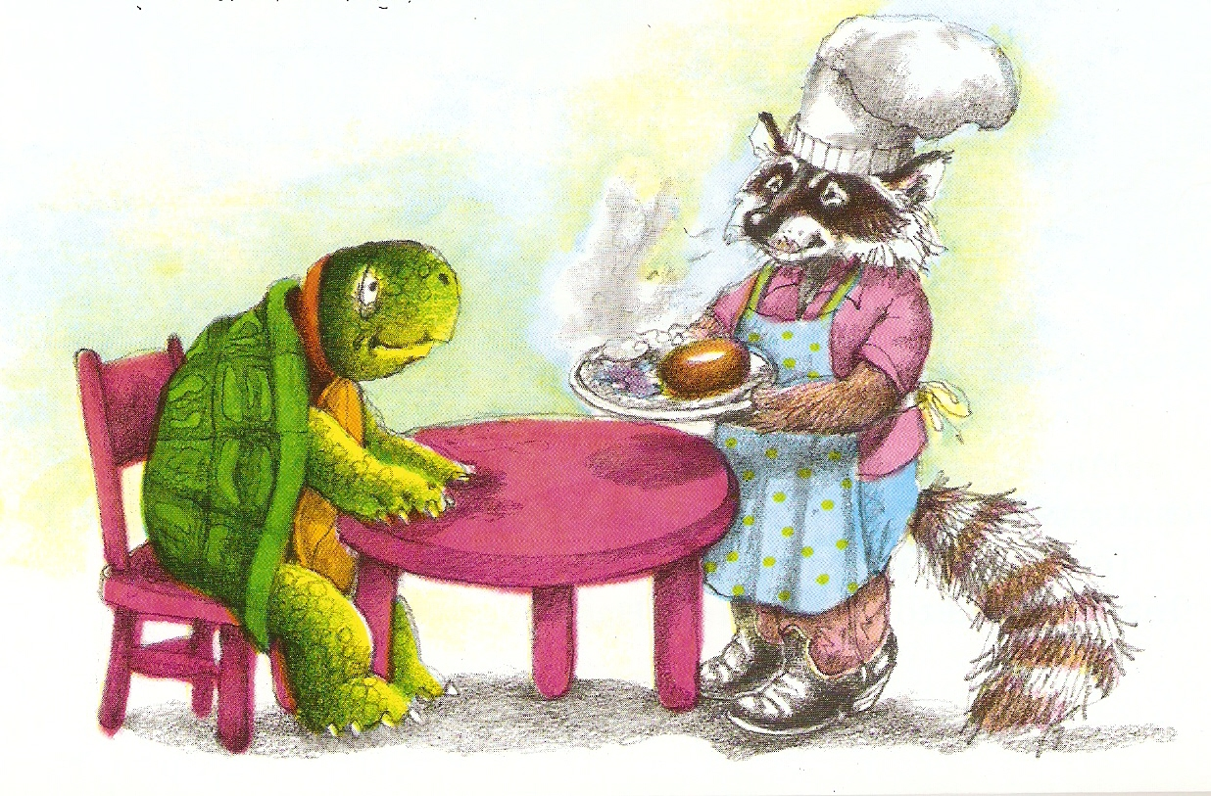
Name :________________________________________________ Date____________________________



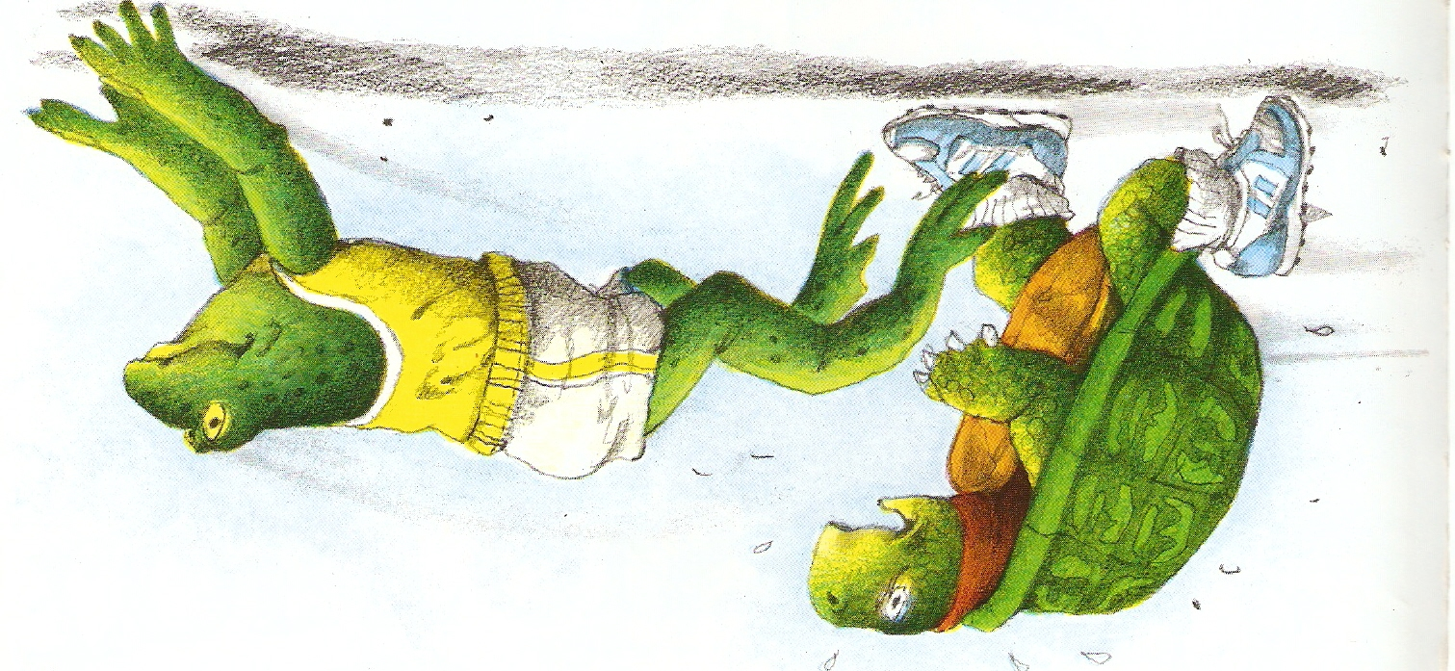

______________
______________
______________
______________

Name :________________________________________________ Date____________________________

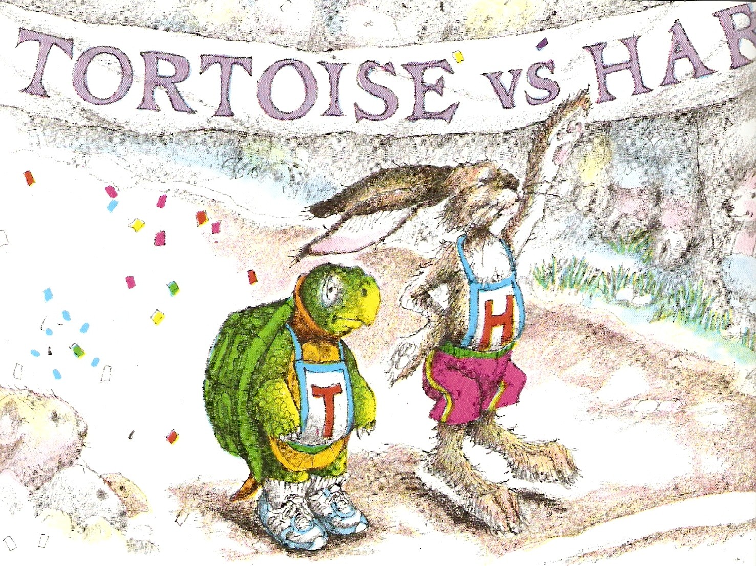

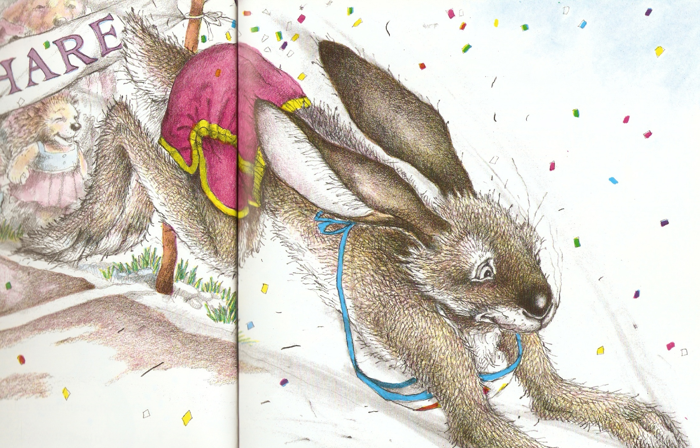


______________
______________
______________
______________

Name :________________________________________________ Date____________________________



______________
______________
______________
______________

Name :________________________________________________ Date____________________________

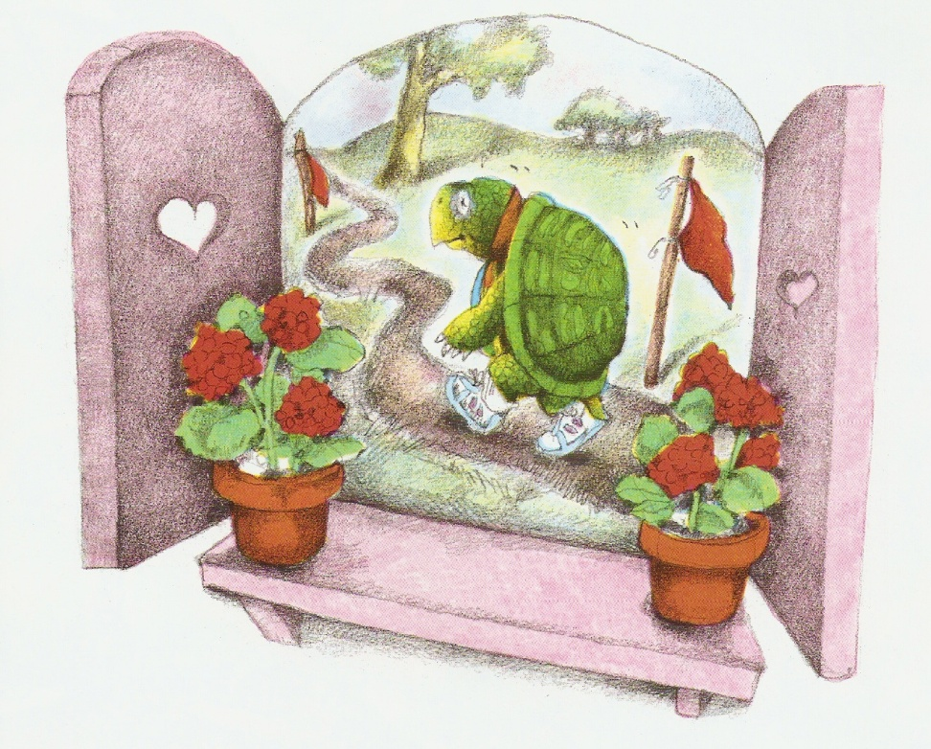

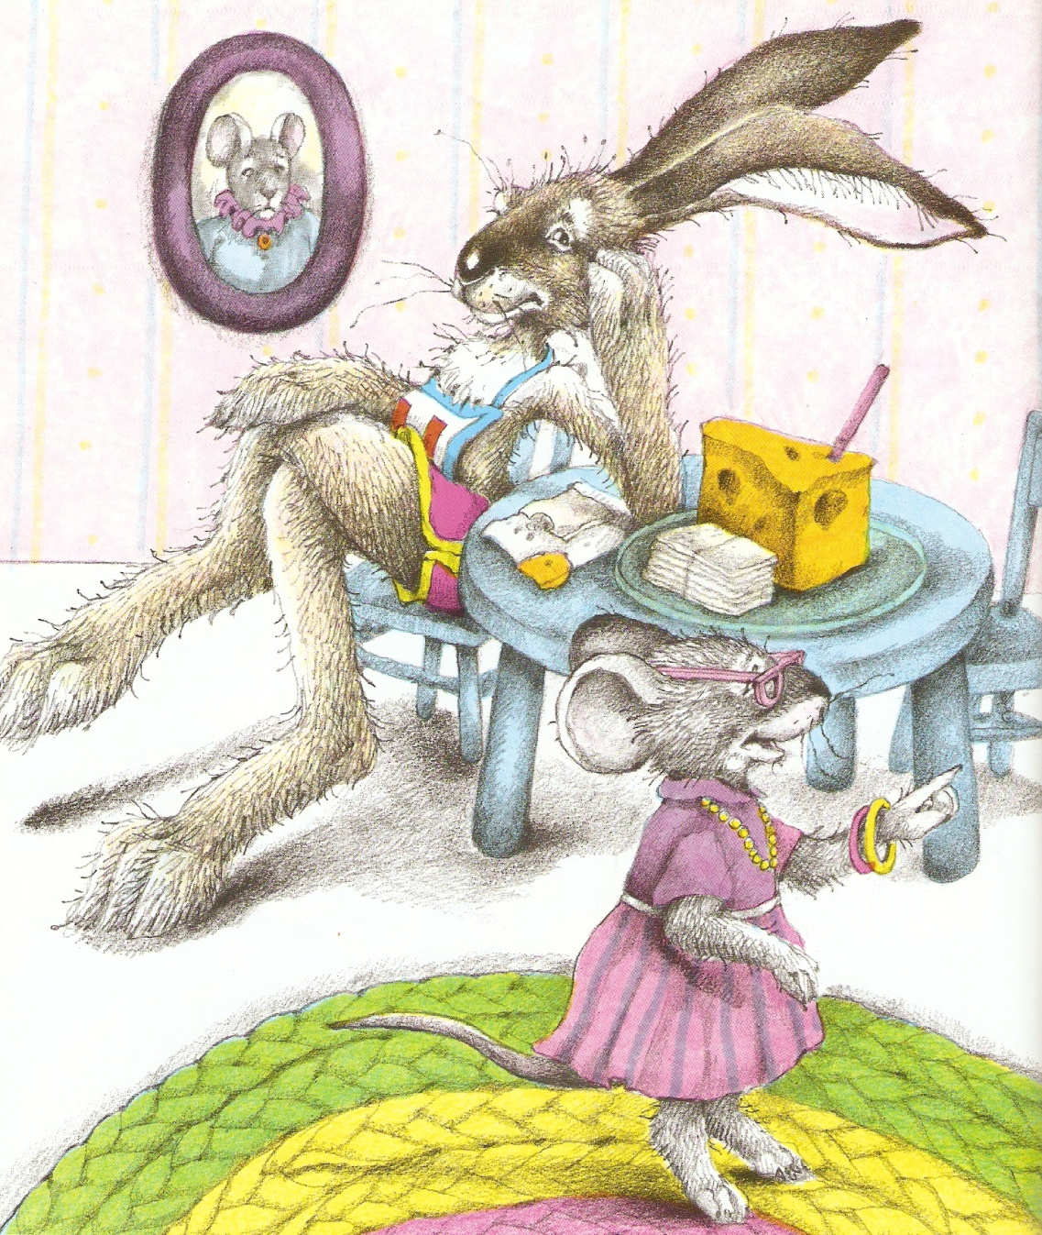

______________
______________
______________
______________

Name :________________________________________________ Date____________________________



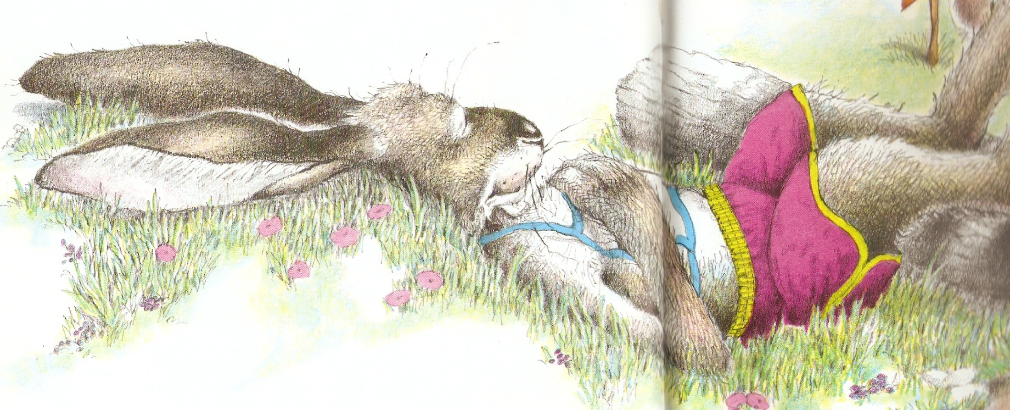

______________
______________
______________
______________

Name :________________________________________________ Date____________________________

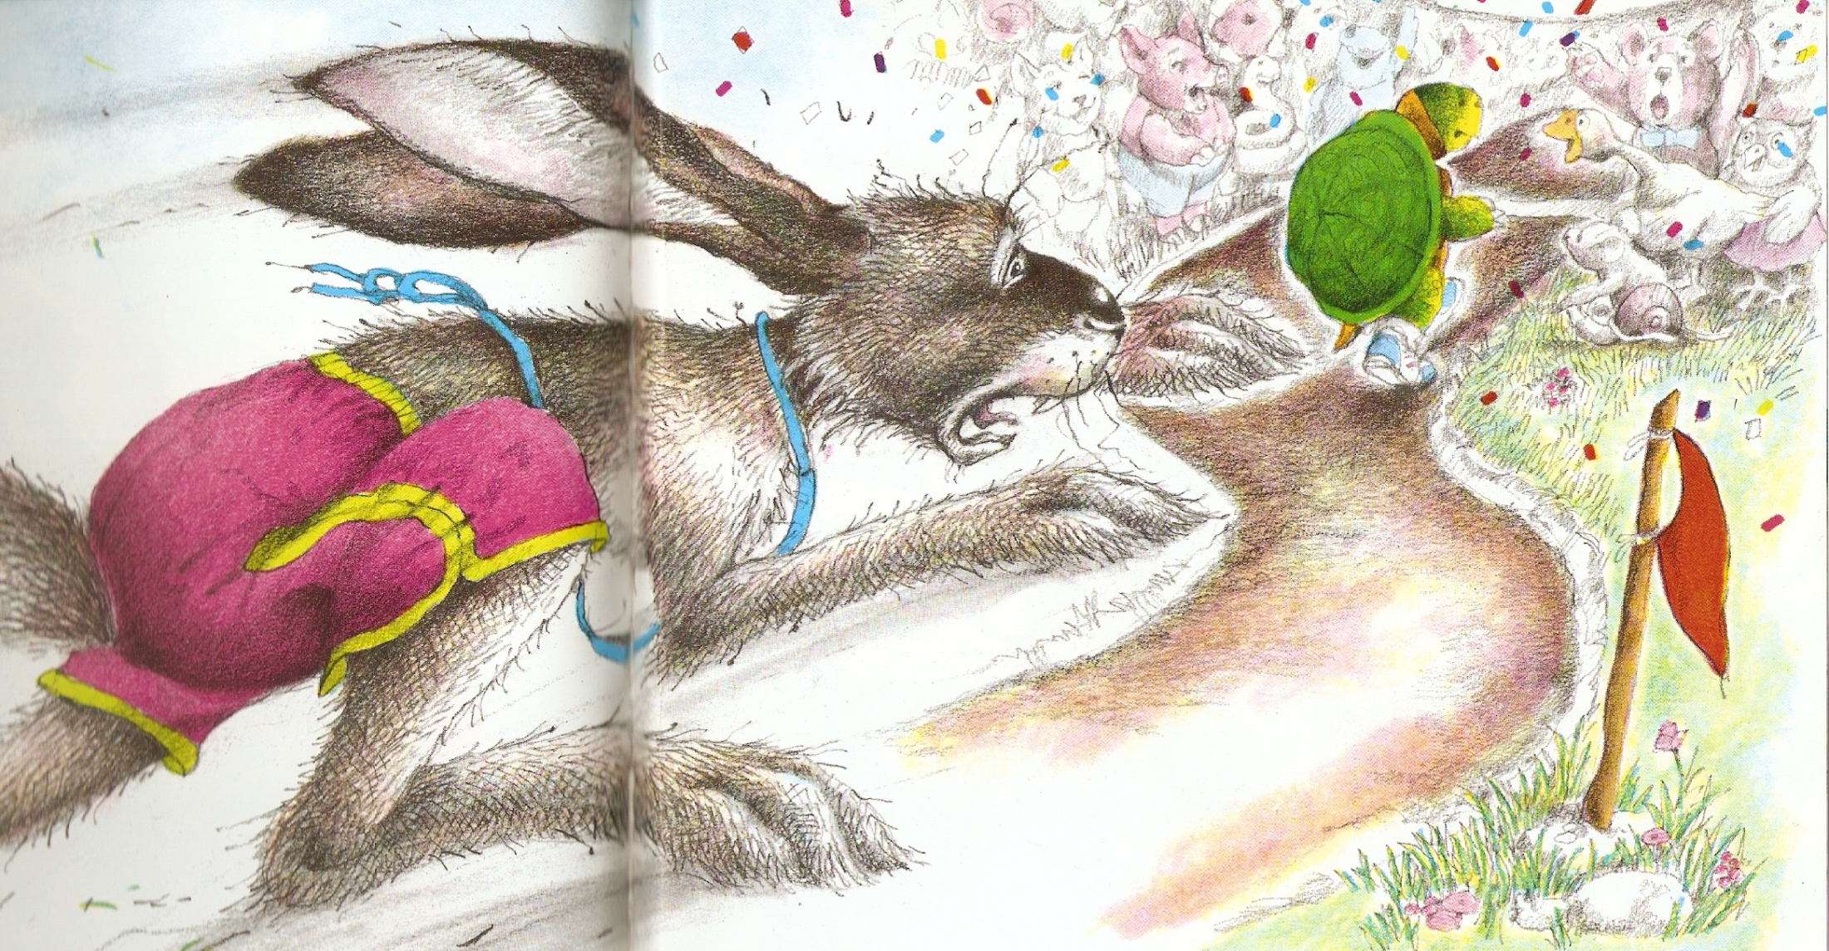

______________
______________
______________
______________

Name :________________________________________________ Date____________________________








