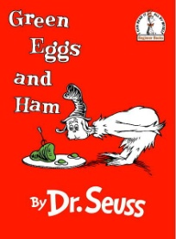Green Eggs and Ham…Mad Libs Style

After reading and discussing Green Eggs and Ham, have your students work as a class or individually to create their own version of the story. Have students generate a list of words using the clues you give them. As much as possible, have students choose words *different* from the words used in the original story.

Here are the clues…

1. Color word
2. Food word
3. Food word
4. Direction word
5. Direction word
6. Rhymes with #5
7. Place
8. Rhymes with #7
9. Something you can get into
10. Rhymes with #9
11. Something you can ride in
12. Rhymes with “see”
13. Something you can ride on
14. A place
15. Rhymes with #14
16. An animal
17. Rhymes with #16

Name the character last. Have students pick a one-syllable name. Then choose a word that rhymes with #3…this one does not have to be a “real” word.

Examples:

“Sam-I-Am” rhymes with “ham”

“Fred-a-rizza” rhymes with “pizza”

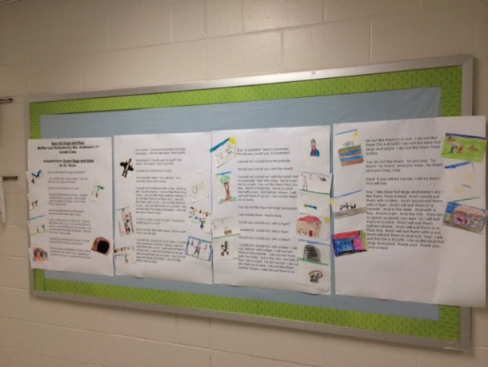Fill in the blanks with the students new words. Read…laugh…and enjoy. This new story makes an excellent addition to fluency folders. Students can also illustrate their new story either printed as a poster or individual copies for each student.

I am (Character’s FIRST Name). (Character’s FIRST Name) I am.

That (Character’s Full Name)! That (Character’s Full Name)! I do not like that (Character’s Full Name)!

Do you like _____1______ _____2______ and _____3______?

I do not like them, (Character’s Full Name). I do not like _____1______ _____2______ and _____3______.

Would you like them_____4______or _____5______?

I would not like them_____4______or _____5______. I would not like them _____6______. I do not like _____1______ _____2______ and _____3______. I do not like them, (Character’s Full Name).

Would you like them in a _____7______? Would you like them with a _____8______?

I do not like them in a _____7______. I do not like them with a _____8______. I do not like them_____4______or _____5______. I do not like them _____6______. I do not like _____1______ _____2______ and _____3______. I do not like them, (Character’s Full Name).

Would you eat them in a _____9______? Would you eat them with a _____10______?

Not in a _____9______. Not with a _____10______. Not in a _____7______. Not with a _____8______. I would not eat them_____4______or _____5______. I would not eat them _____6______. I would not eat _____1______ _____2______ and _____3______. I do not like them, (Character’s Full Name).

Would you? Could you? In a _____11______? Eat them! Eat them! Here they are.

I would not, could not, in a _____11______.

You may like them. You will see. You may like them in a _____12______!

I would not could not in a _____12______. Not in a _____11______! You let me be. I do not like them in a _____9______. I do not like them with a _____10______. I do not like them in a _____7______. I do not like them with a _____8______. I do not like them_____4______or _____5______. I do not like them _____6______. I do not like _____1______ _____2______ and _____3______. I do not like them (Character’s Full Name).

A _____13______! A _____13______! A _____13______! A _____13______! Could you, would you, on a _____13______?

Not on a _____13______! Not in a _____12______! Not in a _____11______! (Character’s FIRST Name)! Let me be!

I would not, could not, in a _____9______. I could not, would not, with a _____10______. I will not eat them with a _____8______. I will not eat them in a _____7______. I will not eat them_____4______or _____5______. I will not eat them _____6______. I do not eat _____1______ _____2______ and _____3______. I do not like them, (Character’s Full Name).

Say! In the _____14______? Here in the _____14______! Would you, could you, in the _____14______?

I would not, could not in the _____14______.

Would you, could you, in the _____15______?

I would not, could not, in the _____15______. Not in the _____14______. Not on a _____13______. Not in a _____11______. Not in a _____12______. I do not like t hem (Character’s FIRST Name), you see. Not in a _____7______. Not in a _____9______. Not with a _____8______. Not with a _____10______. I will not eat them_____4______or _____5______. I do not like them _____6______!

You do not like _____1______ _____2______ and _____3______?

I do not like them, (Character’s Full Name).

Could you, would you, with a _____16______?

I would not, could not, with a _____16______!

Would you, could you, on a _____17______?

I could not, would not, on a _____17______. I will not, will not, with a _____16______. I will not eat them in the _____15______. I will not eat them on a _____13______. Not in the _____14______! Not in a _____12______! Not in a _____11______! You let me be! I do not like them in a _____9______. I do not like them with a _____10______. I will not eat them in a _____7______. I will not eat them with a _____8______. I do not like them_____4______or _____5______. I do not like them _____6______! I do not like _____1______ _____2______ and _____3______! I do not like them (Character’s Full Name).

You do not like them. So you say. Try them! Try them! And you may. Try them and you may, I say.

(Character’s FIRST Name)! If you will let me be, I will try them. You will see.

Say! I like _____1______ _____2______ and _____3______! I do! I like them, (Character’s Full Name)! And I would eat them in a _____17______. And I would eat them with a _____16______…And I will eat them in the _____15______. And in the _____14______. And on a _____13______. And in a _____11______. And in a _____12______. They are so good, so good, you see! So I will eat them in a _____9______. And I will eat them with a _____10______. And I will eat them in a _____7______. And I will eat them with a _____8______. And I will eat them_____4______and _____5______. Say! I will eat the _____6______! I do so like _____1______ _____2______ and _____3______! Thank you! Thank you, (Character’s Full Name)!

**Blue Hot Dogs and Pizza**

**Written and Illustrated by Mrs. Anderson’s 1st Grade Class**

**Adapted from Green Eggs and Ham**

**By Dr. Seuss**

Do you like blue hot dogs and pizza?

I do not like them, Fred-a-rizza. I do not like blue hot dogs and pizza.

Would you like them in or out?

I would not like them in or out. I would not like them on a route. I do not like blue hot dogs and pizza. I do not like them, Fred-a-rizza.

Would you like them in a Pizza Hut? Would you like them with a nut?

I do not like them in a Pizza Hut. I do not like them with a nut. I do not like them in or out. I do not like them on a route. I do not like blue hot dogs and pizza. I do not like them, Fred-a-rizza.

Would you eat them in a cave? Would you eat them before you shave?

Not in a cave. Not before I shave. Not in a Pizza Hut. Not with a nut. I would not eat them in or out. I would not eat them on a route. I would not eat blue hot dogs and pizza. I do not like them, Fred-a-rizza.

Would you? Could you? In a jet? Eat them! Eat them! Don’t you fret.

I would not, could not, in a jet.

You may like them. You will see. You may like them with a key!

I would not could not with a key. Not in a jet! You let me be. I do not like them in a cave. I do not like them before I shave. I do not like them in a Pizza Hut. I do not like them with a nut. I do not like them in or out. I do not like them on a route. I do not like blue hot dogs and pizza. I do not like them Fred-a-rizza.

A city! A city! A city! A city! Could you, would you, in a city?

Not in a city! Not with a key! Not in a jet! Fred! Let me be!

I would not, could not, in a cave. I could not, would not, before I shave. I will not eat them with a nut. I will not eat them in a Pizza Hut. I will not eat them in or out. I will not eat them on a route. I do not eat blue hot dogs and pizza. I do not like them, Fred-a-rizza.

Say! In parade? Here in a parade! Would you, could you, in a parade?

I would not, could not in the parade.

Would you, could you, with the maid?

I would not, could not, with the maid. Not in a parade. Not with a key. Not in a jet. Not in a tree. I do not like them Fred, you see. Not in a Pizza Hut. Not in a cave. Not with a nut. Not before I shave. I will not eat them in or out. I do not like them on a route!

You do not like blue hot dogs and pizza?

I do not like them, Fred-a-rizza.

Could you, would you, with a tiger?

I would not, could not, with a tiger!

Would you, could you, with a biker?

I could not, would not, with a biker. I will not, will not, with a tiger. I will not eat them in the parade. I will not eat them with the maid. Not in the city! Not with a key! Not in a jet! You let me be! I do not like them in a cave. I do not like them before I shave. I will not eat them in a Pizza Hut. I will not eat them with a nut. I do not like them in or out. I do not like them ON A ROUTE! I do not like blue hot dogs and pizza! I do not like them Fred-a-rizza.

You do not like them. So you say. Try them! Try them! And you may. Try them and you may, I say.

Fred! If you will let me be, I will try them. You will see.

Say! I like blue hot dogs and pizza! I do! I like them, Fred-a-rizza! And I would eat them with a biker. And I would eat them with a tiger…And I will eat them in a parade. And in the dark. And with a key. And in a jet. And the city. They are so good, so good, you see! So I will eat them in a cave. And I will eat them before I shave. And I will eat them in a Pizza Hut. And I will eat them with a nut. And I will eat them in and out. Say! I will eat the ON A ROUTE! I do so like blue hot dogs and pizza! Thank you! Thank you, Fred-a-rizza!