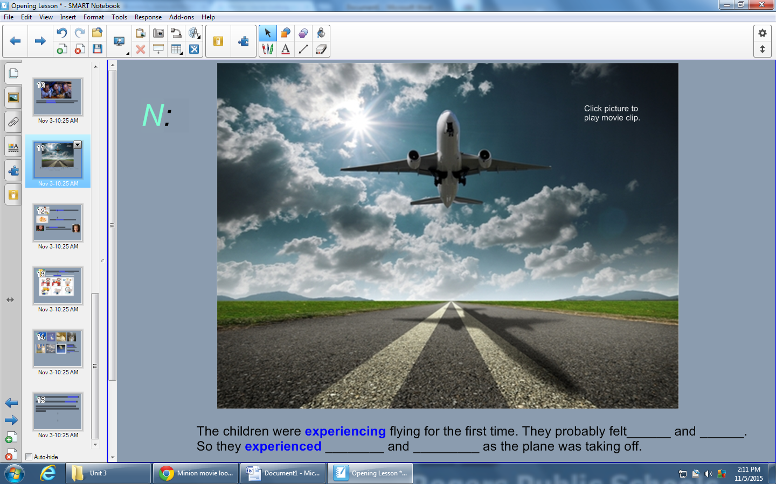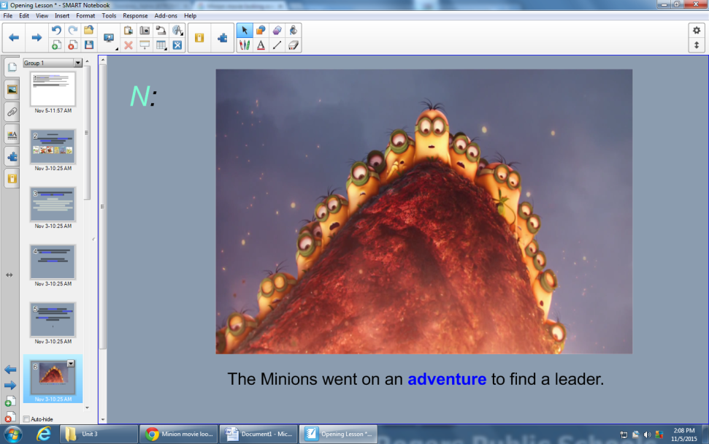

The Minions went on an **adventure** to find a leader.

The children had their first **experience** on an airplane.

*************************************************************************************

**Adventure Experience**