**Life Lessons**

How can stories teach us life lessons?

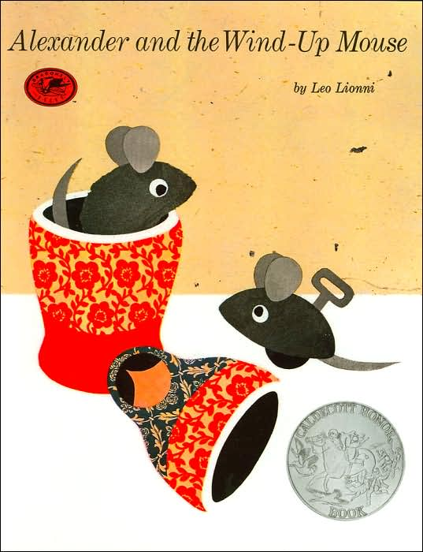

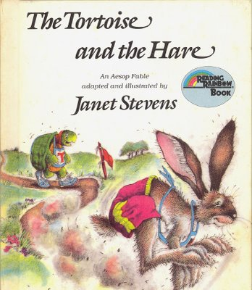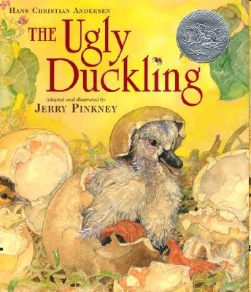

**Table of Contents**

___________________________.....____

___________________________.....____

___________________________.....____

___________________________.....____

___________________________.....____

___________________________.....____

___________________________.....____

___________________________.....____

___________________________.....____

___________________________.....____

___________________________.....____

___________________________.....____

___________________________.....____

___________________________.....____

___________________________.....____

___________________________.....____

___________________________.....____

___________________________.....____

___________________________.....____

**Goal:** Before **1 2 3 4**

I can _________________________________

_____________________________________

**APK** (What do you already know?)

**Apply what you have learned…**

**Goal:** After **1 2 3 4**

Date ___________________________

**New information…**

Page number

**Glossary**