Make labels for: Characters, Setting, Major Events and Lesson

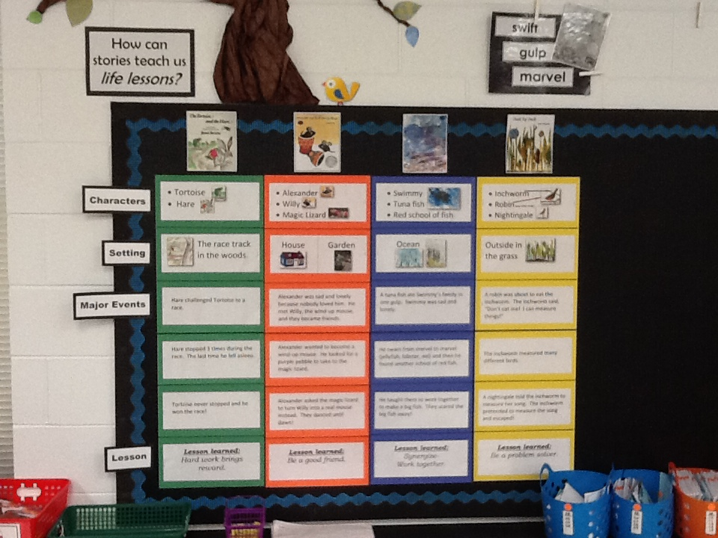

**Directions for Fables Matrix (for bulletin board)**

1. Use images of book covers to display at the top of the matrix.

2. Use two pieces of construction paper for each fable—I use a different color for each fable. Fold into 3 equal sections and staple onto bulletin board.

3. Cut all other papers in this document in half the long way.

They should fit into each folded section of the construction paper.

4. After reading the fables and completing the lesson on retelling,

have students help you put each section in the correct spot on the

large fables matrix.

(The “LESSON” of each fable is what we came up with at Eastside.

Some of them were hard to determine. Feel free to make any

changes.)

*COPY, LAMINATE, and SAVE FOR NEXT YEAR!

[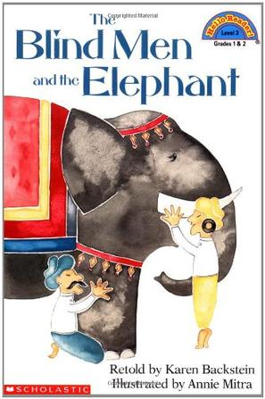](http://www.google.com/url?sa=i&rct=j&q=&esrc=s&frm=1&source=images&cd=&cad=rja&docid=QjLCQSBgks8z3M&tbnid=wu8Arln2wU5b-M:&ved=0CAUQjRw&url=http://www.douban.com/subject/2764170/&ei=kEGiUvDKGYSs2wXduYGICQ&bvm=bv.57752919,d.b2I&psig=AFQjCNG_Dp97jvpEuNrTr2qrBAG5BSnBLQ&ust=1386451694984428)

* 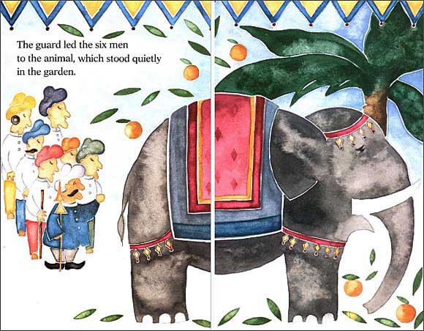6 blind men
* Prince
* Elephant

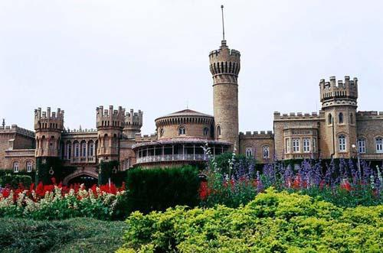Garden at the

Prince’s palace

The blind men went to find out about the Prince’s elephant.

Each man felt a different part of the elephant and thought the elephant was 6 different things. They argued and woke the prince.

The prince told the blind men that they had to put all the parts together to understand what the elephant was. They rode the elephant home.

***Lesson learned:***

*Listen to others.*

*Don’t be blind to*

*your ideas only.*

*[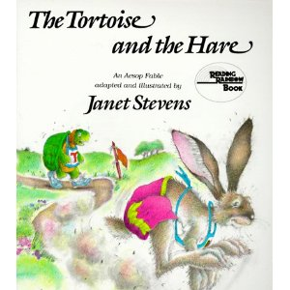](http://www.amazon.com/gp/product/images/0823405648/ref=dp_image_0/187-3007793-4784938?ie=UTF8&n=283155&s=books)*

* [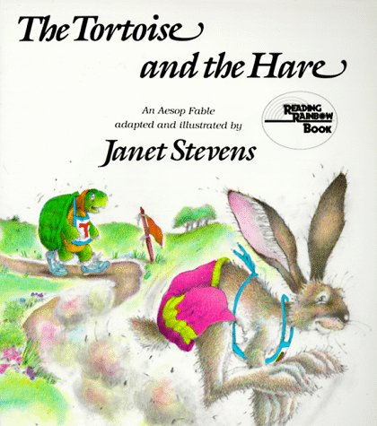](http://www.google.com/url?sa=i&rct=j&q=&esrc=s&frm=1&source=images&cd=&cad=rja&docid=lZvjmBuXJx1LiM&tbnid=zKLaFr7cXzD2WM:&ved=0CAUQjRw&url=http://www.amazon.com/The-Tortoise-Hare-Reading-Rainbow/dp/0823405648&ei=4TuiUtrvLMKi2wWEooD4BA&psig=AFQjCNFDmylSx6qPghQN5F9XFRWG1EATPA&ust=1386450243063560)Tortoise
* Hare

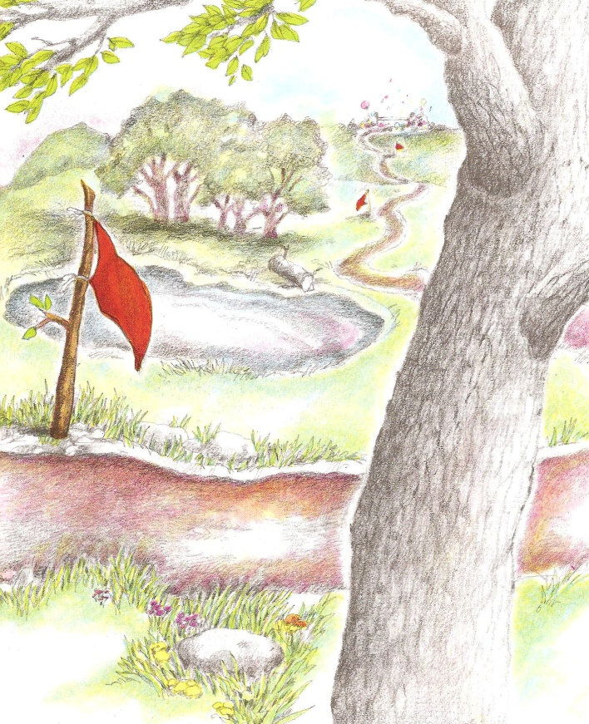The race track in the woods.

Hare challenged Tortoise to a race.

Hare stopped 3 times during the race. The last time he fell asleep.

Tortoise never stopped and he won the race!

***Lesson learned:***

*Hard work brings reward.*

[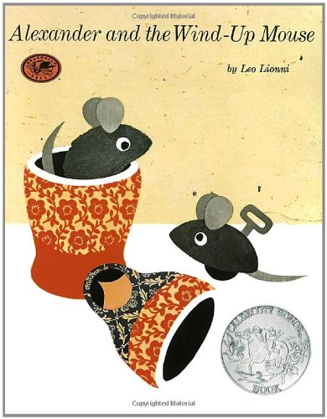](http://www.google.com/url?sa=i&rct=j&q=&esrc=s&frm=1&source=images&cd=&cad=rja&docid=oJxc5Sujw3QVrM&tbnid=D37qTBiT62AXwM:&ved=0CAUQjRw&url=http://www.amazon.com/Alexander-Wind-Up-Mouse-Caldecott-Pinwheel/dp/0394829115&ei=jUOiUunxGc7s2AWAkYGwCA&psig=AFQjCNHvWv9S9GrhuWCoDAQ19wGPUHmGiw&ust=1386452170356213)

* [](http://www.google.com/url?sa=i&rct=j&q=&esrc=s&frm=1&source=images&cd=&cad=rja&docid=oJxc5Sujw3QVrM&tbnid=D37qTBiT62AXwM:&ved=0CAUQjRw&url=http://www.amazon.com/Alexander-Wind-Up-Mouse-Caldecott-Pinwheel/dp/0394829115&ei=jUOiUunxGc7s2AWAkYGwCA&psig=AFQjCNHvWv9S9GrhuWCoDAQ19wGPUHmGiw&ust=1386452170356213)Alexander
* [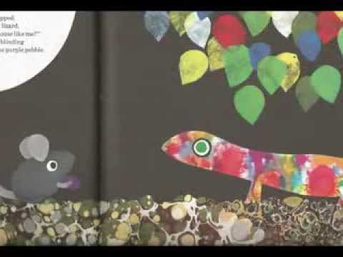](http://www.google.com/url?sa=i&rct=j&q=&esrc=s&frm=1&source=images&cd=&cad=rja&docid=rmZLrMDrVStxCM&tbnid=EfX_1CooJqDjqM:&ved=0CAUQjRw&url=http://www.youtube.com/watch?v=MLyWfZxV5Zs&ei=GEiiUqz9EIXd2AXkmoCABg&psig=AFQjCNGziZ01swIwWTIMCoZ7gonxuqYapA&ust=1386453267954408)Willy
* Magic Lizard

[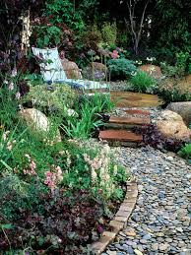](http://www.google.com/url?sa=i&rct=j&q=&esrc=s&frm=1&source=images&cd=&cad=rja&docid=Qzba9OCQ_2iHOM&tbnid=flt59MTpCkHIBM:&ved=0CAUQjRw&url=http://www.hgtvgardens.com/photos/landscape-and-hardscape-photos/a-soft-touch-landscaping-with-gravel-and-other-soft-surfacing&ei=5EaiUrPEEYmx2QWZ0IGQCQ&psig=AFQjCNE60Pj6QcRmDfquqg3YgcHa2f-8KQ&ust=1386453023368994) House Garden

[](http://www.google.com/url?sa=i&rct=j&q=&esrc=s&frm=1&source=images&cd=&cad=rja&docid=P45DgjOHPU9zxM&tbnid=8ixE7kutdBKIfM:&ved=0CAUQjRw&url=http://sjbparish.com/zoning_general.php?id=543&ei=FkaiUrOtJqL82wXqroDQCQ&psig=AFQjCNHQJuGiGM5BBkrtiIop9u22EoZvjQ&ust=1386452796303787)

Alexander was sad and lonely because nobody loved him. He met Willy, the wind-up mouse, and they became friends.

Alexander wanted to become a

wind-up mouse. He looked for a

purple pebble to take to the

magic lizard.

Alexander asked the magic lizard

to turn Willy into a real mouse

instead. They danced until

dawn!

***Lesson learned:***

*Be a good friend.*

[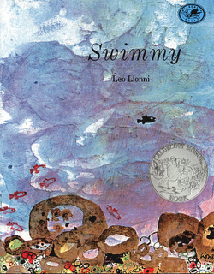](http://www.google.com/url?sa=i&rct=j&q=&esrc=s&frm=1&source=images&cd=&cad=rja&docid=mvtFRT6k0Oow8M&tbnid=jBlwmThY5O8hNM:&ved=0CAUQjRw&url=http://www.doinggoodtogether.org/index.php/blog/kinder-book-club-swimmy/&ei=8UmiUqSLBcPg2gW9pICICw&psig=AFQjCNECT-V-HkYrAalK6lGM-K0Y_4-JWA&ust=1386453708950671)

* [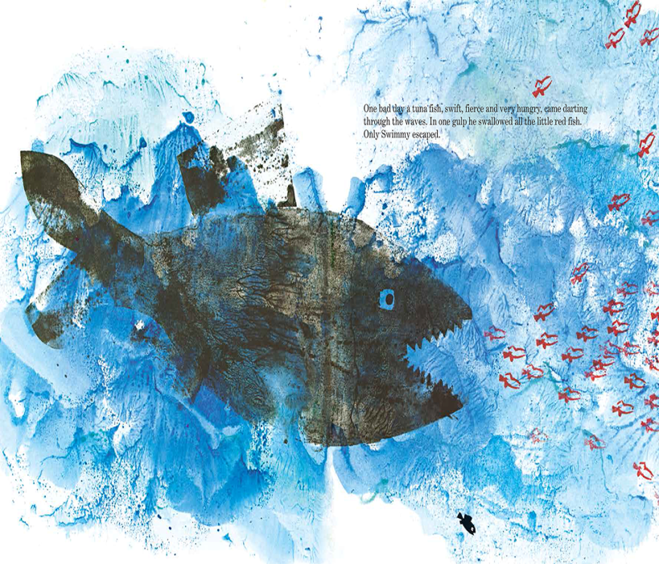](http://www.google.com/url?sa=i&rct=j&q=&esrc=s&frm=1&source=images&cd=&cad=rja&docid=2xPODJNCYQvmVM&tbnid=E46SPetN9V-eoM:&ved=0CAUQjRw&url=http://blaine.org/sevenimpossiblethings/?p=2589&ei=DEyiUtXED6Pz2QWtroG4Cg&psig=AFQjCNECT-V-HkYrAalK6lGM-K0Y_4-JWA&ust=1386453708950671)Swimmy
* Tuna fish
* Red school of fish

[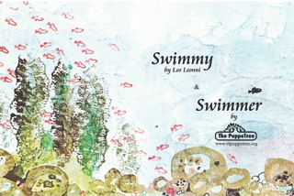](http://www.google.com/url?sa=i&rct=j&q=&esrc=s&frm=1&source=images&cd=&cad=rja&docid=1zMc1NqMFVkFMM&tbnid=D6EEmoTITrnASM:&ved=0CAUQjRw&url=http://vtpuppetree.org/?p=928&ei=CE-iUve1I4qq2wXq9oHgCg&psig=AFQjCNECT-V-HkYrAalK6lGM-K0Y_4-JWA&ust=1386453708950671)[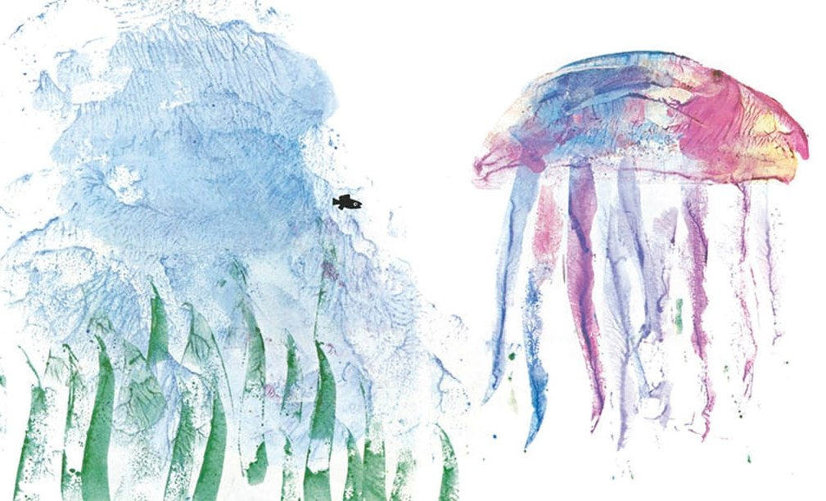](http://www.google.com/url?sa=i&rct=j&q=&esrc=s&frm=1&source=images&cd=&cad=rja&docid=8O1XzTjMhUIbrM&tbnid=kZyge9lo2mIz7M:&ved=0CAUQjRw&url=http://theanimalarium.blogspot.com/2011/09/sunday-safari-gelatinous-beauties.html&ei=qU-iUrLoLaji2gWOjoDIDA&psig=AFQjCNECT-V-HkYrAalK6lGM-K0Y_4-JWA&ust=1386453708950671) Ocean

A tuna fish ate Swimmy’s family in one gulp. Swimmy was sad and lonely.

He swam from marvel to marvel (jellyfish, lobster, eel) and then he found another school of red fish.

He taught them to work together to make a big fish. They scared the big fish away!

***Lesson learned:***

*Synergize-*

*Work together.*

[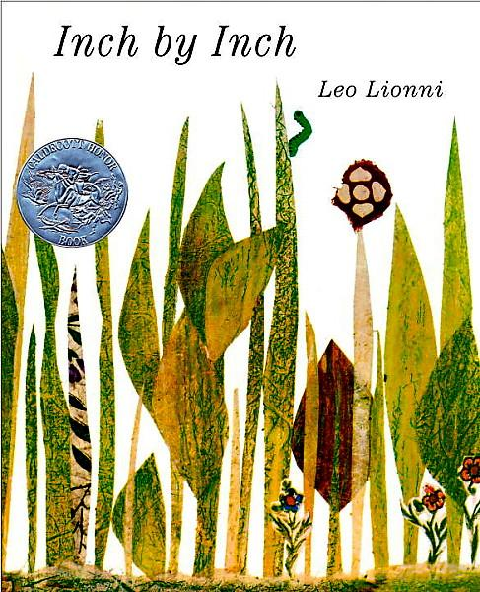](http://www.google.com/url?sa=i&rct=j&q=&esrc=s&frm=1&source=images&cd=&cad=rja&docid=BzLoW5pRvZfJrM&tbnid=q1ru5HT0x5r30M:&ved=0CAUQjRw&url=http://kissthebook.blogspot.com/2010/05/inch-by-inch-by-leo-lionni.html&ei=rVGiUrGzDKX52AX-74HYDg&psig=AFQjCNEAHL3vQBmQsgWKmQJXbMqCGcDsyg&ust=1386455751106982)

* [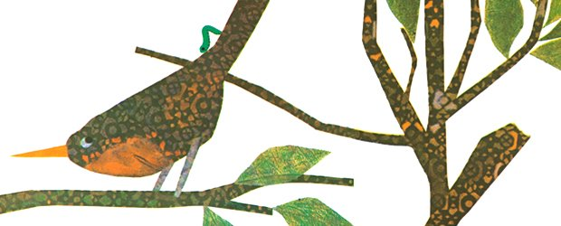](http://www.google.com/url?sa=i&rct=j&q=&esrc=s&frm=1&source=images&cd=&cad=rja&docid=e1fuEhBXkNoUyM&tbnid=xs7jdumsoEBtVM:&ved=0CAUQjRw&url=http://www.randomhousekids.com/brand/leo-lionni/?work=101914&ei=N1KiUuHoOsiy2gXopYDAAQ&psig=AFQjCNEAHL3vQBmQsgWKmQJXbMqCGcDsyg&ust=1386455751106982)Inchworm
* 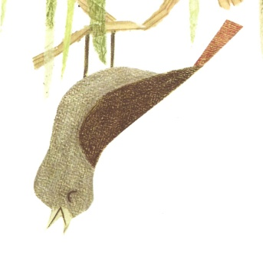Robin (and other birds)
* Nightingale

[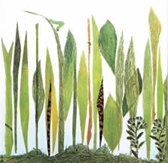](http://www.google.com/url?sa=i&rct=j&q=&esrc=s&frm=1&source=images&cd=&cad=rja&docid=r0ClEP6-tcBALM&tbnid=8klfrztKgK8XAM:&ved=0CAUQjRw&url=http://www.uis.edu/sangamonauditorium/classacts/Swimmy.htm&ei=FlWiUqnDAeaY2QXz_4HIBg&psig=AFQjCNFqpkgVEfhnBY63unqqO4TevYQCgw&ust=1386456212372228)Outside in

the grass

A robin was about to eat the inchworm. The inchworm said, “Don’t eat me! I can measure things!”

The inchworm measured many different birds.

A nightingale told the inchworm to measure her song. The inchworm pretended to measure the song and escaped!

***Lesson learned:***

*Be a problem solver.*

[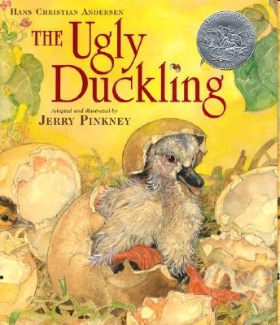](http://www.google.com/url?sa=i&rct=j&q=&esrc=s&frm=1&source=images&cd=&cad=rja&docid=11FMbEhtFbnH6M&tbnid=R3z-_RUVia8kOM:&ved=0CAUQjRw&url=http://creativemadnessmama.com/blog/2012/02/16/the-ugly-duckling-adapted-and-illustrated-by-jerry-pinkney/&ei=2VaiUty0B4iu2QW_iYGABQ&psig=AFQjCNH3YFaXsk0hr0ap0s0oxRZEXyRCPg&ust=1386457064489560)

* [](http://www.google.com/url?sa=i&rct=j&q=&esrc=s&frm=1&source=images&cd=&cad=rja&docid=11FMbEhtFbnH6M&tbnid=R3z-_RUVia8kOM:&ved=0CAUQjRw&url=http://creativemadnessmama.com/blog/2012/02/16/the-ugly-duckling-adapted-and-illustrated-by-jerry-pinkney/&ei=2VaiUty0B4iu2QW_iYGABQ&psig=AFQjCNH3YFaXsk0hr0ap0s0oxRZEXyRCPg&ust=1386457064489560)Ugly duckling
* [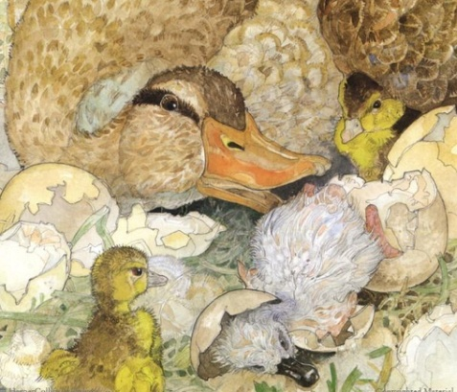](http://www.google.com/url?sa=i&rct=j&q=&esrc=s&frm=1&source=images&cd=&cad=rja&docid=QUCcekaYxwJdoM&tbnid=pbLfaCEk-s6gMM:&ved=0CAUQjRw&url=http://www.englishwordplay.com/ugly.html&ei=8FeiUtz9G-e-2gX98oHYAQ&psig=AFQjCNH3YFaXsk0hr0ap0s0oxRZEXyRCPg&ust=1386457064489560)Mother duck

and baby ducklings

* [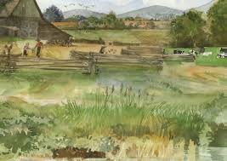](http://www.google.com/url?sa=i&rct=j&q=&esrc=s&frm=1&source=images&cd=&cad=rja&docid=QUCcekaYxwJdoM&tbnid=0qoGiDYMNhnVNM:&ved=0CAUQjRw&url=http://www.englishwordplay.com/ugly.html&ei=on-wUuOtOMH42QWFwIC4CQ&bvm=bv.57967247,d.b2I&psig=AFQjCNFwP_YXdKP1yrsTH8VZ_lqeVdQ45w&ust=1387385107520888)Farm
* Pond

After the ugly duckling hatched, all the animals were mean to him because he looked different. His mother still loved him.

The ugly duckling was all alone. As winter came, the pond froze around him. A nice man saved him.

The ugly duckling survived the long winter. He had become a beautiful swan!

***Lesson learned:***

*Be proud of*

*Who you are.*

[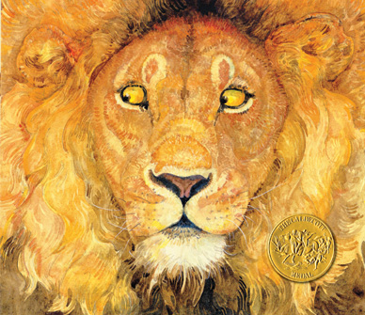](http://www.google.com/url?sa=i&rct=j&q=&esrc=s&frm=1&source=images&cd=&cad=rja&docid=2PJDNKXDslONVM&tbnid=yOmhyVYlerNEtM:&ved=0CAUQjRw&url=http://littleelfman.blogspot.com/2012/02/lion-and-mouse-by-jerry-pinkney.html&ei=mVuiUsCoBofq2gXY7YDwCg&psig=AFQjCNEE4xVoRdwPbcIAEz8AxfnXAR7QIg&ust=1386458328058024)

* [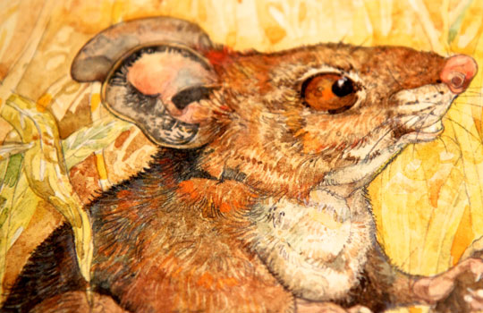](http://www.google.com/url?sa=i&rct=j&q=&esrc=s&frm=1&source=images&cd=&cad=rja&docid=2lzbXlpgTKoWyM&tbnid=83i-a_l8Ib6U0M:&ved=0CAUQjRw&url=http://childrensbooksguide.com/reviews/lion-and-the-mouse&ei=6VuiUuewMuWL2AX44oDoBg&psig=AFQjCNEE4xVoRdwPbcIAEz8AxfnXAR7QIg&ust=1386458328058024)[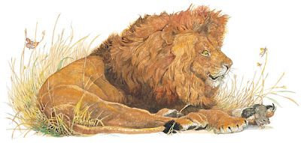](http://www.google.com/url?sa=i&rct=j&q=&esrc=s&frm=1&source=images&cd=&cad=rja&docid=2PJDNKXDslONVM&tbnid=ODjVtSSMVZmdmM:&ved=0CAUQjRw&url=http://littleelfman.blogspot.com/2012/02/lion-and-mouse-by-jerry-pinkney.html&ei=F1yiUufmF-fW2QXJ-YHQCw&psig=AFQjCNEE4xVoRdwPbcIAEz8AxfnXAR7QIg&ust=1386458328058024)Lion
* Mouse

[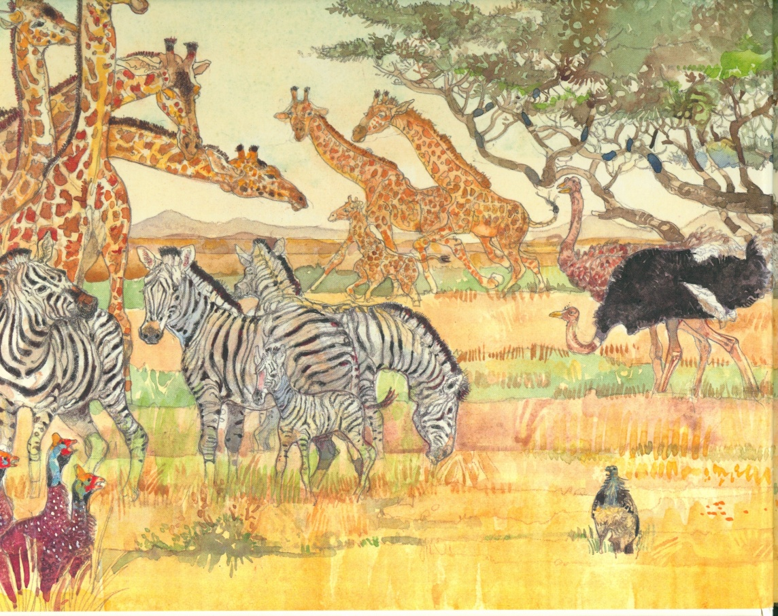](http://www.google.com/url?sa=i&rct=j&q=&esrc=s&frm=1&source=images&cd=&cad=rja&docid=hQPl-WsnMpU4SM&tbnid=SPtOoSdgQvBiyM:&ved=0CAUQjRw&url=http://www.pbs.org/parents/booklights/archives/awards/&ei=p1yiUoaMGcT22AWhzYDgDg&psig=AFQjCNEE4xVoRdwPbcIAEz8AxfnXAR7QIg&ust=1386458328058024)African plains

The lion caught the mouse. He

decided to let the mouse go.

Hunters set a trap. The lion got

caught in the net and the mouse

chewed through the net. The

lion escaped.

The lion and the mouse became

friends.

***Lesson learned:***

*Help others.*

***[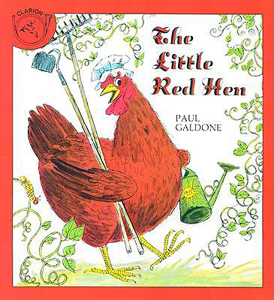](http://www.google.com/url?sa=i&rct=j&q=&esrc=s&frm=1&source=images&cd=&cad=rja&docid=m4dv7m90u3khZM&tbnid=Iuux2ljBO0PxsM:&ved=0CAUQjRw&url=http://www.betterworldbooks.com/the-little-red-hen-book-cassette-with-book-id-0395899028.aspx&ei=K16iUuzpMoP-2gXmvYGwDQ&bvm=bv.57752919,d.b2I&psig=AFQjCNG-2Fru4lSb7fLFayHVcQMx-PHmqg&ust=1386459013718489)***

* [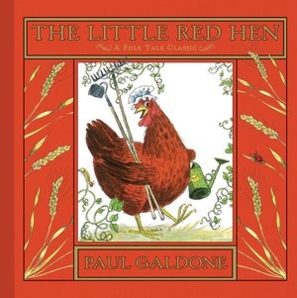](http://www.google.com/url?sa=i&rct=j&q=&esrc=s&frm=1&source=images&cd=&cad=rja&docid=y3ARX9MHiiuCAM&tbnid=T4OtL2zfrMgjuM:&ved=0CAUQjRw&url=http://blog.littlepicklepress.com/2012/02/book-review-little-red-hen.html&ei=pF-iUoryF6H12wWkmYDgDg&bvm=bv.57752919,d.b2I&psig=AFQjCNG-2Fru4lSb7fLFayHVcQMx-PHmqg&ust=1386459013718489)Little Red Hen
* [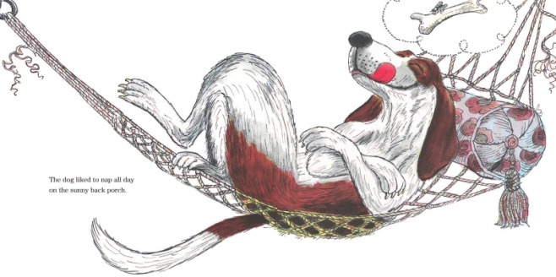](http://www.google.com/url?sa=i&rct=j&q=&esrc=s&frm=1&source=images&cd=&cad=rja&docid=VMUdy2m7LrQPAM&tbnid=hlXgO02k9HzetM:&ved=0CAUQjRw&url=http://librarianbooksforchildren.blogspot.com/2012/11/celebration-of-paul-galdone-folk-tales.html&ei=116iUu3qLan92QWpjoHQAg&bvm=bv.57752919,d.b2I&psig=AFQjCNG-2Fru4lSb7fLFayHVcQMx-PHmqg&ust=1386459013718489)[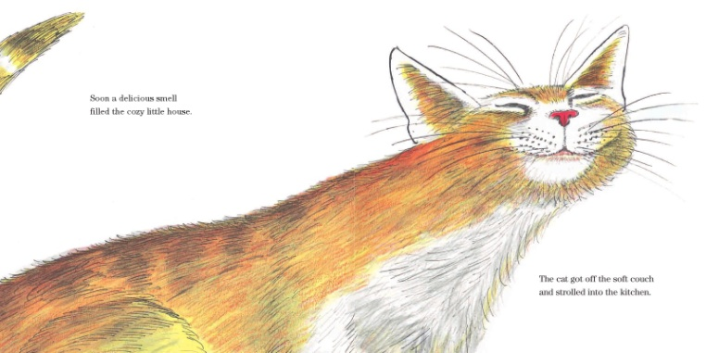](http://www.google.com/url?sa=i&rct=j&q=&esrc=s&frm=1&source=images&cd=&cad=rja&docid=_93iPMtQKSj-mM&tbnid=I-Pt3eEL_jvQDM:&ved=0CAUQjRw&url=http://blaine.org/sevenimpossiblethings/?p=2126&ei=e16iUvPRIsi82gX0j4BY&bvm=bv.57752919,d.b2I&psig=AFQjCNG-2Fru4lSb7fLFayHVcQMx-PHmqg&ust=1386459013718489)Cat
* 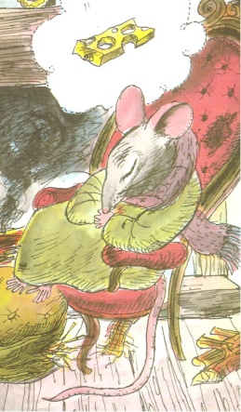Dog
* Mouse

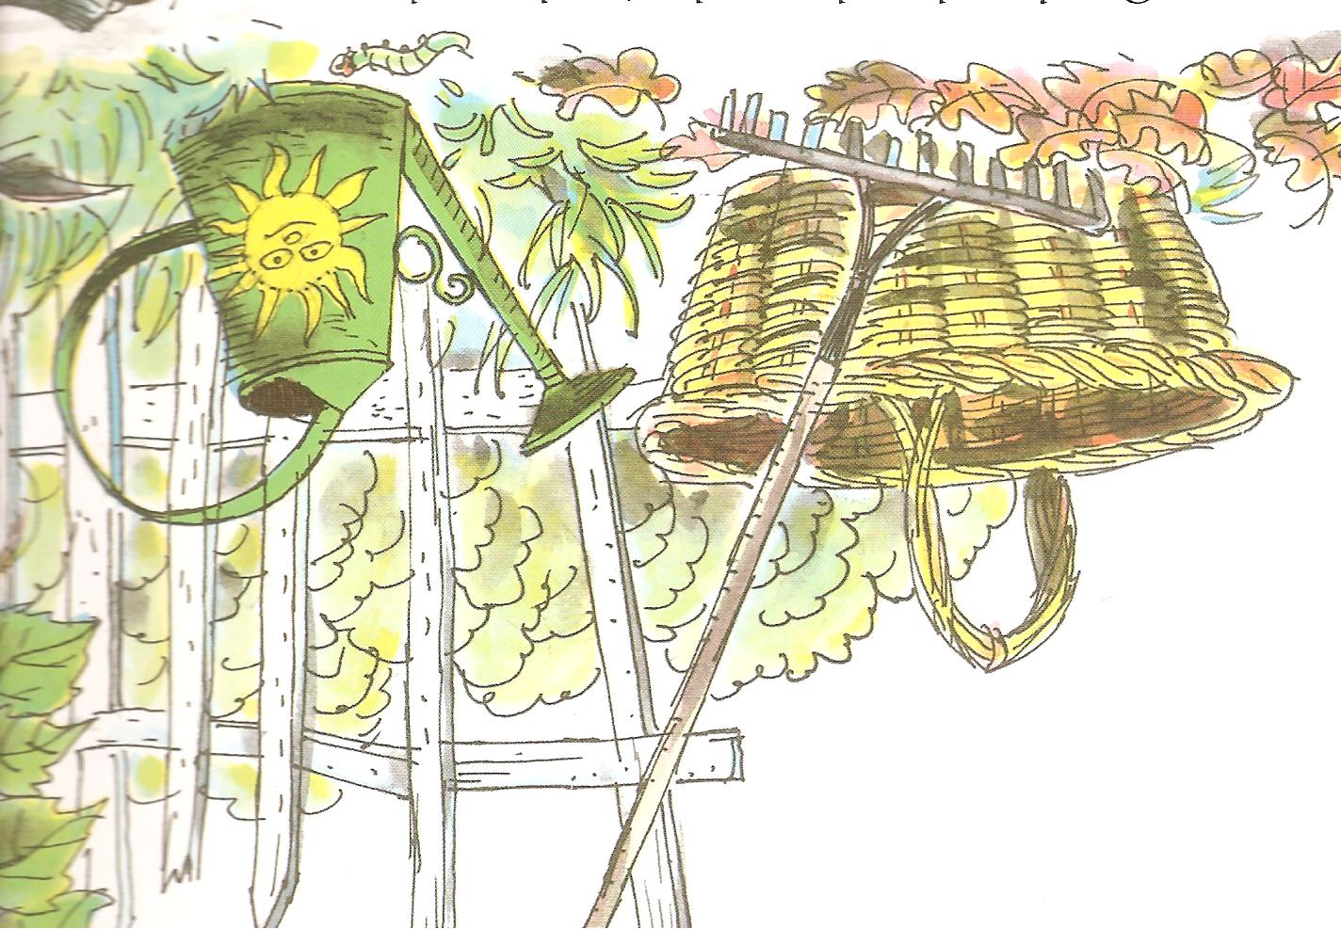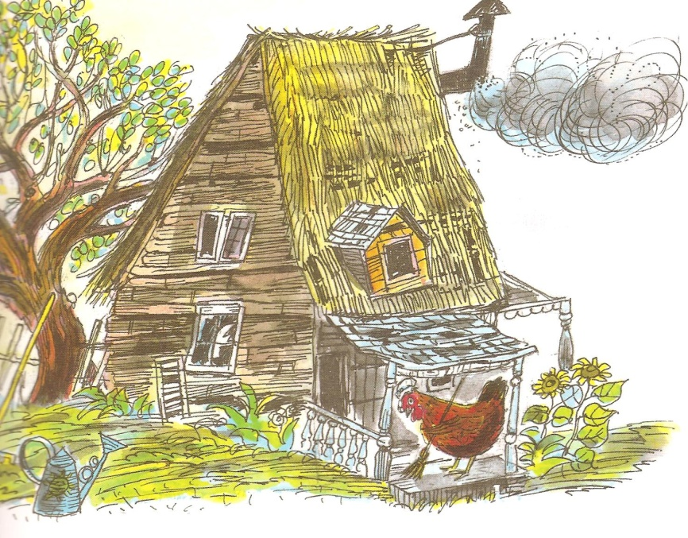 House Garden

The Little Red Hen asked for help.

The cat, dog, and mouse all said,

“No.”

The Little Red Hen worked hard

tending, cutting, and baking the

bread. The animals never helped

her.

When she asked, “Who will help me eat this bread?” the animals replied, “I will!” The Little Red Hen ate it all by herself!

***Lesson learned:***

*Work hard.*

*Help others.*