Name________________________

A Picture Book of

George Washington Carver

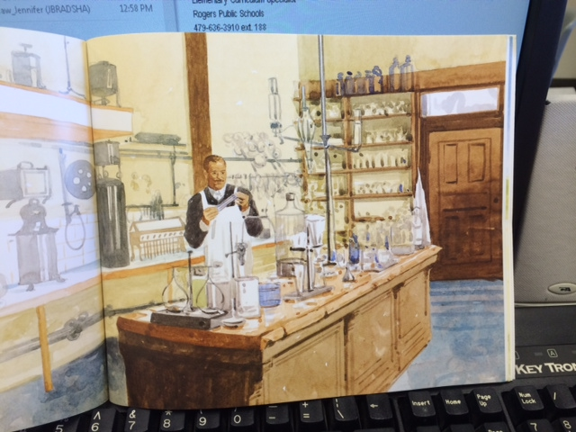

George is a ___________.

Scientist Police Officer Custodian

He is working in his ____________.

bath kitchen lab

George is probably a __________ thinker.

boring lazy creative