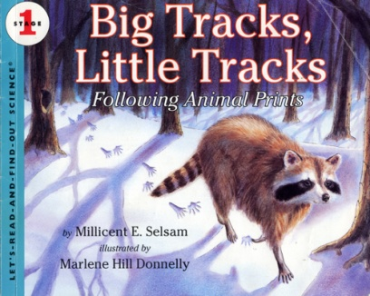Name________________________

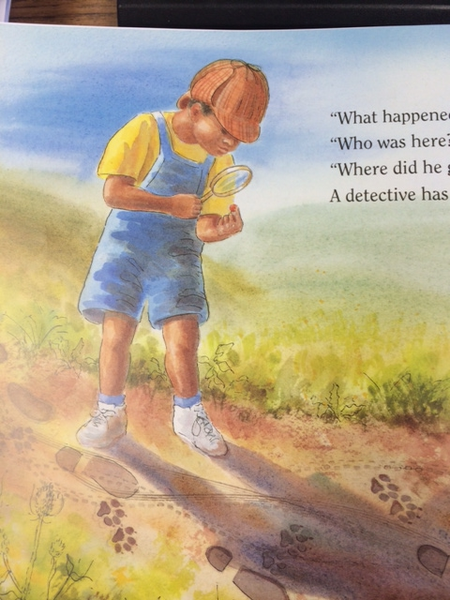

The boy is looking ___________ the magnifying glass.

around through beside

He is looking at something very ____________.

pretty tiny huge

If he ___________ the tracks, he might find the animal.

makes dreams follows

RL.1.7