A Nest Full of Eggs

By Priscilla Beiz Jenkins

Listen. “Cheer-up, cheer-up, cheer-up.” That is the song of a robin. It must be spring!

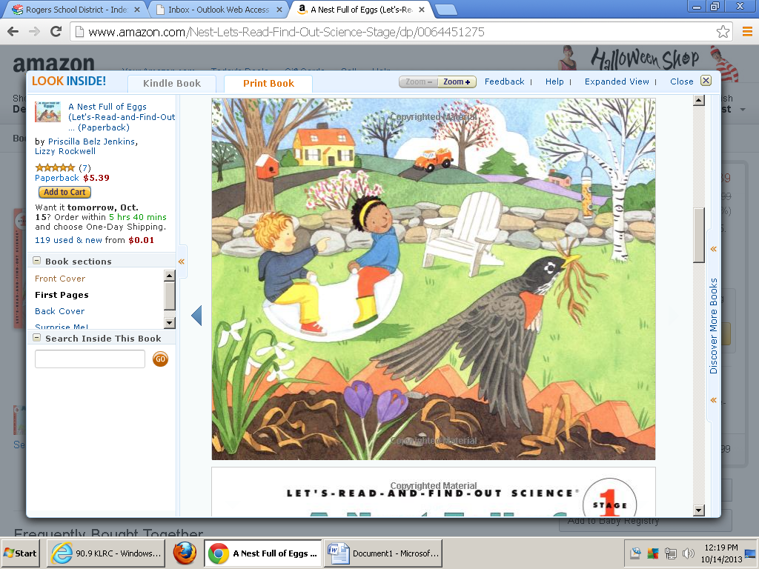Up in a tree outside my window, a pair of American robins is very busy. They are gathering dry weeds and twigs. They work carefully but quickly. It is almost time.

TEACHER NOTES

* Highlighted words are possible vocabulary words for this passage. Let students identify which words they do not understand. If possible, work as a class to use context clues and/or illustrations to determine meaning.
* First read- blue questions (key ideas and details)
* Second read- orange questions (craft and structure)
* Third read (if necessary)- purple questions (integration of knowledge and ideas)

A Nest Full of Eggs

Who is saying this? How do you know?

The author chose to use the word “song.” How should we read this part?

By Priscilla Beiz Jenkins

Listen. “**Cheer-up, cheer-up, cheer-up.**” That is the song of a robin. It must be spring!

Why does the author put this illustration with this text? Which words does the illustration help you to figure out?

Why does the author begin “American” with a capital A?

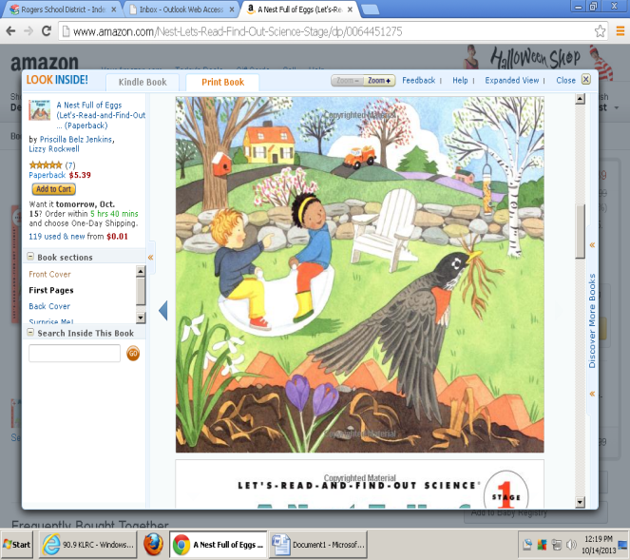Up in a tree outside my window, a pair of American robins is very busy. They are gathering dry weeds and twigs. They work carefully but quickly. It is almost time.

Think about what is happening in this passage…the birds and what they are doing. How is this similar to Are You My Mother? How is it different? (Show attached illustration from Mother if necessary.

(Nest is high in a tree; don’t know what kind of bird in Mother; fiction vs. informational; etc.)

Why do the twigs need to be dry?

Think about what you know about birds. Why do they need weeds and twigs?

What are the birds gathering?

Think about the title of our story…what is it “almost time” to do?

