*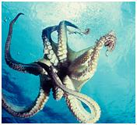1st Grade, Unit 2 Formative Assessment*

This assessment is meant to measure progress towards the following standards:

* RL.1.3 Describe characters, settings, and major events in a story, using key details.
* RI.1.4 Ask and answer questions to help determine or clarify the meaning of words and phrases in a text.

Students are expected to choose the best definition for the words “character” and “describe.” Students will identify a character from the story by drawing and/or writing the character’s name in the center of a character web. After identifying the character, students will use the outside bubbles on the character map to give details from the story that describe the character. Students may write and/or draw the details. In future units and assessments, students will describe the settings and major events of stories as they progress towards end of year proficiency.

Because we know that vocabulary is typically a tricky spot for our students, questions 1-2 address standard RI.1.4. Question 3 measures standard RL.1.3.

Directions for Giving the Assessment:

Students should spend 5 minutes independently reading the passage and answering the questions on this assessment. Encourage students, especially struggling readers, to think about strategies they have for reading difficult passages/texts.

After 5 minutes, please read the passage and questions aloud for the class. If asked, continue to read aloud any portion of the passage or question. While we know that *read aloud* is not an allowable accommodation on the reading portion of high-stakes testing, the purpose of this assessment is to measure reading comprehension…not independent reading comprehension.

Reminder: Allow students to dictate their descriptions of the character if necessary. Use the phrase, “Tell me about…” when asking students about their character and descriptions.

Joey put on his mask. He flapped his cape in front of the mirror.

Superhero Joey

By Katherine Rollins

Name: ____________________

This is the best costume, he thought. I’m sure to win the contest.

Joey skipped downstairs.

“Here I come to rescue you!” Joey shouted.

“Nice costume,” said Joey’s dad.

“I’m a superhero,” said Joey.

“Joey,” said Mom, “I need you to watch Mindy at the party.”

Joey looked at his little sister. “But Mom, superheroes don’t have kid sisters.”

“Well this superhero has a sister,” said Mom.

“What will Mindy’s costume be?” asked Dad.

“I’m not sure,” said Mom.

Joey got an idea.

“I know!” Joey took Mindy upstairs to his room. He dug through his closets. Joey found his baby blanket. He put it around Mindy’s shoulders.

At the party, Superhero Joey and his sidekick Supergirl Mindy won first prize!

1. What is a **character**?
   1. Where the story takes place
   2. What someone does or says
   3. The facts or details
   4. Who is in the story
2. What does **describe** mean?
   1. To tell what is the same and different
   2. To watch and learn
   3. To tell about using evidence
   4. To listen to and enjoy
3. Fill in the character map below telling about one of the characters from the story. In the center, write the character’s name a draw a picture of the character. Describe the character in the boxes. Use as many boxes as you can to describe the character.

Name: ____________________

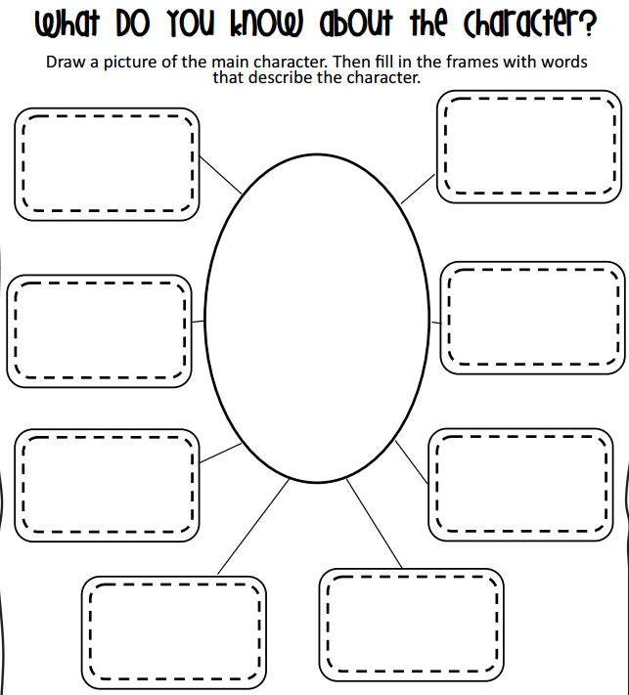

1. What is a **character**?
   1. Where the story takes place
   2. What someone does or says
   3. The facts or details
   4. Who is in the story
2. What does **describe** mean?
   1. To tell what is the same and different
   2. To watch and learn
   3. To tell about using evidence
   4. To listen to and enjoy
3. Fill in the character map below telling about a character from the story. In the center, write the character’s name a draw a picture of the character. Describe the character in the boxes. Use as many boxes as you can to describe the character.



Character: Joey

Details to describe: wearing a superhero costume; has a cape; has a mask; has little sister named Mindy; does not want his sister to go to the party; helps sister be a superhero

*Note to Teachers: Hopefully students will choose Joey, the main character, to describe, but they could also choose Mom, Dad, or Mindy. Students will likely struggle to describe the other characters with enough detail. If this happens, ask prompting questions, such as, “Is there another character you could choose that has more details?”*