**Poems about Reading**

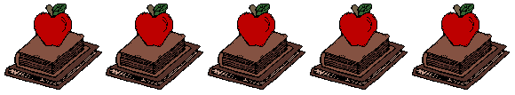

**Read to me**

**Jane Yolen**

**Read to me riddles and read to me rhymes  
Read to me stories of magical times   
Read to me tales about castles and kings   
Read to me stories of fabulous things   
Read to me pirates and read to me knights   
Read to me dragons and dragon-book fights   
Read to me spaceships and cowboys and then   
When you are finished- please read them again.**



### [Books Fall Open](http://novelties.edublogs.org/2010/06/28/hello-world/)

Books fall open, you fall in,  
delighted where you’ve never been;  
hear voices not once heard before,  
reach world on world through door on door;  
find unexpected keys to things locked up beyond imaginings.

What might you be, perhaps become,  
because one book is somewhere?

Some wise delver into wisdom, wit,  
and wherewithal has written it.  
True books will venture, dare you out,  
whisper secrets, maybe shout  
across the gloom to you in need,  
who hanker for a book to read.

**~ David McCord**

# Books to the ceiling, Books to the sky, My pile of books is a mile high. How I love them! How I need them! I'll have a long beard by the time I read them.”

― [Arnold Lobel](https://www.goodreads.com/author/show/12447.Arnold_Lobel)