About Jimmy James

Jimmy James when he was three

Tried to run away to sea,

Got his feet wet in the foam,

Had to turn and go back home.

C:\Users\Sarah\AppData\Local\Microsoft\Windows\Temporary Internet Files\Content.IE5\27JMD61S\MC900017133[1].wmf

He tried to run away once more

To join the army when he was four.

Alas, the General made him pack

His bubble-gum and go right back.

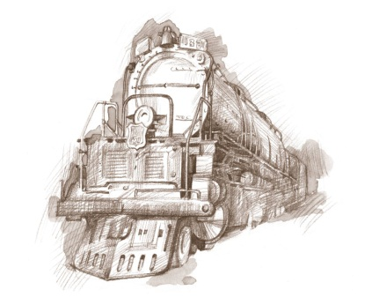At five he tried to catch a train

But gave it up because of rain.

(At six and seven he tried again

But got a cinder in his eye

And had to run back home to cry.)

At eight he kicked up such a fuss

His parents put him on a bus

With eighteen cents, a ball of twine,

And transfers to another line.

They went home feeling rather fine.

But Jimmy came back home at nine.

His father groaned, his mother sighed.

His sister just sat down and cried.

Still Jimmy wasn’t satisfied.

At ten, to everyone’s delight,

He stole out of the house one night

And, this time, ran away for good,

C:\Users\Sarah\AppData\Local\Microsoft\Windows\Temporary Internet Files\Content.IE5\JMR9USSY\MC900101054[1].wmfTaking the short cut through the wood.

That’s what he did. But sad to say

He met a tiger on the way.

Though in justice I must add

The tiger acted rather glad.

What Jimmy felt is not quite clear:

It was a little hard to hear

C:\Users\Sarah\AppData\Local\Microsoft\Windows\Temporary Internet Files\Content.IE5\12E0Z6ZG\MC900364214[1].wmfJust what he had to say, because

When talking past a tiger’s jaws

One’s best remarks may be cut off

By a yawn or sneeze or cough.

And the whole conversation stops

When the tiger licks his chops.

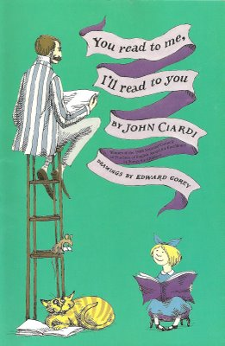

 CCC Ciardi, J. (1962) *You read to me, I’ll read to you.* Hong Kong: The Curtis Publishing Company