A Warning About Bears

A Poem by John Ciardi

Some bears are **fierce**, and most grow fiercer

When any one bites off their ears, sir.

With bears it’s best to be polite.

And a bit distant—that’s all right.

But, please, when meeting bears, don’t bite.

More About Bears

A Poem by John Ciardi

Some bears are **fierce**, and some are fiercer.

Few bears (I rather hope) are near sir.

From what I know of bears, they are

Better few and better far.

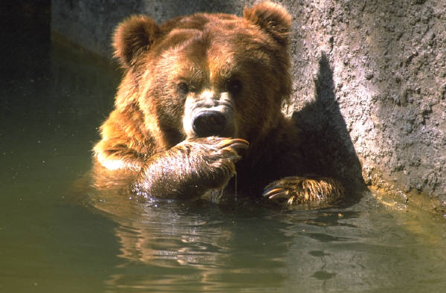

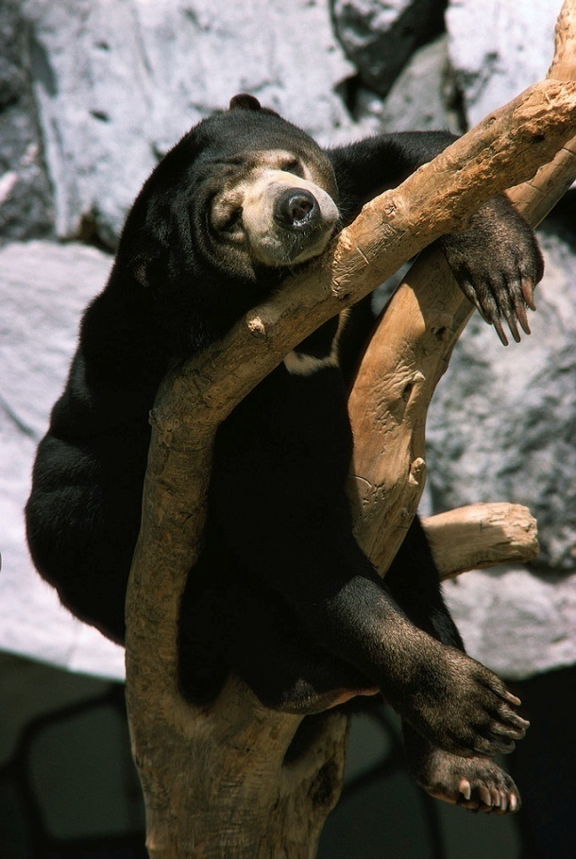

Still More About Bears

Draw a fierce bear

A Poem by John Ciardi

The fiercest bear of all is very

(A good thing, too) **imaginary**.

I say “a good thing” for my dear,

If he were real, he might be here.

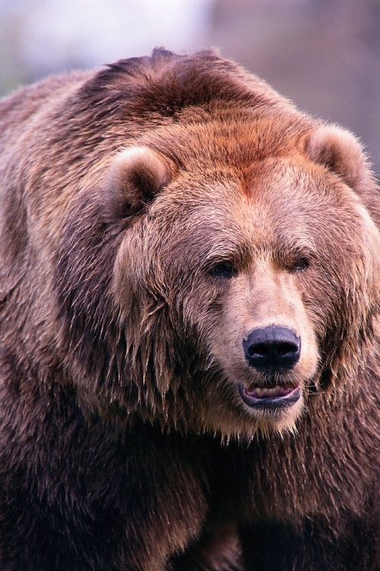 Last Word About Bears

A Poem by John Ciardi

I meet few bears and few meet me.

But still it’s my **belief**

That, meeting bears, the thing to be

Is—brief