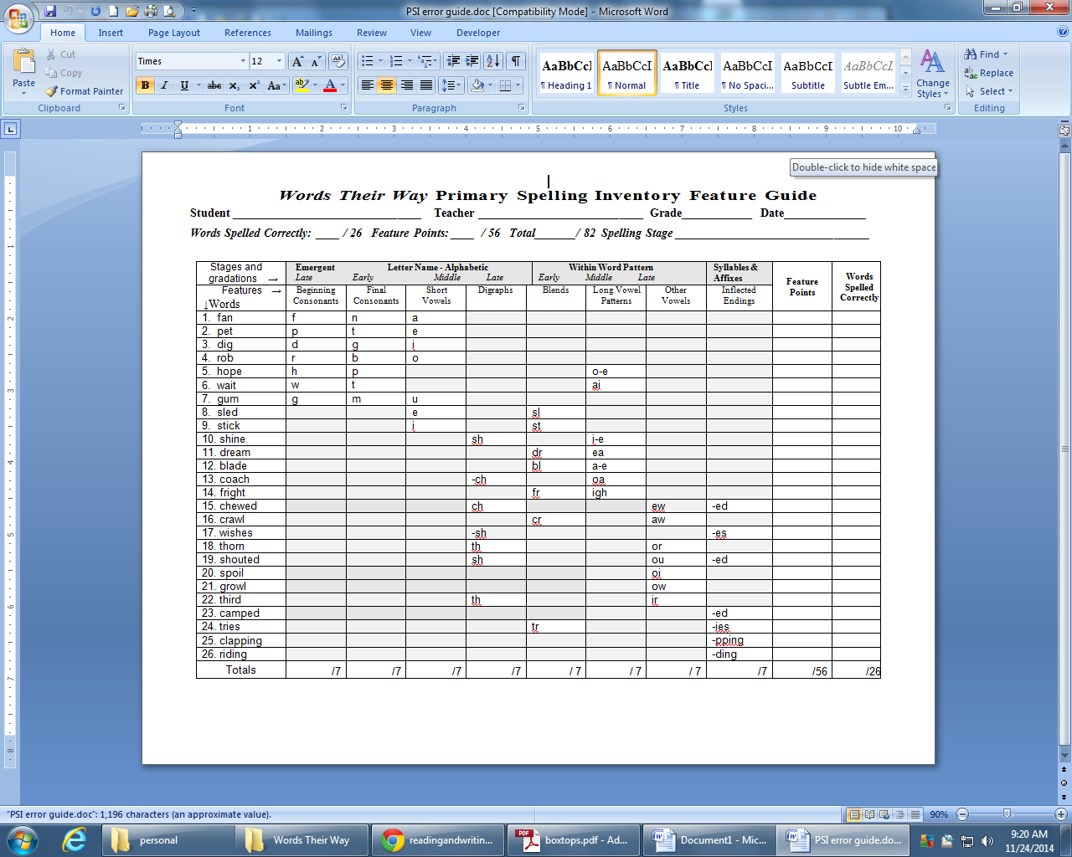

**Scoring and Analyzing the PSI**

**Scoring**

Score the words by circling or highlighting the features spelled correctly in the cells to the right of each word. Put a slash through features that are not correct.

**EXAMPLE**

A student spells **bed** as *bad*

* Circle the initial **b** cell and the final **d** cell, not for the short vowel. Write the incorrect spelling next to the word.

**EXAMPLE**

A student spells **train** as *trane*

* She gets a check in the initial **tr** cell and the final **n** cell, but not for the long vowel pattern. Write the incorrect spelling next to the word.
* Put a check in the “Correct” column if the word is spelled correctly.
* Do NOT count reversed letters as errors but note them in the cells.
* If unnecessary letters are added, give the speller credit for what is correct (e.g., if **bed** is spelled *bede*, the student still gets credit for representing the short vowel), but do not check “Correct” spelling.

**Analyzing the Data**

The total score can be compared over time but the most useful information will be the feature analysis.

QUALITATIVELY (using the Feature Analysis):

* Look down each feature column to determine the needs of individual students. For example, a student who spells 6 of 7 short vowels correctly on the primary inventory is knowledgeable about short vowels although some review work might be in order.
* A student who spells only 2 or 3 of the 7 short vowels needs to be involved in word study

around this feature. If a student did not get any points for a feature, then the feature is beyond the student’s instructional range and earlier features need to be studied first.

QUANTITATIVELY:

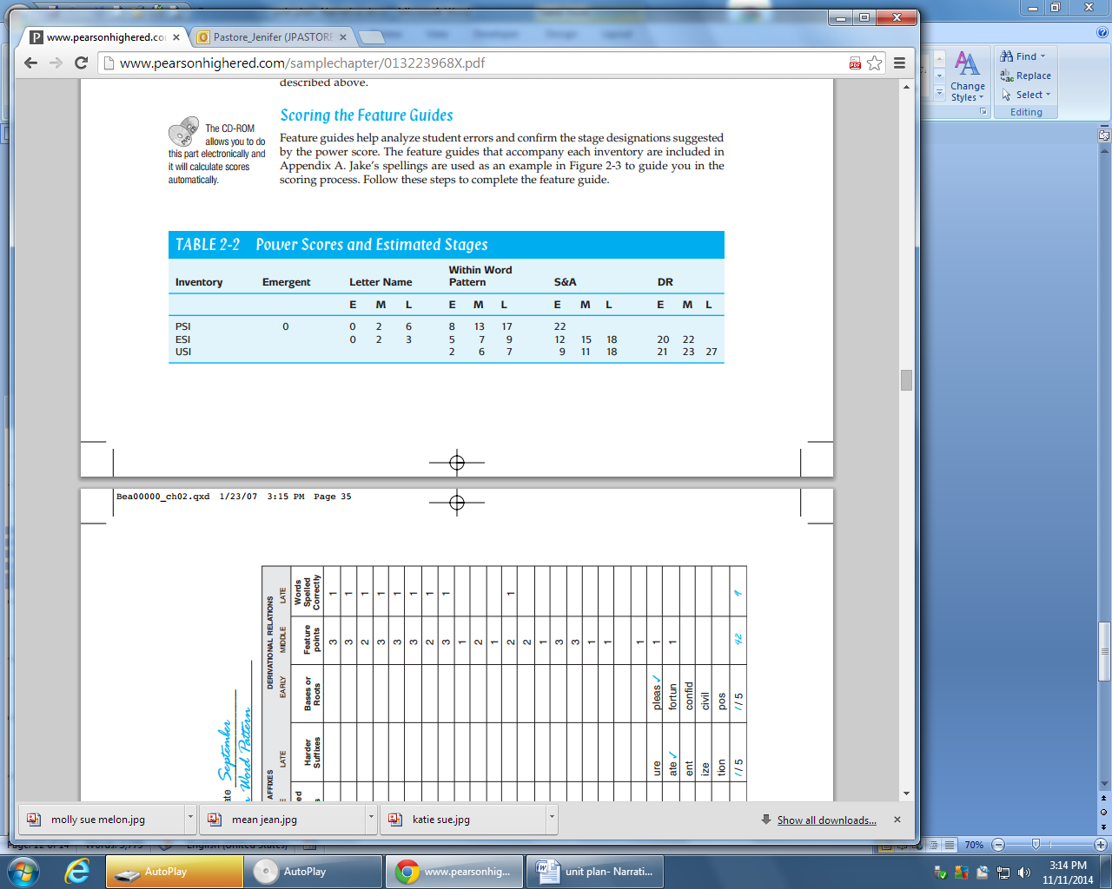Refer to Power Scores and Estimated Stages.

|  |  |  |
| --- | --- | --- |
| **Grade Level** | **Spelling Stage Ranges**  **Within the Grade** | **End-of-Year**  **Spelling Stage Goal** |
| K | Emergent-Letter Name | Mid Letter Name |
| 1 | Late Emergent-Within Word | Early Within Word |
| 2 | Late Letter Name-Early Syllable Affix | Late Within Word |
| 3 | Within Word- Syllable Affix | Early Syllable Affix |
| 4 | Within Word-Syllable Affix | Mid Syllable Affix |
| 5 | Syllable Affix- Derivational | Late Syllable Affix |

From *Words Their Way: Word Study for Phonics, Vocabulary and Spelling Instruction*. Bear, D. et al. (2008) pp. 34,46, 49