|  |  |  |  |  |
| --- | --- | --- | --- | --- |
| **Fourth Grade Universal Screening** (August- September) | | | | |
| **DIBELS** | | | **Arkansas Rapid Naming Screener** | |
| **Assessment** | **Student Score** | **Benchmark**  *At risk = intensive & strategic* | **Student Score** | |
| **Oral Reading Fluency** |  | Scores from Beginning of Year  4th Grade 6th Edition  **w/c accuracy**  **0-65** **0-90%** **Intensive**  **66-85** **91-95%** **Strategic**  **86+ 96+ Core** | Combine time for Form A & B  **Score:** | **Total Errors:** |
| **Letter Naming Fluency** |  | |
| **PASS** | **Student Score**  Rhyme _____  Blending _____  Segmentation _____  Deletion _____  Phoneme Discrimination _____ | | **DSA** | |
| **Student Score**  Letter Name:  Within Word: | |

Student Name_________________________________________________________________ School____________________

Date _________________________________________________ Teacher_____________________________________________

**Alphabet Knowledge**

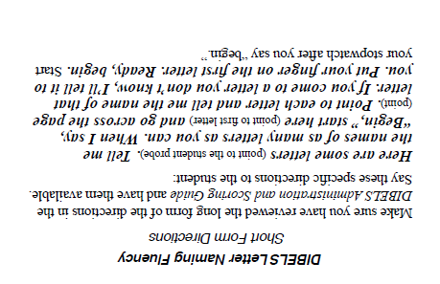

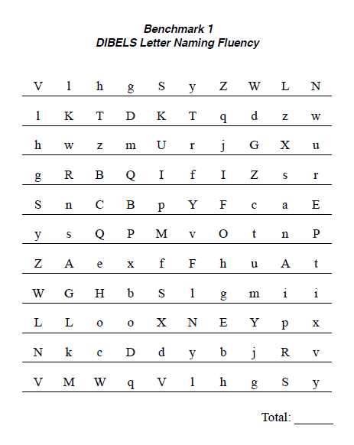

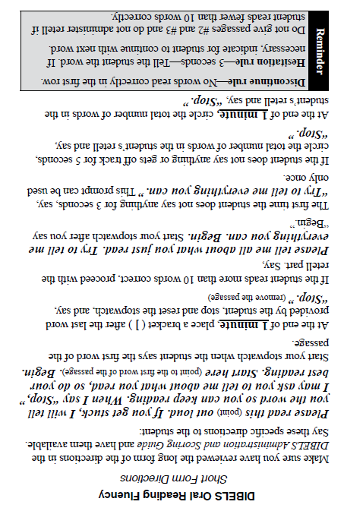

**Decoding Skills/Fluency**

