Student Name_________________________________________________________________ School____________________

Date _________________________________________________ Teacher_____________________________________________

|  |  |  |  |  |
| --- | --- | --- | --- | --- |
| **Second Grade Universal Screening** (August- September) | | | | |
| **DIBELS** | | | **Arkansas Rapid Naming Screener** | |
| **Assessment** | **Student Score** | **Benchmark**  *At risk = intensive & strategic* | **Student Score** | |
| **Nonsense Word Fluency** | **CLS** | Scores from Beginning of Year  2nd Grade 6th Edition  **0-51** **Intensive**  **52-61** **Strategic**  **62 and above** **Core** | Combine time for Form A & B  **Score:** | **Total Errors:** |
| **WRC** | Scores from Beginning of Year  2nd Grade 6th Edition  **0 - 4 Intensive**  **5 - 12** **Strategic**  **13 and above** **Core** | **PASS** | **Student Score**  Rhyme____  Blending _____  Segmentation ____  Deletion _____  Phoneme Discrimination _____ |
| **Oral Reading Fluency** |  | Scores from Beginning of Year  2nd Grade 6th Edition  **w/c accuracy**  **0-27** **80%** **Intensive**  **28-40** **81- 90%** **Strategic**  **41+**  **91% +** **Core** |
| **DSA** | |
| **Letter Naming Fluency** |  | | **Student Score**  Letter Name: | |
| **CLS**= Correct letter-sound correspondences  **WRC**= Words recoded completely and correctly as a whole word | | |  | |

**Alphabet Knowledge**

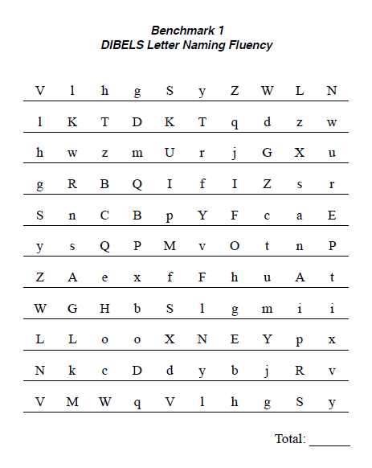

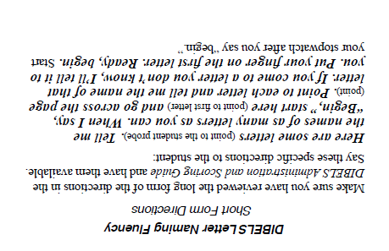

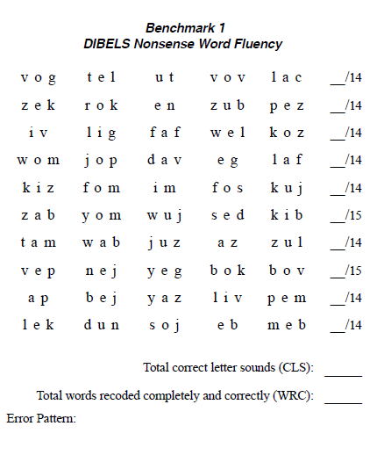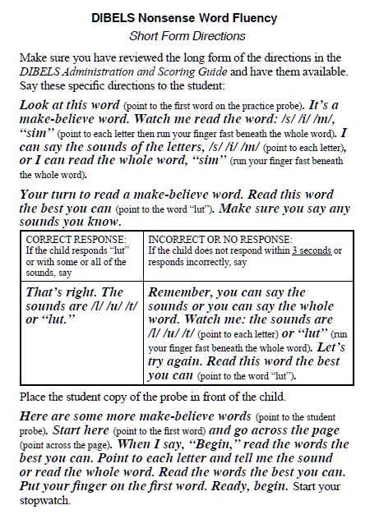

**Sound Symbol Recognition/Decoding Skills**

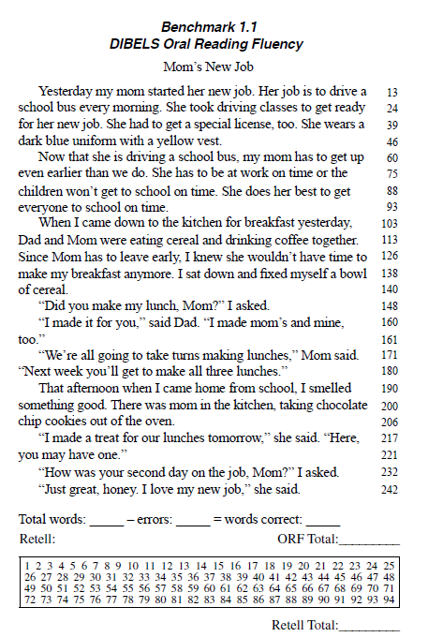

**Decoding Skills/Fluency**

