|  |  |  |  |  |
| --- | --- | --- | --- | --- |
| **First Grade Universal Screening** (August- September) | | | | |
| **DIBELS** | | | **Arkansas Rapid Naming Screener** | |
| **Assessment** | **Student Score** | **Benchmark**  *At risk = intensive & strategic* | **Student Score** | |
| **Letter Naming Fluency** |  | Scores from Beginning of Year  1st Grade 6th Edition  **0-32** **Intensive**  **33-37** **Strategic**  **38 and above** **Core** | Combine time for Form A & B  **Score:** | **Total Errors:** |
| **Phoneme Segmentation Fluency** |  | Scores from Middle of Year  Kindergarten 6th Edition  **0-27** **Intensive**  **28-32** **Strategic**  **33 and above** Core | **DSA** | |
| **Nonsense Word Fluency** | **CLS** | Scores from Beginning of Year  1st Grade 6th Edition  **0-18** **Intensive**  **19-24** **Strategic**  **25 and above** Core | **Student Score**  Letter Name: | |
| **WRC** | Scores from Beginning of Year  1st Grade 6th Edition  **0 Intensive**  **1** **Strategic**  **2 and above** **Core** |
| **CLS**= Correct letter-sound correspondences  **WRC**= Words recoded completely and correctly as a whole word | | | | |

Student Name_________________________________________________________________ School____________________

Date _________________________________________________ Teacher_____________________________________________

**Phonemic Awareness**

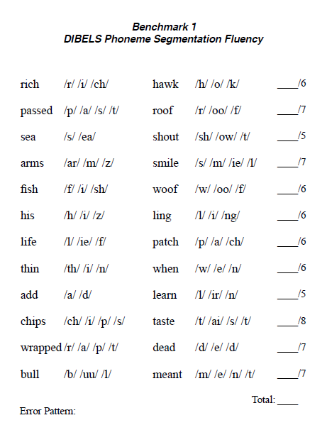

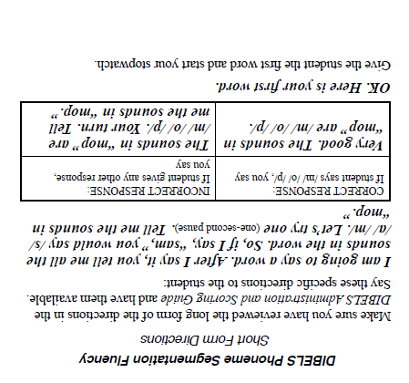

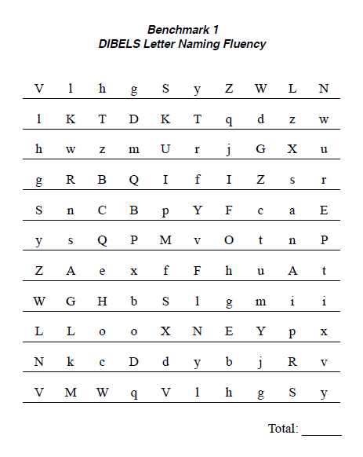

**Alphabet Knowledge**

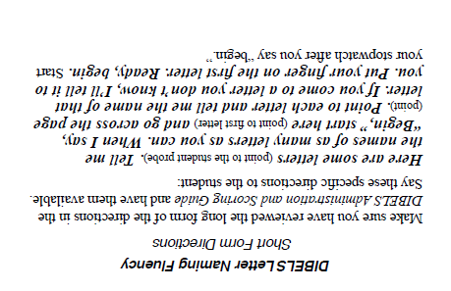

**Sound Symbol Recognition/Decoding Skills**

