Amos (4) | Amos helped himself but he also helped others who needed help. | 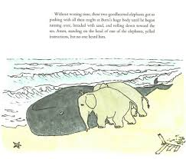
Amos (3) | Curious – Comes up with a plan.  Carries out the plan.  If it is difficult he keeps trying.  May ask for help if he needs it. | 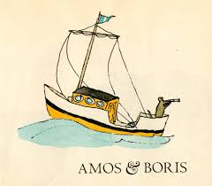
Amos (2) | Be curious – He might not know what to do. He might daydream about what he could do but never follows through.  He might always want others to do most of the work. | 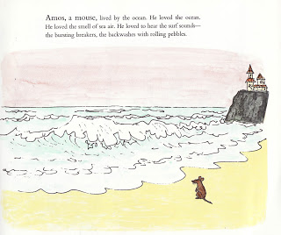
Amos (1) | He stayed where he was living.  Rarely did any work except to survive.  He might try something but give up before he completes a task. | 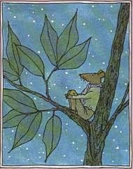

Are you a 1 2 3 or 4 for effort on this activity?

