Cooperative Learning Structures

Think-Pair-Share (Timed-Pair-Share)
- The teacher presents a question or a problem.
- Students are given time to think about the content.
- Students, as a pair, interact over the content.
- Students share responses with each other.

Management Tips:
- Make sure students know who should share first
(partner A or B)
- Make sure students are aware of who their partners will be
(Shoulder, Face, carpet partner…)
- Teacher should put something in place so students know
when their turn is up and it is their partners’ turn to share.
(Timer, tell them to switch)
- Keep it short so they don’t get off topic
- Have a signal for partners to give you when each has shared (Hands up, thumbs, up, etc…)

Round Robin
- Teacher poses a problem to which there are many possible
responses or solutions.
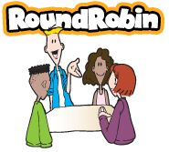
- Students take turns stating responses or solutions going
around the table or in pairs.
- Continue until time is up or everyone is out of ideas.

Management Tips:
- Make sure the teacher circulates
- Set a timer
- Decide who will go first and what to do if that person does
not have an idea
- Let students refer back to interactive notebooks, text, anchor
charts, etc… for answers
- Rally Robin is the structure used for pairs because you “rally”
back and forth. Round Robin refers to going “around” the whole table or group

Round Table
- Teacher provides a task to which there are multiple possible responses.
- In teams, students take turns passing a paper and pencil or a team project, each writing one answer or making a contribution. (Voices off)

Management Tips:
- Teacher circulates
- Make sure students have all supplies needed and know
which way they are passing the paper before they start
- Students should know who writes first. Could be table
captain, or whomever has the first idea
- Tell students if you want them to write one word, a
phrase, draw, etc…
- Make sure they read each others’ ideas before submitting
their own
- If they don’t have an idea they can read the others, say
pass, and rewrite one when the papers comes back around
- Tell students how many passes to make or set a timer

 | Writing | Talking
2 pairs | Rally Table | Rally Robin
4 or groups/teams | Round Table | Round Robin | Simultaneous: 4 pieces of paper, or 1 for each group member

Find the Fiction
1. Students/Teacher write statements: two true, one false
2. One teammate/Teacher stands and reads statements
3. Teammates each write best guess, reach consensus, and
announce guess
4. Standing student/Teacher reveals answer
5. Students celebrate, praise, or correct
6. Next teammate shares or teacher poses a new set of statements
Management Tips:
- Allow them to look back in their interactive notebook, text,
anchor charts, etc… for answers.
- Make sure if you are having students create, that you are circulating.
- Use information from the previous days lessons as the statements for the APK.

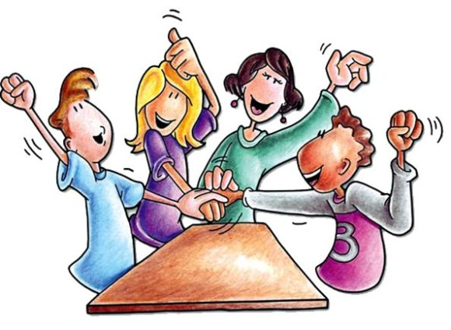
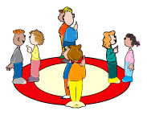
Find Someone Who
1. Stand up, hand up, pair up
2. A asks question; B responds; A records answer
3. B checks and initials answer
4. Switch roles
5. Repeat with a new partner each time
6. When worksheets are complete, students sit and compare
Inside-Outside Circle
1. Half the class forms outside circle
2. Remaining students form inside circle
3. “Inside” students ask; “outside” students respond
4. Partners switch roles
5. Students rotate
Mix Pair Share
1. Students mix
2. Teacher calls, “pair”
3. Hand up, pair up
4. Teacher asks question, gives think time
5. Share: Timed Pair Share or Rally Robin
Numbered Heads Together
1. Students number off
2. Teacher asks question
3. Students think and write
4. Heads together: share and discuss
5. Teams signal when ready
6. Teacher calls number
7. That number answers
Quiz-Quiz-Trade
1. Students stand up, hand up, pair up
2. Quiz: A quizzes
3. B answers
4. A praises or tutors
5. Quiz: partners switch roles
6. Trade: partners trade cards
7. Students repeatedly Quiz-Quiz-Trade
Stand Up, Hand Up, Pair Up
1. Students stand up, hand up, pair up
2. Teacher asks question
3. Think time
4. Partners share using: Rally Robin or Timed Pair Share

