Letter Recognition & Naming Intervention
This intervention is for students who are struggling with basic letter recognition as evidenced by Letter ID and DIBELS LNF assessments. Students may progress through the goals at different paces.
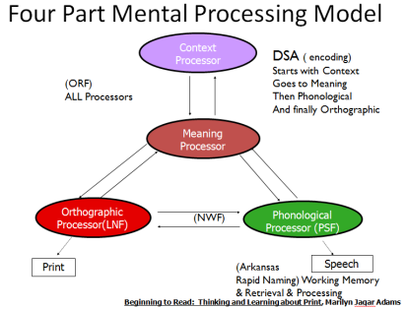
Letter Recognition and Naming
Isolating & Focusing on the Orthographic Processor
&
Working Memory Retrieval and Recall

Rogers Kindergarten Benchmark Expectations
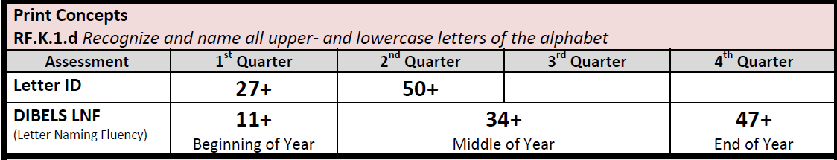

Goal 1:
- Student can match manipulative (magnetic) letters to templates
- Student can point letters that teacher names (It is ok for them not to be able to name the letter independently at this stage)
Guidelines: Start with known letters (in name) and gradually add in unknown, starting with letters that are not visually similar.
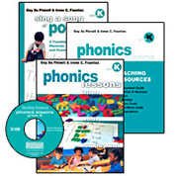

Activities to solidify letter recognition:
- Match magnetic letters to template. *Template found in Phonics Lessons, Grade K, pages 137-147
- Trace letters in sand tray, sandpaper, in shaving cream, saying letter name each time the letter is formed (use letter formation teacher script)
- Using known letters, sort magnetic letters by features (circles, sticks, curves, etc.), saying letter names for each as you sort them. See “Ways to Sort or Match Letters” in Phonics Lessons, pg. 167-168
- Make letters in name with Pasta Names, using elbow macaroni & spaghetti, so students can see how curves and straight lines work together to make letters. (http://www.fcrr.org/studentactivities/P_006a.pdf)
- Using different fonts of letters (Ex: H, H, H, H, H, etc.) students put letters together in groups.

Once the student has mastered almost all letter names, move to goal 2.

Goal 2:
- Using a printed alphabet template, students match magnetic letters to the model and name the letters in sequence (both capital and lowercase).

Activities to solidify letter recognition & naming:
- Alphabet Arc (http://www.fcrr.org/studentactivities/P_003a.pdf)

*Once a student masters this, move to goal 3.

Goal 3:
- Student can independently match upper- and lowercase letters while naming them.

Activities to solidify letter recognition, matching, & naming:
- Clip-a-Letter (http://www.fcrr.org/studentactivities/P_004a.pdf)
- Upper- & lowercase letter cards to match (http://www.fcrr.org/studentactivities/P_002a.pdf)
- Match magnetic upper- and lowercase letters
- Find upper- and lowercase letter matches in names or environmental print

Goal 4:
- Students increase fluency in naming randomly ordered upper- and lowercase letters to benchmark level. DIBELS Benchmark levels: 11 in fall, 34 in winter, 47 in spring
*Note: DIBELS Benchmark is the minimum expectation for each student.

Activities to solidify letter recognition & naming:
- Speed Drills
- Letter Memory (game)

