**Vowel Phoneme and Grapheme Wall**

Revised 9-20-18

A **Vowel Phoneme and Grapheme Wall** should be displayed in addition to the Consonant Phoneme Grapheme Wall. Cards are displayed according to how they are produced in the mouth. Cards should be covered or not posted until that sound has been explicitly taught.

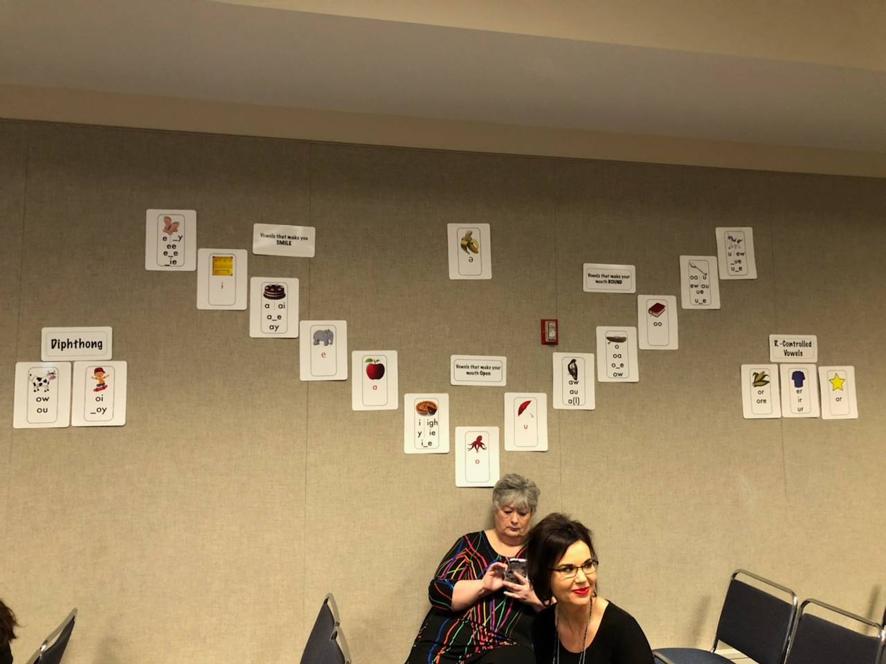

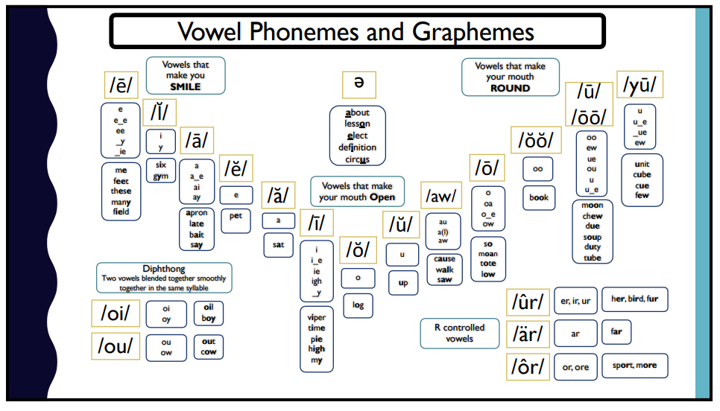

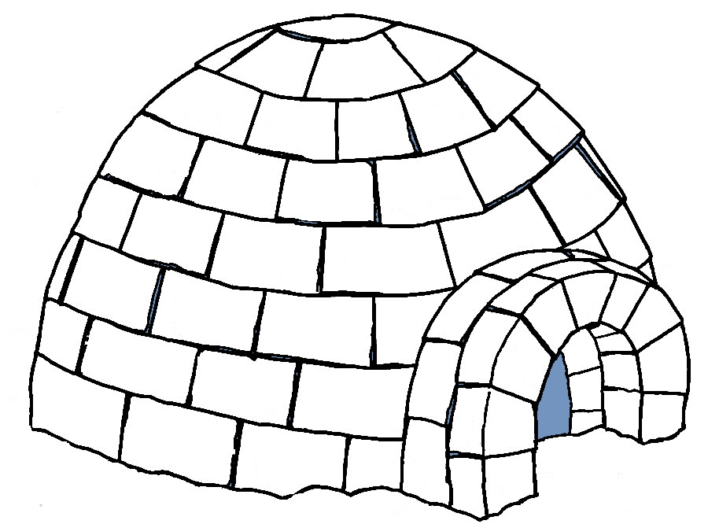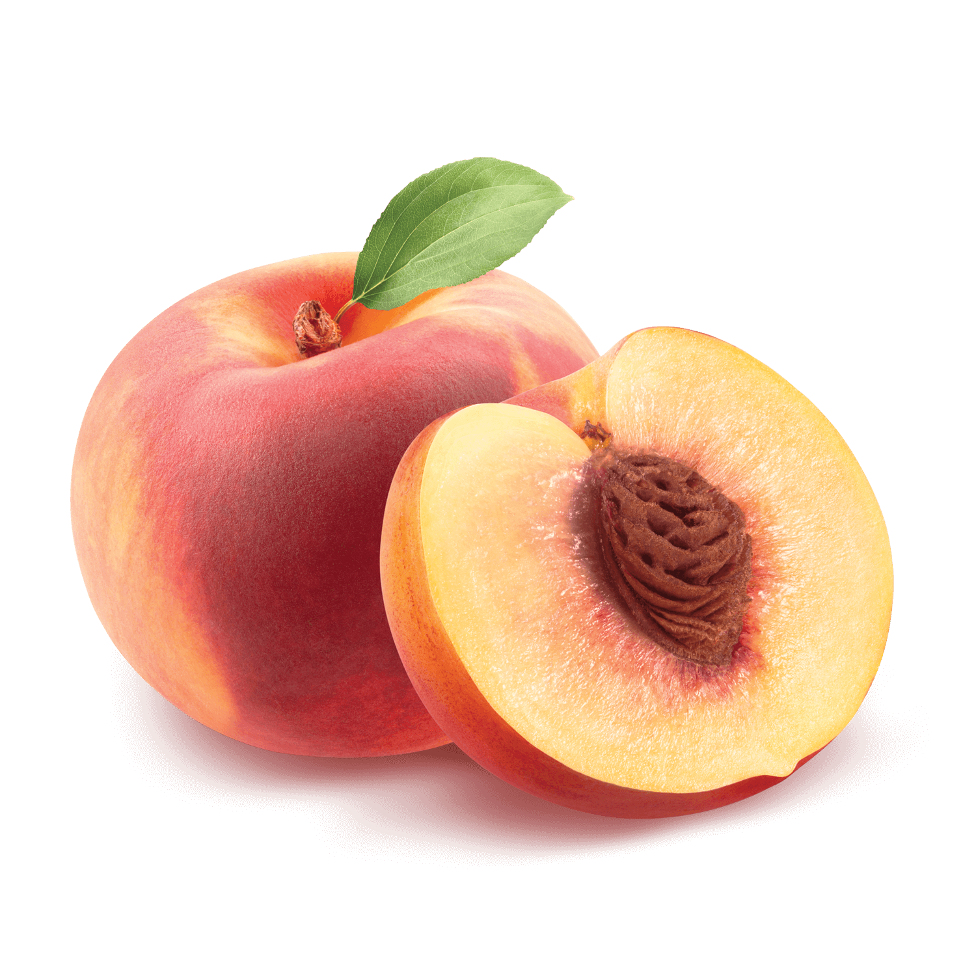

**i**

**e _y**

**ea ee**

**e_e**

**_ie**

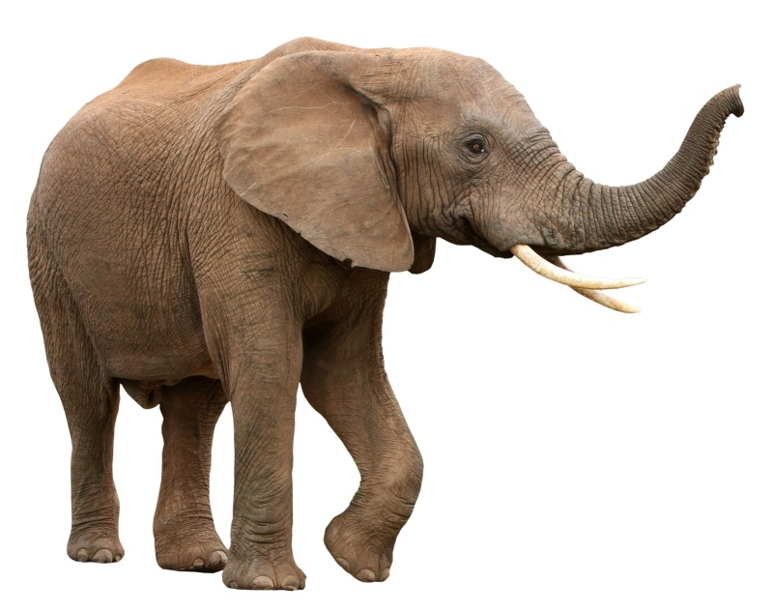

**e**

**a ai**

**a_e**

**ay**

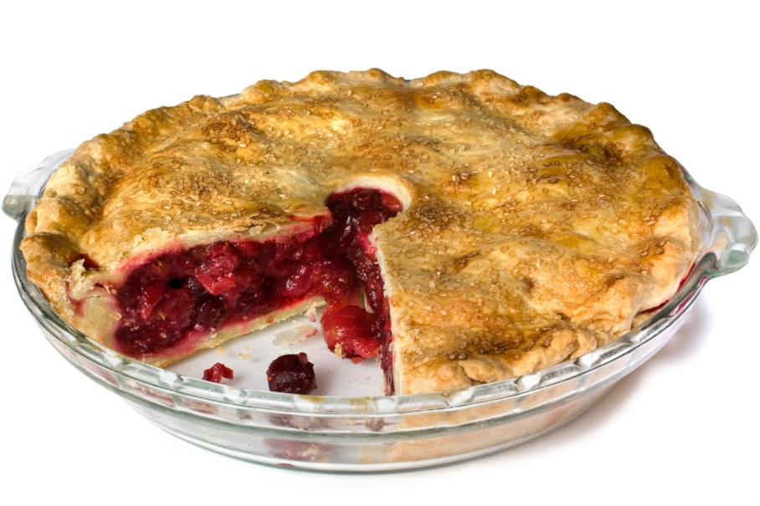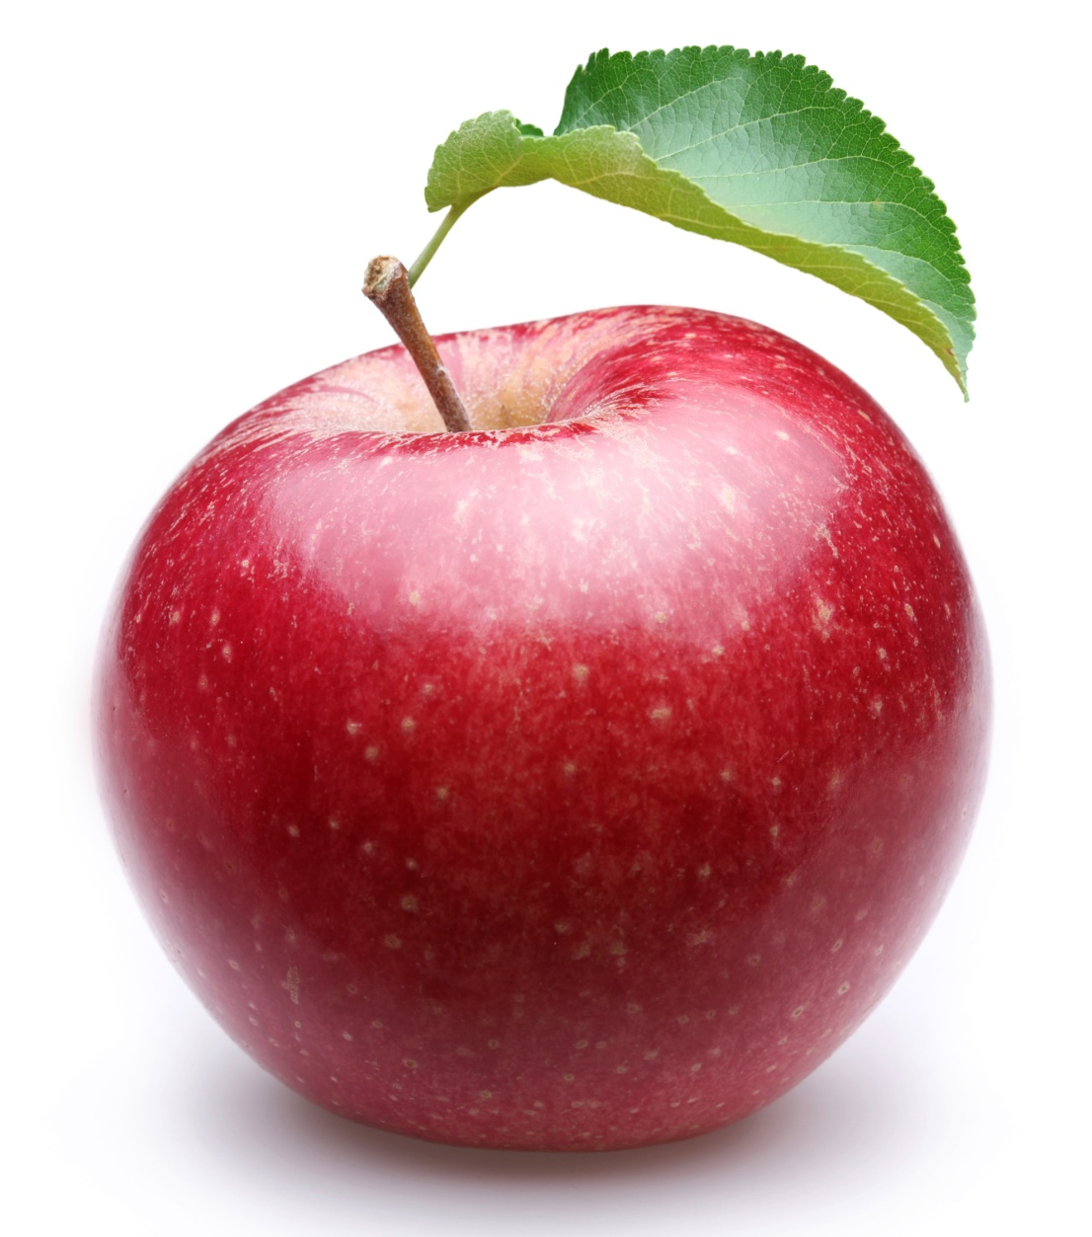

**i igh**

**y ie**

**i_e**

**a**

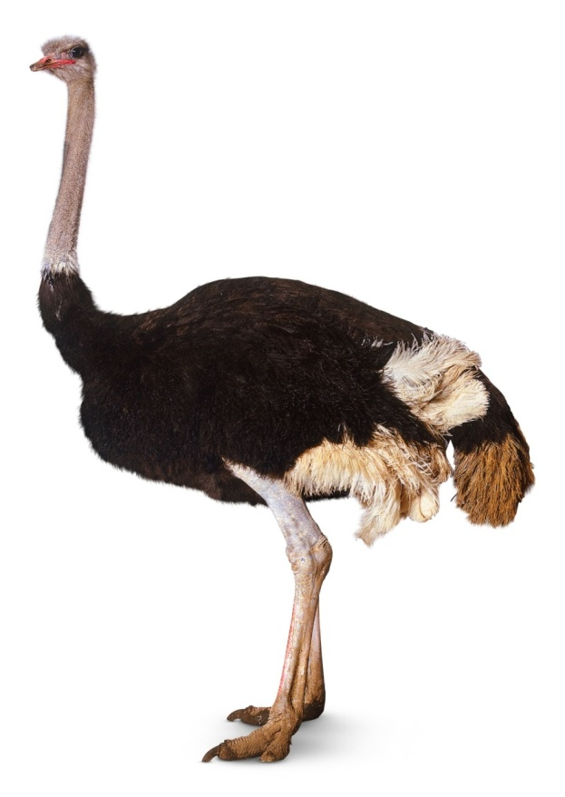

**u**

**o**

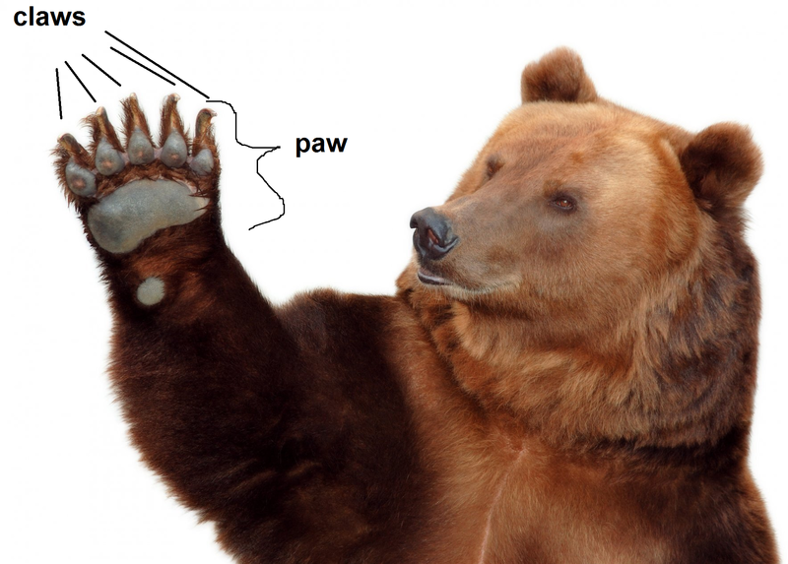

**o**

**oa**

**o_e**

**ow**

**aw au**

**a(l)**

**o**

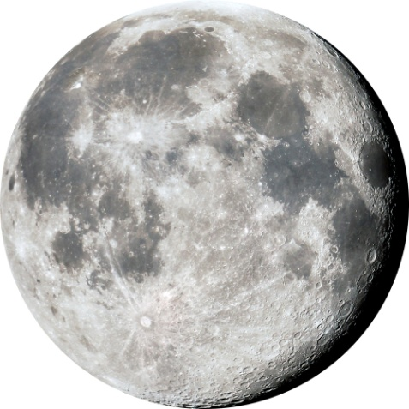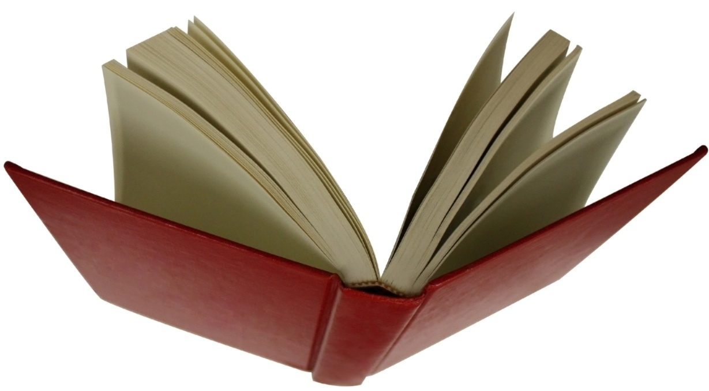

**oo u**

**ew ou**

**ue**

**u_e**

**oo**

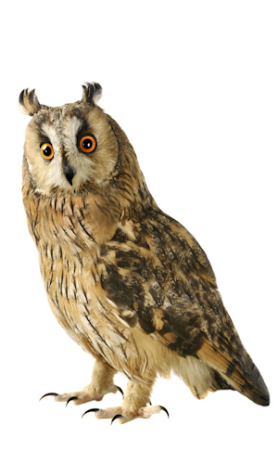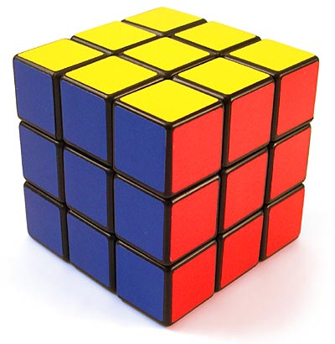

**ow**

**ou**

**u ew**

**_ue**

**u_e**

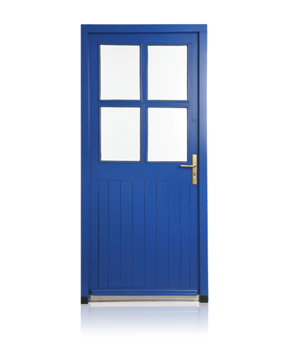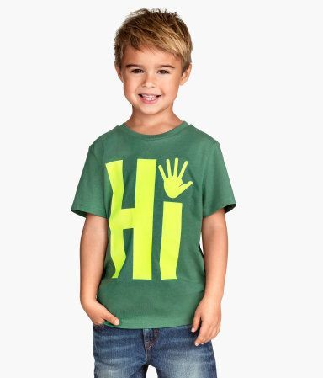

**or**

**ore**

**oi**

**_oy**

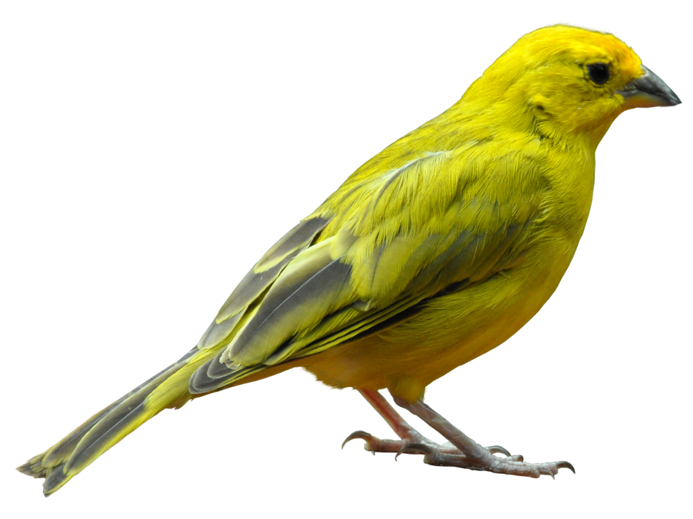

**ar**

**er**

**ir**

**ur**

**e**

This card is meant to be displayed upside down.

The picture on this card is upside down for a reason. An upside down “e” represents the “schwa” sound, so turn this card so the picture is upright and the “e” is upside down before posting.

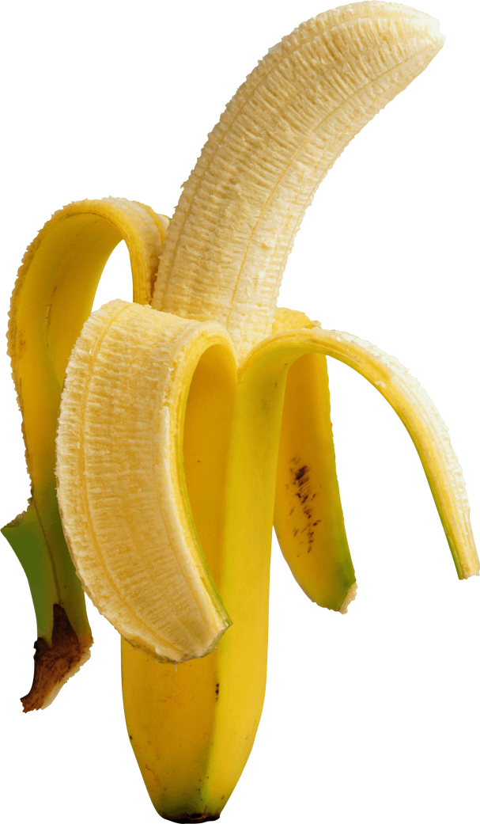

Labels may be printed as is, or you may choose to fill each label with a color that complements your classroom color scheme prior to printing.

Vowels that make you **smile**

Vowels that make your **mouth open**

Vowels that make your **mouth round**

**Diphthongs**

**R-controlled vowels**