**Roll and Write** Name: ____________________________

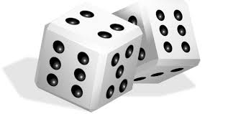

|  |  |  |  |  |  |
| --- | --- | --- | --- | --- | --- |
| clip-art-dice-singles-rows-5306502.jpg | p | p | p | p | p |
| clip-art-dice-singles-rows-5306502.jpg | g | g | g | g | g |
| clip-art-dice-singles-rows-5306502.jpg | d | d | d | d | d |
| clip-art-dice-singles-rows-5306502.jpg | h | h | h | h | h |
| clip-art-dice-singles-rows-5306502.jpg | l | l | l | l | l |
| clip-art-dice-singles-rows-5306502.jpg | c | c | c | c | c |