Roll and Write Name: ____________________________
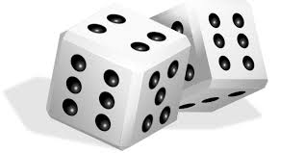

 | f | f | f | f | f
 | w | w | w | w | w
 | j | j | j | j | j
 | h | h | h | h | h
 | y | y | y | y | y
 | v | v | v | v | v

