**Roll and Write** Name: ____________________________

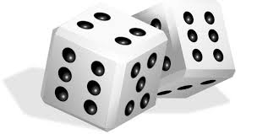

|  |  |  |  |  |  |
| --- | --- | --- | --- | --- | --- |
| clip-art-dice-singles-rows-5306502.jpg | b | b | b | b | b |
| clip-art-dice-singles-rows-5306502.jpg | m | m | m | m | m |
| clip-art-dice-singles-rows-5306502.jpg | s | s | s | s | s |
| clip-art-dice-singles-rows-5306502.jpg | r | r | r | r | r |
| clip-art-dice-singles-rows-5306502.jpg | t | t | t | t | t |
| clip-art-dice-singles-rows-5306502.jpg | n | n | n | n | n |