Roll and Write Name: ____________________________
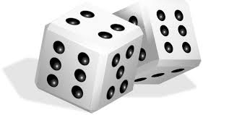

 | P | P | P | P | P
 | G | G | G | G | G
 | D | D | D | D | D
 | H | H | H | H | H
 | L | L | L | L | L
 | C | C | C | C | C

