Roll and Write Name: ____________________________
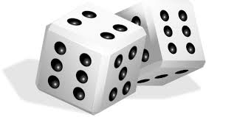

 | F | F | F | F | F
 | W | W | W | W | W
 | J | J | J | J | J
 | H | H | H | H | H
 | Y | Y | Y | Y | Y
 | V | V | V | V | V

