Roll and Write Name: ____________________________
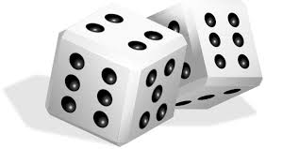

 | B | B | B | B | B
 | M | M | M | M | M
 | S | S | S | S | S
 | R | R | R | R | R
 | T | T | T | T | T
 | N | N | N | N | N

