Pip and Tim

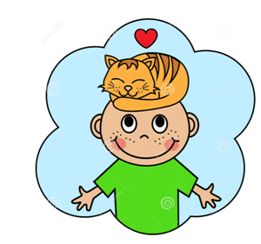

------------------------

Pip is sad.
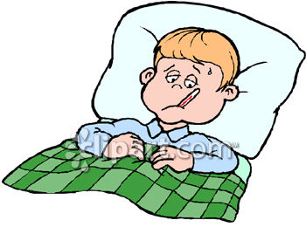
Pip is on a cot. 1
Pip has a cat, Tim.
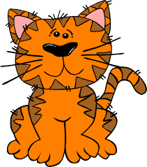

Tim is not on the cot. Tim! Tim! 2
-------------------

Tim has a nap.

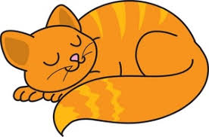 3
Pip has a nap.

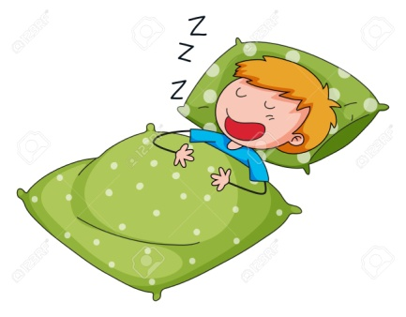 4

------------------------

Tim sat on Pip!

5

