3rd Grade, Quarter 3 Formative Assessment
This assessment is meant to measure progress towards the following standards:

RI.3.2 Determine the main idea of a text; recount the key details and explain how they support the main idea
RI.3.4 Determine the meaning of general academic and domain-specific words and phrases in a text relevant to a grade 3 topic or subject area

From the Q3 Proficiency Rubric:
- Identify the main idea
- Recount the key details
- Explain how key details in the text support the main idea (Using text and text features)

Students are to define the terms ”main idea” and “key detail.” Students then read an informational passage and answer questions related to the main idea and key details of the passage. The final task asks students to describe two specific details from the passage.

Questions on this formative assessment as aligned to the question types on ACT Aspire. Students will complete the formative assessment using a digital platform to be shared later.

Directions for Giving the Assessment:

Students should spend 10 minutes independently reading the passage and answering the questions on this assessment. Encourage students, especially struggling readers, to think about strategies they have for reading difficult passages/texts.

After 10 minutes, please read the passage and questions aloud for the class. If asked, continue to read aloud any portion of the passage or question. While we know that read aloud is not an allowable accommodation on the reading portion of high-stakes testing, the purpose of this assessment is to measure reading comprehension…not independent reading comprehension.

440L
- What does “main idea” mean?
  - Details or evidence from the text
  - An inferred lesson about life the author wants me to learn
  - The biggest idea the author wants me to learn about the topic
  - an explicit or inferred piece of information from the text that is related to and supports the main idea
- What does “key detail” mean?
  - Details or evidence from the text
  - An inferred lesson about life the author wants me to learn
  - The biggest idea the author wants me to learn about the topic
  - an explicit or inferred piece of information from the text that is related to and supports the main idea

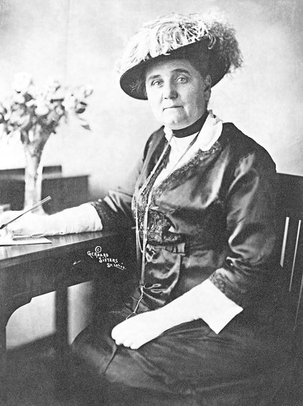
Chicago Changer
Reform means to make things better. Jane Addams saw things in Chicago to reform. She saw poor people living in crowded neighborhoods. The houses were small. They did not have enough rooms for all of the people who lived in them. The streets were dirty. People did not have places to get clean water. They did not have places to wash. Jane Addams wanted to help poor people have a better life, and she did. She believed that helping poor people would make everyone’s life better. She would make Chicago better.
In 1889 Jane Addams set up a place to help people. She called it Hull-House. Hull-House was a settlement house. It helped immigrants to Chicago. Immigrants are people who move to a new country. The immigrants needed to find homes. They needed to learn English. They needed to learn about the city. Jane Addams wanted to teach them the skills they needed to live well on their own. When people came to thank her, that was fine. But she liked it better when they did not come back. She was glad that they were independent.
Jane Addams had more than one idea about how to help the people of Chicago. One thing she did was to live in the same community where the poor people lived. This helped her to understand their problems. She listened to them. She helped them work together to change things in their neighborhood. She was one of Chicago’s first community organizers.
Another thing Jane Addams did was talk to Chicago’s leaders. Jane Addams was a powerful woman. She knew the Mayor. She talked to him and the other leaders about the problems of the poor people. Sometimes the leaders listened. Sometimes they did not. Someone once heard the mayor say “Here comes that woman again, let’s get out of here.” But she kept trying. She made changes. She made the schools better. She helped to set up playgrounds. She made people’s jobs safer. She fought for people to get better pay. She even became the Garbage Inspector in her ward. Then she could help clean up the neighborhood.
Jane Addams worked with many other people to help families. She helped neighborhoods. She became famous around the world for her hard work. She won a Nobel Peace Prize. That is a very important honor. Jane Addams left Chicago an important legacy. Hull-House is still in Chicago today. It still helps people make progress. She showed how one person can make progress for a whole city.

- What is the main idea of the passage?
- Jane Addams set up a place to help people.
- Jane Addams became the Garbage Inspector in her ward.
- Jane Addams improved life for many of Chicago’s people.
- Jane Addams lived in the same neighborhood as the people she helped.

- Choose two details from the passage that help the reader understand how powerful Jane Addams was in Chicago.
- She wanted to teach them the skills they needed to live well on their own.
- She talked to the mayor and other important people about the people’s needs.
- She believed that helping poor people would make everyone’s life better.
- The mayor once said, “Here comes that woman again, let’s get out of here.”

- What is the main idea of paragraph two?
- Hull-House was a settlement house.
- Immigrants needed to learn English.
- Hull-House helped to make immigrants more independent.
- Jane Addams used Hull-House to teach immigrants about Chicago.

- What does ward mean as it is used in paragraph 4?
- A place to make clean and tidy
- An exciting place to live
- A difficult or challenging job
- A section of a city or town

- Describe two Jane Addams was rewarded for her efforts to improve the lives of poor people in Chicago. Use specific details from the passage to support your answer.
- What is the main idea of the passage?
- Jane Addams set up a place to help people.
- Jane Addams became the Garbage Inspector in her ward.
- Jane Addams improved life for many of Chicago’s people.
- Jane Addams lived in the same neighborhood as the people she helped.

- Choose two details from the passage that help the reader understand how powerful Jane Addams was in Chicago.
- She wanted to teach them the skills they needed to live well on their own.
- She talked to the mayor and other important people about the people’s needs.
- She believed that helping poor people would make everyone’s life better.
- The mayor once said, “Here comes that woman again, let’s get out of here.”

- What is the main idea of paragraph two?
- Hull-House was a settlement house.
- Immigrants needed to learn English.
- Hull-House helped to make immigrants more independent.
- Jane Addams used Hull-House to teach immigrants about Chicago.

- What does ward mean as it is used in paragraph 4?
- A place to make clean and tidy
- An exciting place to live
- A difficult or challenging job
- A section of a city or town

- Describe two Jane Addams was rewarded for her efforts to improve the lives of poor people in Chicago. Use specific details from the passage to support your answer.

Answers will vary.
Students could tell about Jane Addams receiving a Nobel Peace Prize for her hard work, becoming garbage inspector of her ward, the pride and happiness she felt when people’s lives were improved, becoming famous for her efforts to help people, etc.

