1st Grade, Quarter 3
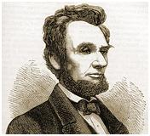
Formative Assessment

This assessment is meant to measure progress towards the following standards:

- RL.1.3 Describe characters, settings, and major events in a story, using key details.
- RI.1.4 Ask and answer questions to help determine or clarify the meaning of words and phrases in a text.

Students are expected to choose the best definition for the words “major character” and “setting.” Students will tell whether a character is a “major” or a “minor” character. They will then draw and write to tell the major events from the story.

Because we know that vocabulary is typically a tricky spot for our students, questions 1-2 address standard RI.1.4. Question 3 measures standard RL.1.3.

Directions for Giving the Assessment:

Students should spend 15 minutes independently reading the passage and answering the questions on this assessment. Encourage students, especially struggling readers, to think about strategies they have for reading difficult passages/texts.

After 15 minutes, please read the passage and questions aloud for the class. If asked, continue to read aloud any portion of the passage or question. While we know that read aloud is not an allowable accommodation on the reading portion of high-stakes testing, the purpose of this assessment is to measure reading comprehension…not independent reading comprehension.

Reminder: Allow students to dictate their descriptions of the events if necessary. Use the phrase, “Tell me about…” when asking students about their character and descriptions.

- What is a major character?
Name: ____________________
  - The important things that happen in the story
  - Words and pictures from the story
  - Who the story is mostly about
  - Where and when the story takes place

- What does setting mean?
  - The important things that happen in the story
  - Words and pictures from the story
  - Who the story is mostly about
  - Where and when the story takes place

Phil was a basset hound. He had very long ears. His favorite person in the world was Shelly. Shelly was his owner’s daughter. She always played with him and gave him treats. Phil’s favorite treat was ice water but Phil had a problem. Every time he tried to drink his water, he got his ears wet. Then his wet ears would get water everywhere. It was not a nice feeling.
Shelly was a smart girl. She liked to play with Phil and help him. When she saw his wet ears, she started to think. “How can I fix his ears? They always get wet.”
“Get the scissors and make his ears shorter,” said her friend Jack. She definitely didn’t want to use scissors to make his ears shorter! That was a scary idea. She would never hurt Phil. Phil’s ears were the best thing about him.
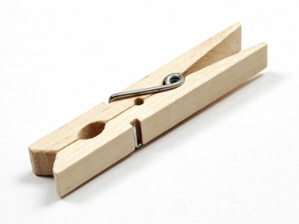
“You could try taping his ears,” said her sister Jane. So Shelly tried to tape his ears up. The tape wouldn’t stick well to his fur. Phil yelped when the tape pulled off his hair, too! Poor Phil.
“How about a clothespin?” said Mom. Shelly used a clothespin to hold Phil’s ears back behind his head. It worked! Phil drank his ice water before his nap, and he didn’t get his ears wet. Now he could sleep without wet ears.
Shelly was so happy, but Phil was happier!

- Think about the characters in the story. Some of them are major characters, and some are minor characters. Next to each name, circle whether the character is major or minor.

Shelly | major minor
Phil | major minor
Jack | major minor
Jane | major minor
Mom | major minor

- What is Phil?
  - A cat
  - A girl
  - A dog
  - A mom

- Which detail is tells about Phil?
  - He loves to play fetch.
  - His favorite treat is his bone.
  - His ears are short and pointy.
  - His ears fall into his water bowl.

- In the boxes below, draw and/or write to describe the key details from the story.

- What is a major character?
Name: ____________________
  - The important things that happen in the story
  - Words and pictures from the story
  - Who the story is mostly about
  - Where and when the story takes place

- What does setting mean?
  - The important things that happen in the story
  - Words and pictures from the story
  - Who the story is mostly about
  - Where and when the story takes place

- Major or Minor Characters
Shelly | major minor
Phil | major minor
Jack | major minor
Jane | major minor
Mom | major minor

- What is Phil?
  - A cat
  - A girl
  - A dog
  - A mom

- Which detail is tells about Phil?
  - He loves to play fetch.
  - His favorite treat is his bone.
  - His ears are short and pointy.
  - His ears fall into his water bowl.

- Key details…Choose from any of the following:
- Phil’s ears are long and get wet
- Shelly tried to help Phil.
- Jack said to get scissors
- Jane said to use tape.
- Mom said clothespin.
- Shelly helped Phil.

